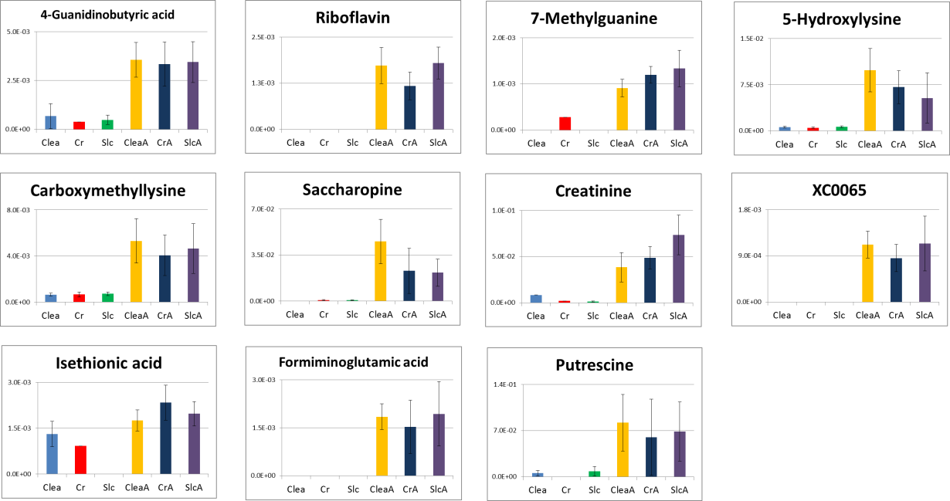

Additional File 4. Comparison of relative peak area of metabolite picked up by the PCL < -0.7
Clea: untreated mice group of Clea, Cr: untreated group of Charles river, Slc: untreated group of Slc, CleaA: antibiotic-treated group of Clea, CrA: antibiotic-treated group of Charles river, SlcA: antibiotic-treated group of Slc. Data are represented as mean ± SD.

