Additional Information
Biosynthesis of Flower-shaped Au Nanoclusters with EGCG and their Application for Drug Delivery

Shichao Wu, Xiangrui Yang, Fanghong Luo, Ting Wu, Peilan Xu, Mingyuan Zou, ＆ Jianghua Yan.

The file includes
- Formula S1
- Table S1-3
- Figure S1-8

Formula S1. The formal chemical equations of the synthetic procedure of Au-Cys-MTX/DOX NCs
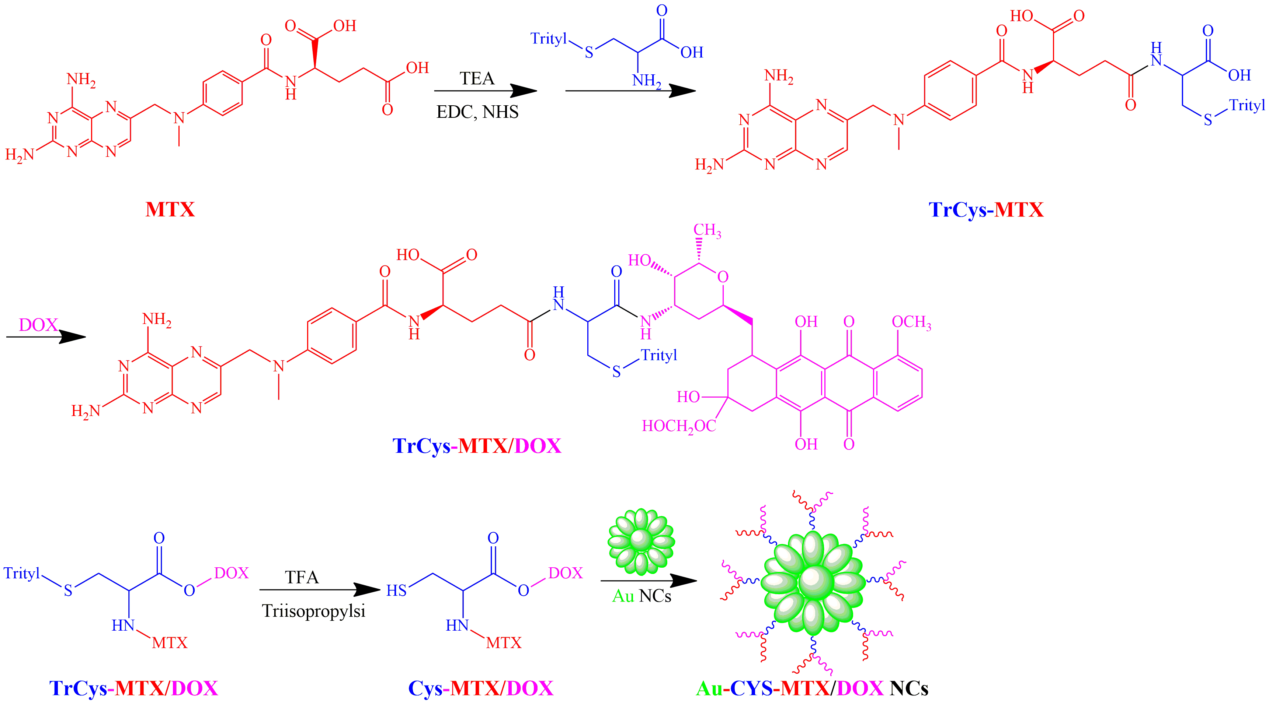

Table S1. The Element composition of Au NCs by EDS
Element | Weight% | Atomic%
C K | 4.38 | 27.07
O K | 8.67 | 40.20
N K | 0.00 | 0.00
S K | 0.00 | 0.00
Au K | 86.95 | 32.74
Totals | 100
Table S2. The Element composition of Au-Cys-MTX/DOX NCs by EDS
Element | Weight% | Atomic%
C K | 6.31 | 20.68
O K | 19.35 | 50.94
N K | 6.99 | 16.53
S K | 3.36 | 6.59
Au K | 63.99 | 12.80
Totals | 100
Table S3. The Drug loading, Zeta potential and stability of Au-Cys-MTX/DOX NCs
Drug loading (TGA, wt%) | Drug loading (UV, wt%) | Zeta potential(mv) | Stability(d)
0 | 0 | -25.7 ± 1.2 | 43.4 ± 4.2
8.2 ± 1.2 | 8.6 ± 1.6 | -21.4 ± 1.0 | 33.8 ± 5.6
13.4 ± 1.1 | 13.9 ± 1.5 | -20.3 ± 0.6 | 27.9 ± 6.1
17.1 ± 1.5 | 17.9 ± 1.9 | -15.6 ± 0.7 | 15.4 ± 3.8
20.9 ± 2.4 | 21.3 ± 2.8 | -10.5 ± 0.9 | 3.4 ± 2.2

Figure S1. HRTEM image (A) and the SAED pattern (B) of Au NCs.
Figure S2. The Zeta potential of Au NCs (A) and Au-Cys-MTX/DOX NCs (B).
Figure S3. The Size distributions of Au NCs and Au-Cys-MTX/DOX NCs.
Figure S4. The H¹NMR of TRCys-MTX (A) and TRCys-MTX/DOX (B).

Figure S5. TGA curves Au NCs (a) and Au-Cys-MTX/DOX NCs (b-e) with different drug loading.
Figure S6. UV/Vis absorbance spectras of Cys-MTX/DOX (a) and Au-Cys-MTX/DOX NCs (b).

Figure S7. In vitro release profiles of free MTX, free DOX, and Au-Cys-MTX/DOX NCs.

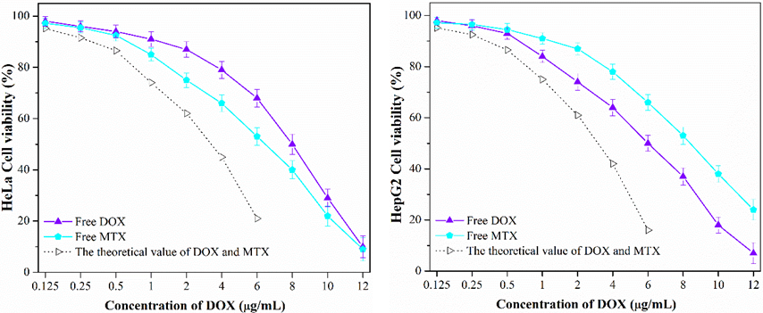
Figure S8. In vitro cell viability of HeLa cells or HepG2 cells treated with the free MTX, free DOX, and the theoretical value of bulk DOX and MTX after incubation of 24 h.

