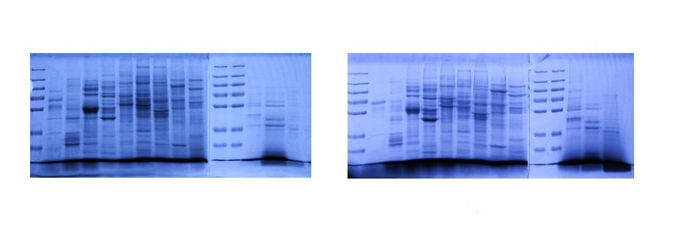
a
Ex1

m 1 2 3 4 5 6 7 8 9 m m 10 11 12
m 1 2 3 4 5 6 7 8 9 m m 10 11 12

IAPP treated Rin-5F cells
Untreated Rin-5F cells (control)
Ex2
b

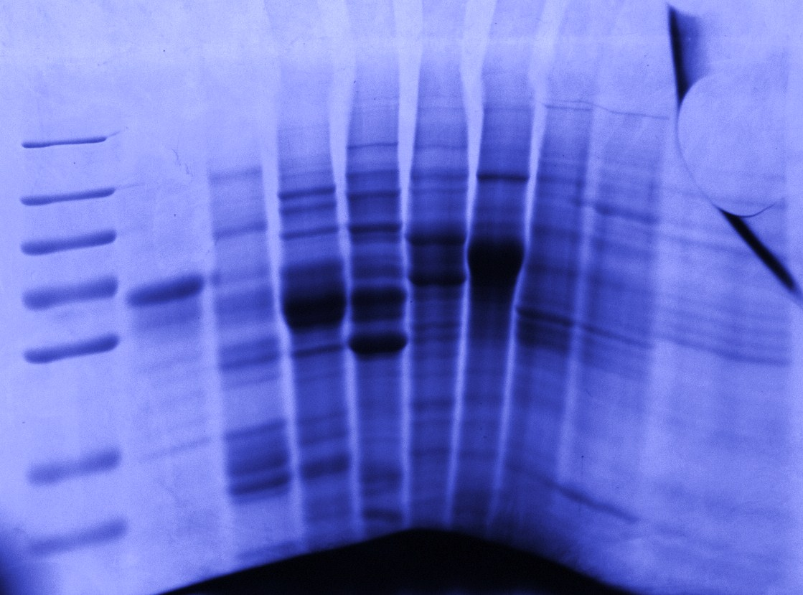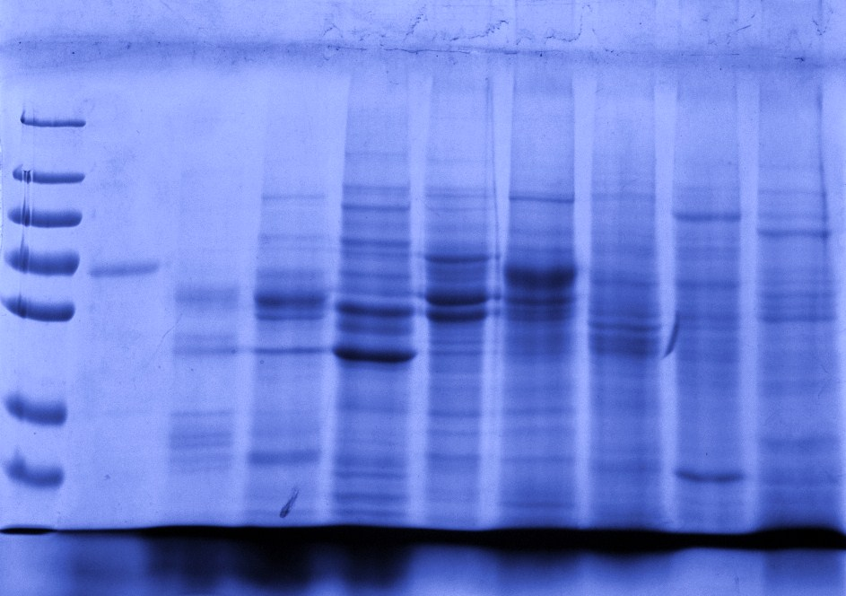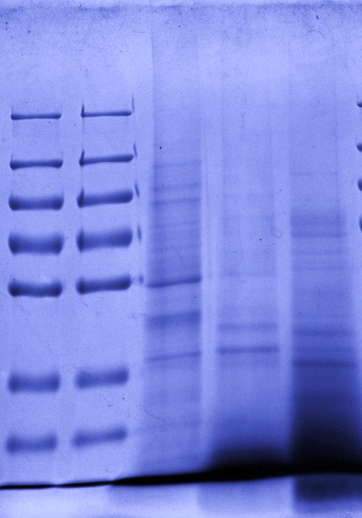
m 1 2 3 4 5 6 7 8 9 m m 10 11 12
m 1 2 3 4 5 6 7 8 9 m m 10 11 12

IAPP treated Rin-5F cells
Untreated Rin-5F cells (control)
Ex3
c

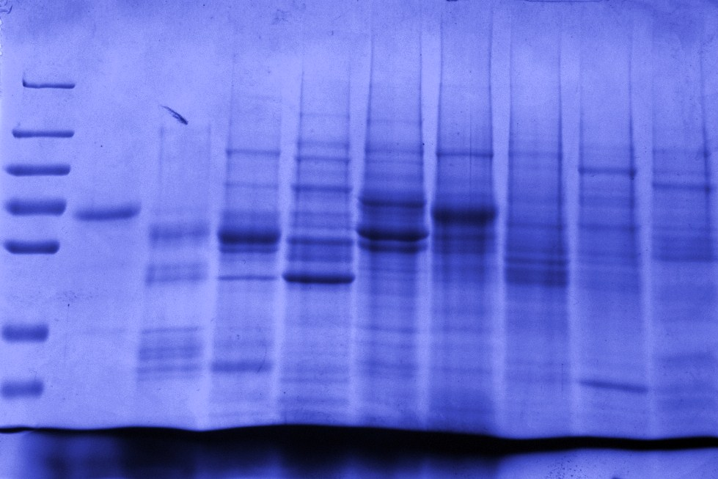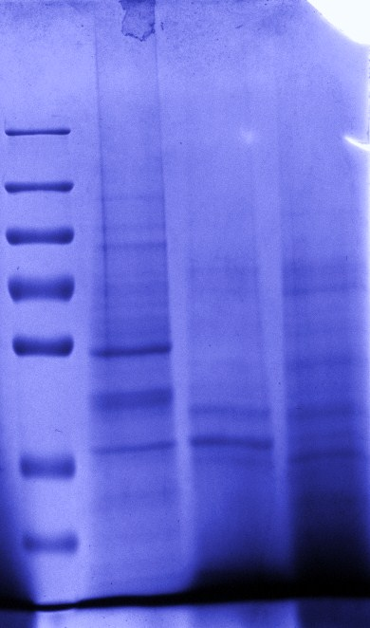
m 1 2 3 4 5 6 7 8 9 m 10 11 12
m 1 2 3 4 5 6 7 8 9 m 10 11 12

Untreated Rin-5F cells (control)
IAPP treated Rin-5F cells

SI Fig. 1 SDS-PAGE analysis of the OFFGELTM fractions of untreated and IAPP treated Rin-5F cells from 3 independent experiments (Ex1, Ex2 and Ex3). Numbers 1-12 represent the corresponding fractions of 1-12 from the OFFGELTM electrophoresis. The letter ‘m’ is an abbreviation for molecular weight markers (250, 130, 95, 72, 55, 36 and 28 kDa).

