Additional file

Additional file 2: Figure S1 Risk of bias.
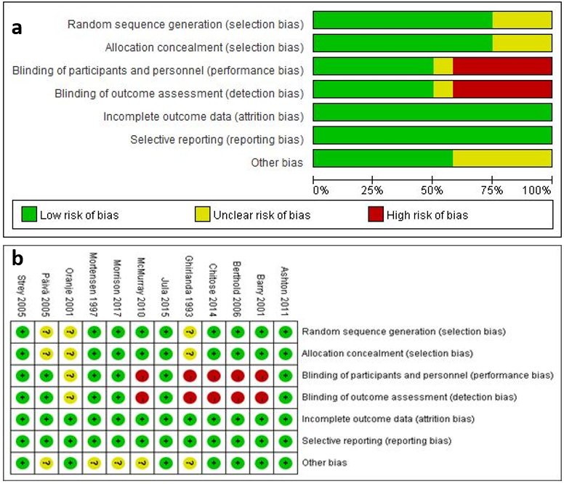
Figure S1 Risk bias of included studies, a, risk of bias graph; b, risk of bias summary.

