Table S1 TEs with divergence rate <=10% in the four carnivore genomes
 | Panda |  | Polar bear |  | Dog |  |  | Ferret
Types | Counts | Gp* | Counts | Gp | Counts | Gp |  | Counts | Gp
SINE | 226,459 | 1.83% | 222,343 | 1.81% | 392,978 | 2.79% |  | 214,254 | 1.54%
LINE | 50,453 | 1.40% | 43,262 | 1.18% | 59,301 | 2.25% |  | 11,290 | 0.07%
LTR | 3,892 | 0.06% | 4,121 | 0.07% | 4,208 | 0.11% |  | 1,406 | 0.01%
DNA | 1,260 | 0.00% | 1,236 | 0.00% | 954 | 0.00% |  | 816 | 0.00%
*Gp: Genome percentage

Figure S1 Divergence rate distribution of four major types of TEs in panda (a), polar bear (b), dog (c), and ferret (d) genomes. The divergence rate was calculated between their identified TE elements in the genome and the consensus sequences (Repbase).

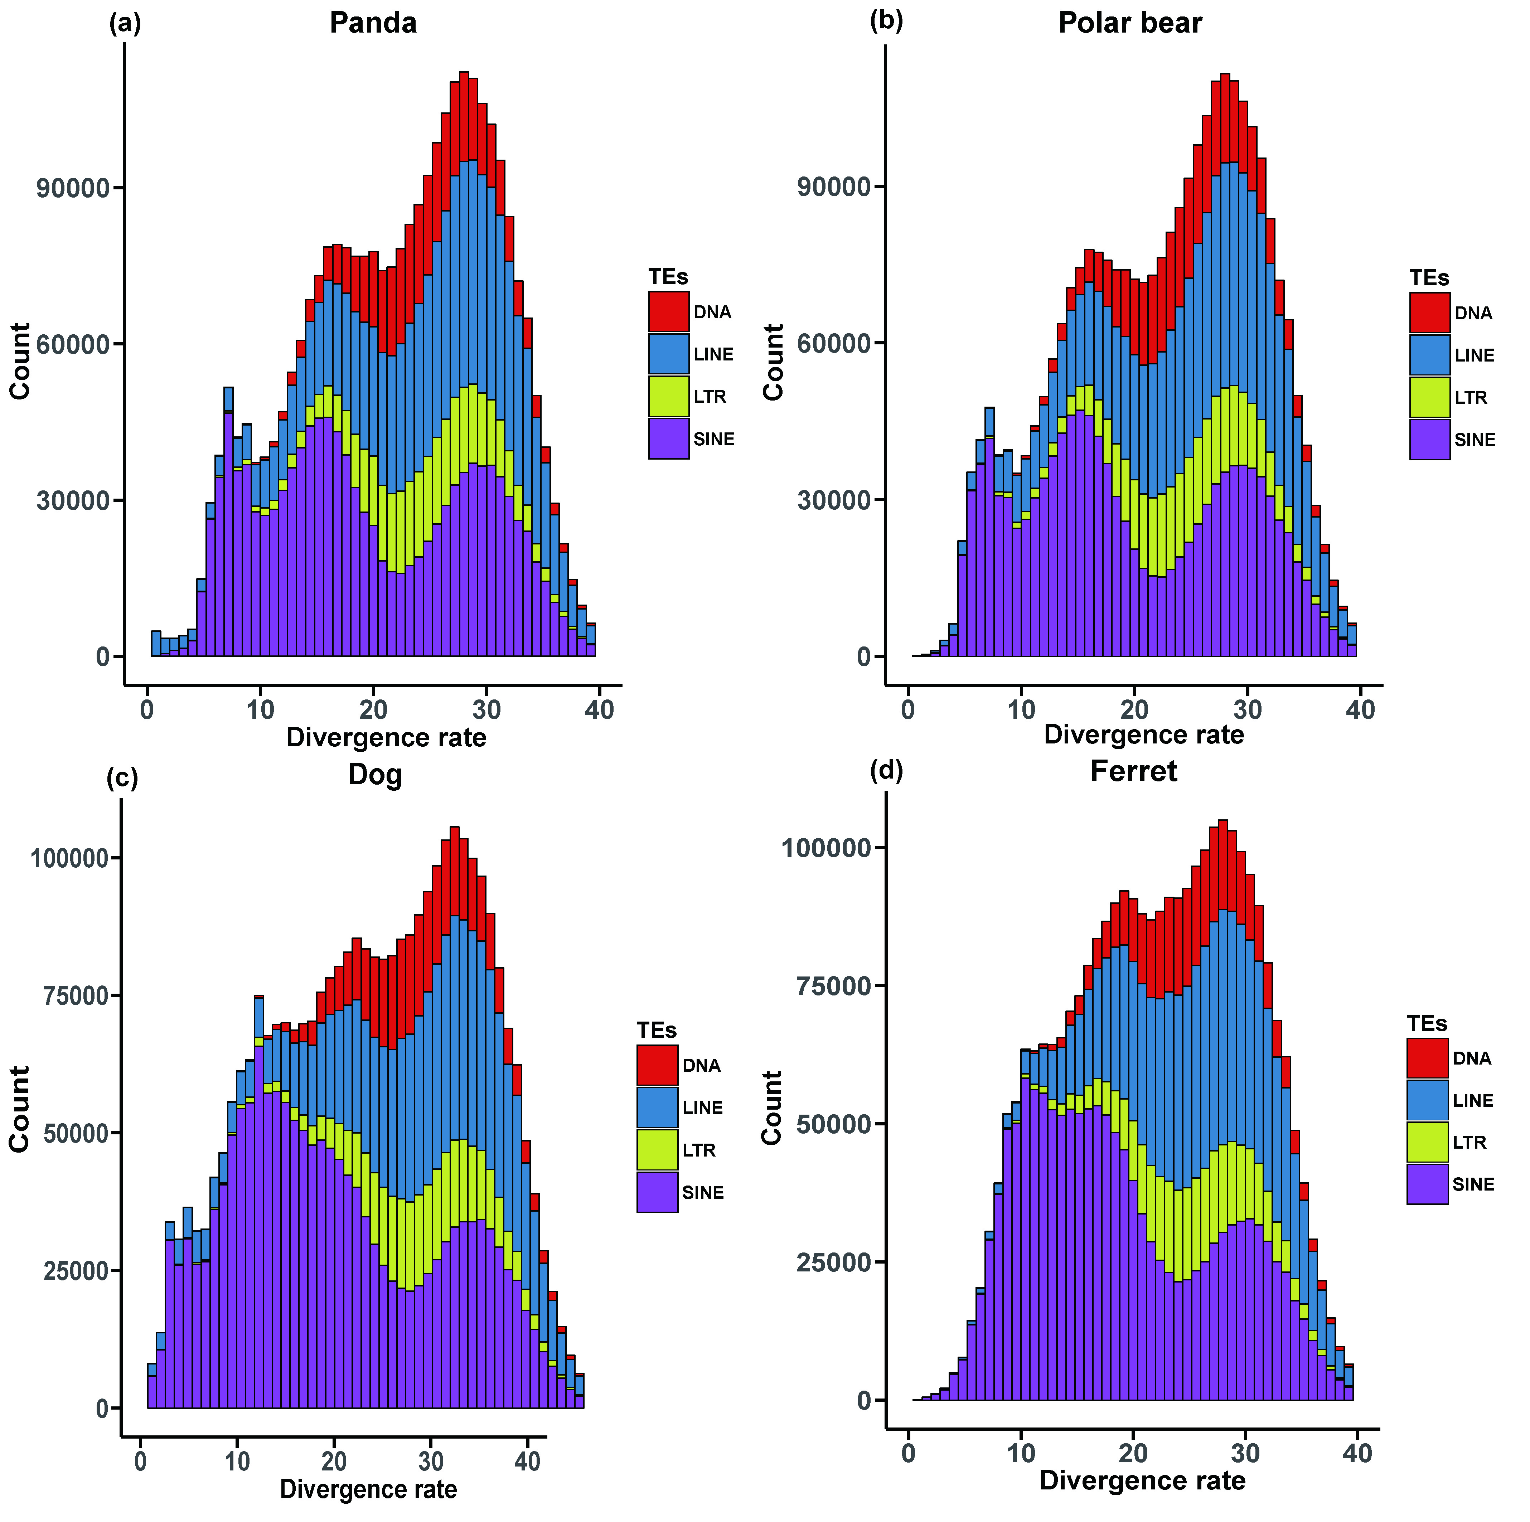
Table S2 SINE subfamilies with average divergence rate ≤10% in the panda genome
SINE Type | Length (bp) | Percentage | Copy number | Copy number Percentage
SINEC1_AMe | 34,596,819 | 82.93% | 180,010 | 79.49%
SINEC1B_AMe | 4,875,793 | 11.69% | 27,122 | 11.98%
SINEC_b2 | 560,175 | 1.34% | 4,867 | 2.15%
SINEC_b1 | 468,170 | 1.12% | 3,747 | 1.65%
tSINE_Fc | 393,906 | 0.94% | 3,060 | 1.35%
SINEC2_AMe | 246,012 | 0.59% | 2,068 | 0.91%
CAN | 133,085 | 0.32% | 744 | 0.33%
SINEC_c1 | 127,222 | 0.30% | 796 | 0.35%
SINEC_c2 | 109,892 | 0.26% | 1,079 | 0.48%
SINEC_old | 67,204 | 0.16% | 760 | 0.34%
SINEC1C2_CF | 28,760 | 0.07% | 187 | 0.08%
SINEC_Fc3 | 20,108 | 0.05% | 410 | 0.18%
SINEC_Mv | 18,987 | 0.05% | 433 | 0.19%
SINEC_a1 | 15,522 | 0.04% | 59 | 0.03%
SINEC1C1_CF | 13,004 | 0.03% | 89 | 0.04%
MIRc | 6,442 | 0.02% | 177 | 0.08%
MVB2 | 5,843 | 0.01% | 33 | 0.01%
SINEC_Pv | 5,237 | 0.01% | 105 | 0.05%
MIR | 4,821 | 0.01% | 129 | 0.06%
MIR3 | 4,570 | 0.01% | 127 | 0.06%
SINEC_a2 | 4,520 | 0.01% | 59 | 0.03%
MIR1_Amn | 2,813 | 0.01% | 85 | 0.04%
MIRb | 2,569 | 0.01% | 69 | 0.03%
SINEC_Fc2 | 2,079 | 0.00% | 32 | 0.01%
SINEC_Cf2 | 1,651 | 0.00% | 27 | 0.01%
SINEC_Cf3 | 1,141 | 0.00% | 16 | 0.01%
SINEC_Fc | 665 | 0.00% | 9 | 0.00%
MamSINE | 337 | 0.00% | 7 | 0.00%
AmnSINE | 317 | 0.00% | 9 | 0.00%
SINE_FS | 144 | 0.00% | 4 | 0.00%
SINEC_Cf | 140 | 0.00% | 2 | 0.00%
LFSINE_Vert | 121 | 0.00% | 4 | 0.00%
SINE_OM | 72 | 0.00% | 1 | 0.00%
SINE_FN | 28 | 0.00% | 1 | 0.00%

Table S3 SINE (including SINEC1_AMe2) subfamilies with average divergence rates ≤10% in the panda genome
SINE Type | Length(bp) | Percentage | Copy number | Copy number Percentage
SINEC1_AMe2 | 24,632,856 | 57.47% | 124,118 | 52.49%
SINEC1_AMe | 10,803,543 | 25.20% | 60,599 | 25.63%
SINEC1B_AMe | 5,140,363 | 11.99% | 28,583 | 12.09%
SINEC_c2 | 611,299 | 1.43% | 7,341 | 3.10%
SINEC_b2 | 572,543 | 1.34% | 5,175 | 2.20%
SINEC_b1 | 423,277 | 0.99% | 2,793 | 1.18%
SINEC2_AMe | 253,063 | 0.59% | 2,125 | 0.90%
SINEC_old | 145,145 | 0.34% | 1,618 | 0.68%
SINEC_c1 | 129,658 | 0.30% | 1,541 | 0.65%
SINEC_Fc3 | 60,676 | 0.14% | 859 | 0.36%
SINEC_Mv | 19,466 | 0.05% | 440 | 0.19%
SINEC_a1 | 17,868 | 0.04% | 214 | 0.09%
SINEC_Fc2 | 14,179 | 0.03% | 172 | 0.07%
MIRc | 6,442 | 0.02% | 177 | 0.07%
SINEC_Pv | 6,014 | 0.01% | 113 | 0.05%
SINEC_a2 | 5,009 | 0.01% | 64 | 0.03%
MIR | 4,731 | 0.01% | 127 | 0.05%
MIR3 | 4,570 | 0.01% | 127 | 0.05%
MIR1_Amn | 2,813 | 0.01% | 85 | 0.04%
MIRb | 2,569 | 0.01% | 69 | 0.03%
SINEC_Cf2 | 2,564 | 0.01% | 35 | 0.01%
SINE_OM | 2,080 | 0.00% | 31 | 0.01%
SINEC_Cf3 | 1,574 | 0.00% | 20 | 0.01%
SINEC_Fc | 1,482 | 0.00% | 20 | 0.01%
MamSINE1 | 337 | 0.00% | 7 | 0.00%
AmnSINE1 | 317 | 0.00% | 9 | 0.00%
SINEC_Cf | 195 | 0.00% | 3 | 0.00%
SINE_FS | 144 | 0.00% | 4 | 0.00%
LFSINE_Vert | 121 | 0.00% | 4 | 0.00%
SINE_FN | 28 | 0.00% | 1 | 0.00%

