Study of the anti-allergic and anti-inflammatory activity of Brachychiton rupestris and Brachychiton discolor leaves (Malvaceae) using in vitro models

Amany A. Thabet^{1†}, Fadia S. Youssef^{1†}, Michal Korinek^{2,3,4,5}, Fang-Rong Chang^{2,6}, Yang-Chang Wu^{2,7,8}, Bing-Hung Chen^{3,8,9}, Mohamed El-Shazly^{1,10*} and Abdel Nasser B. Singab^{1*} and Tsong-Long Hwang^{4,5,11,12,13*}

¹Department of Pharmacognosy, Faculty of Pharmacy, Ain Shams University, African Union Organization Street, Abbassia 11566, Cairo, Egypt
²Graduate Institute of Natural Products, College of Pharmacy, Kaohsiung Medical University, Kaohsiung 80708, Taiwan
³Department of Biotechnology, College of Life Science, Kaohsiung Medical University, Kaohsiung 80708, Taiwan
⁴Graduate Institute of Natural Products, College of Medicine, Chang Gung University, Taoyuan 33302, Taiwan
⁵Research Center for Chinese Herbal Medicine, Research Center for Food and Cosmetic Safety, and Graduate Institute of Health Industry Technology, College of Human Ecology, Chang Gung University of Science and Technology, Taoyuan 33302, Taiwan
⁶National Research Institute of Chinese Medicine, Ministry of Health and Welfare, Taipei 11221, Taiwan
⁷Research Center for Natural Products & Drug Development, Kaohsiung Medical University, Kaohsiung 80708, Taiwan
⁸Department of Medical Research, Kaohsiung Medical University Hospital, Kaohsiung 80708, Taiwan
⁹The Institute of Biomedical Sciences, National Sun Yat-sen University, Kaohsiung 80424, Taiwan
¹⁰Department of Pharmaceutical Biology, Faculty of Pharmacy and Biotechnology, German University in Cairo, Cairo 11835, Egypt
¹¹Department of Anesthesiology, Chang Gung Memorial Hospital, Taoyuan 33305, Taiwan
¹²Chinese Herbal Medicine Research Team, Healthy Aging Research Center, Chang Gung University, Taoyuan 33302, Taiwan
¹³Department of Chemical Engineering, Ming Chi University of Technology, New Taipei City 24301, Taiwan

†These authors have contributed equally to this work
*Corresponding authors:
Assoc. Professor Mohamed El-Shazly; Tel: +201-001401091; Fax: +202-24051107; E-mail:
mohamed.elshazly@pharma.asu.edu.eg (M. El-Shazly). Department of Pharmacognosy, Faculty of Pharmacy, Ain Shams University, African Union Organization Street, Abbassia 11566, Cairo, Egypt.

Professor Dr. Abdel Nasser B. Singab; Tel: +201-005036231; Fax: +202-24051107; E-mail: dean@pharma.asu.edu.eg (B. Singab); Department of Pharmacognosy, Faculty of Pharmacy, Ain Shams University, African Union Organization Street, Abbassia 11566, Cairo, Egypt.

Professor Tsong-Long Hwang, Tel: +886-3-2118800 ext. 5523; Email: htl@mail.cgu.edu.tw (T.-L. Hwang); Graduate Institute of Natural Products, College of Medicine, Chang Gung University, Taoyuan 33302, Taiwan

Supporting information
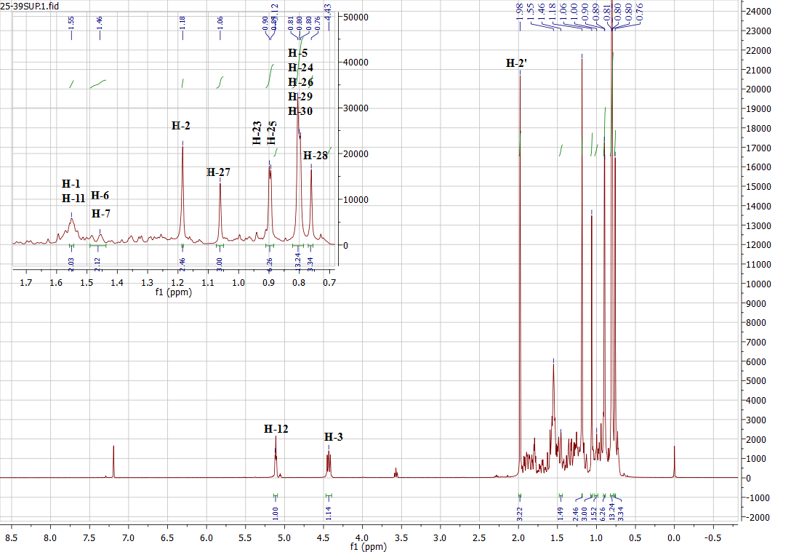
Fig. S1a: ¹H NMR spectrum of β-amyrin acetate (1)
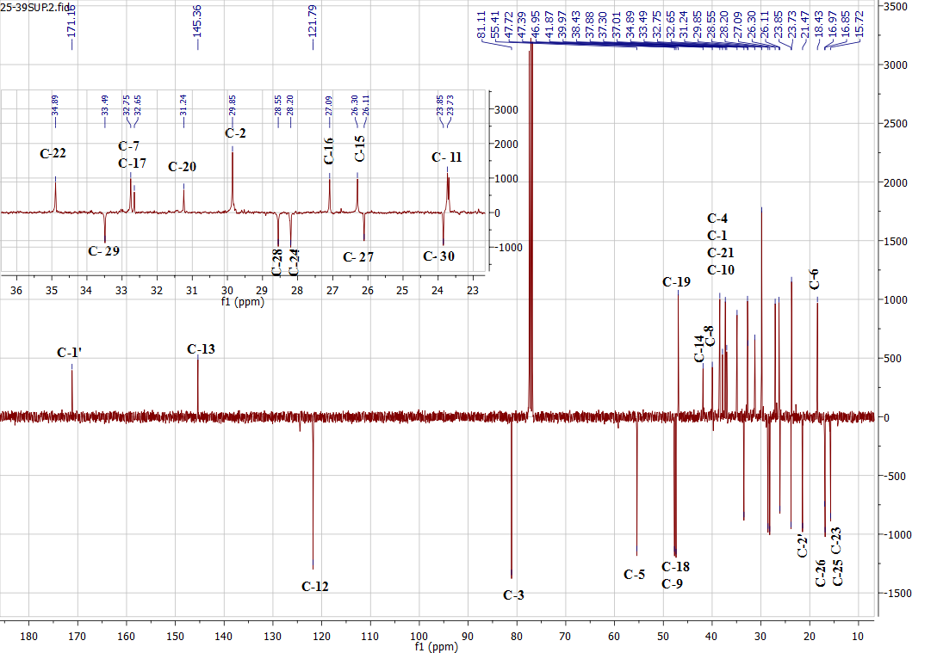
Fig. S1b: APT spectrum of β-amyrin acetate (1)
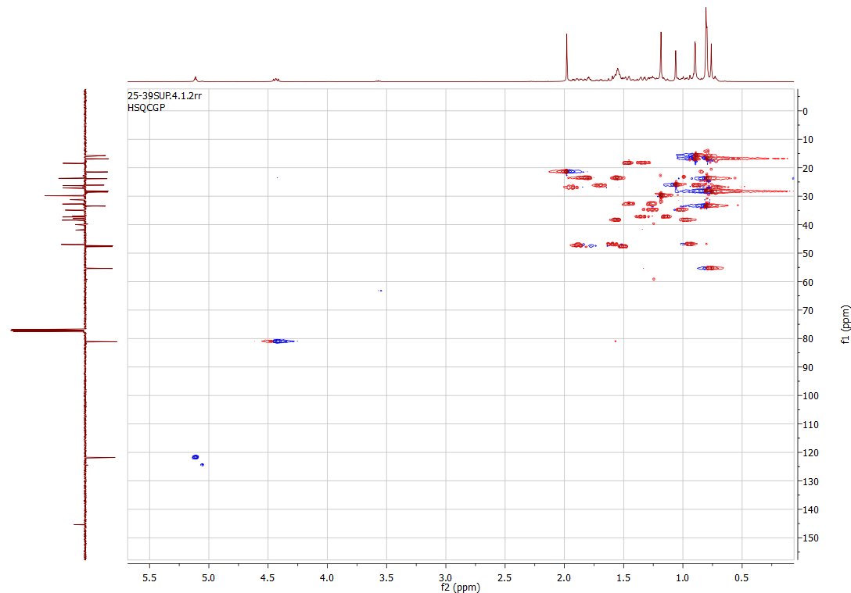
Fig. S1c: HSQC spectrum of β-amyrin acetate (1)
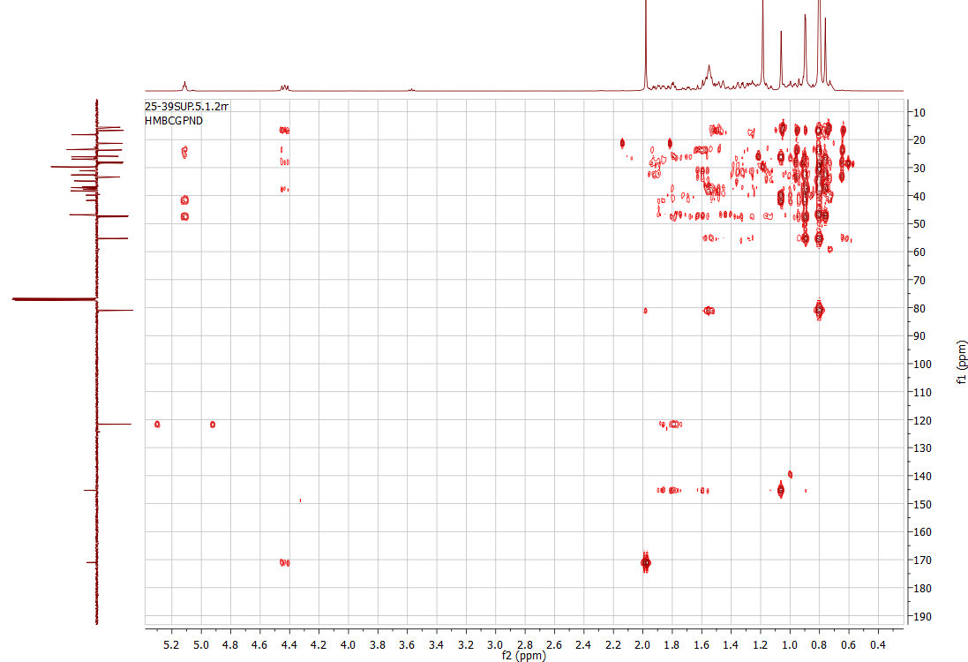
Fig. S1d: HMBC spectrum of β-amyrin acetate (1)

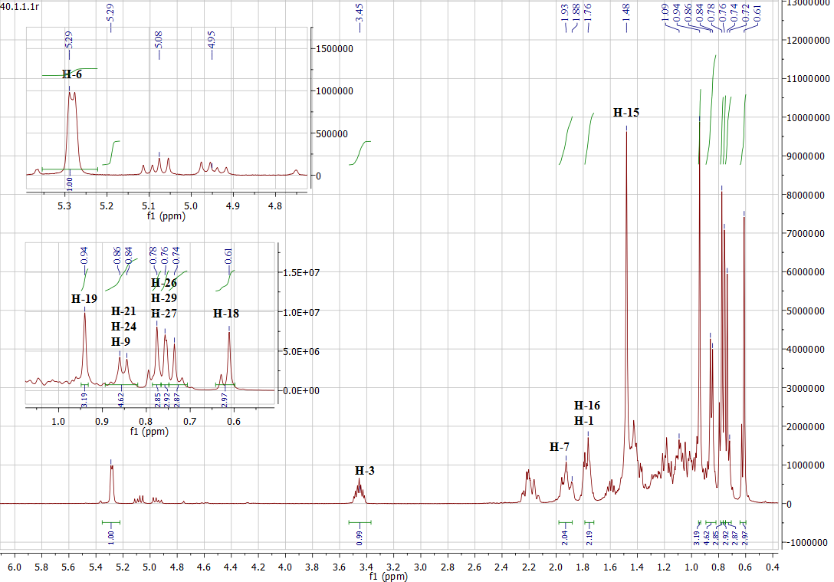
Fig. S2a: ¹H NMR spectrum of β-sitosterol (2) and stigmasterol (3)
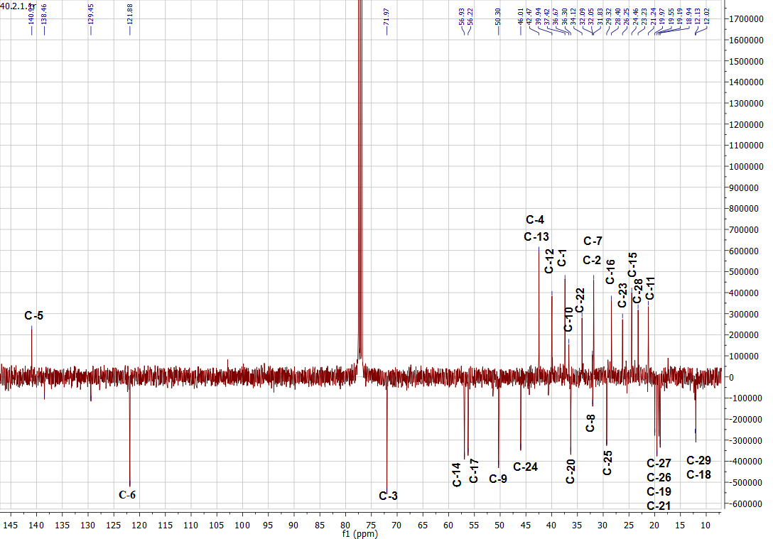
Fig. S2b: APT spectrum of β-sitosterol (2) and stigmasterol (3)
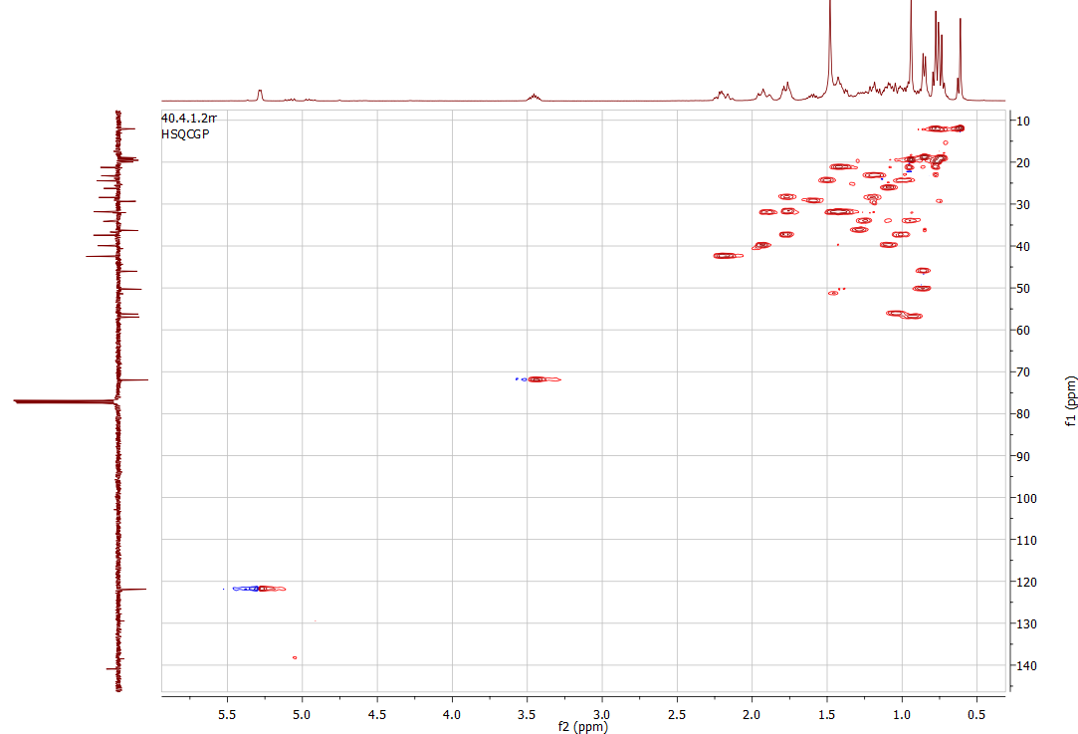
Fig. S2c: HSQC spectrum of β-sitosterol (2) and stigmasterol (3)
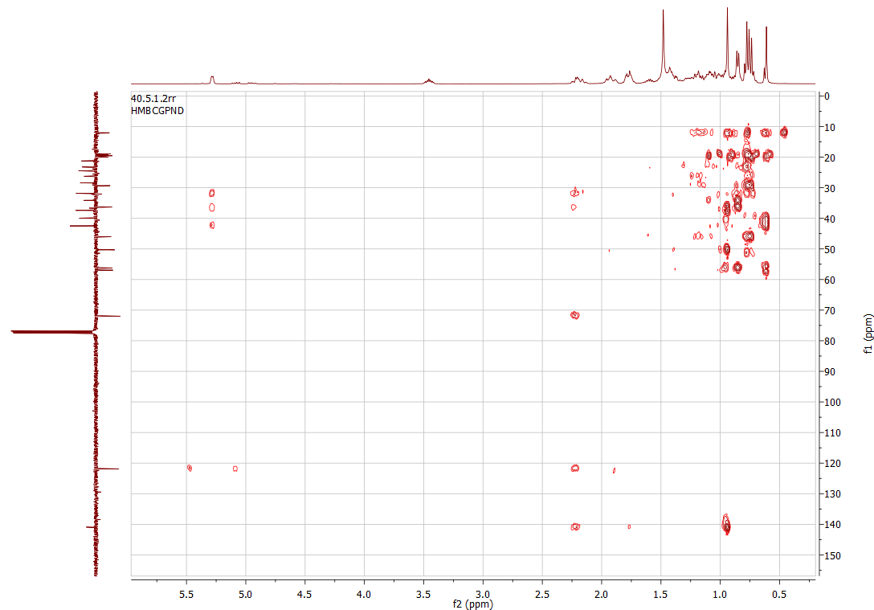
Fig. S2d: HMBC spectrum of β-sitosterol (2) and stigmasterol (3)

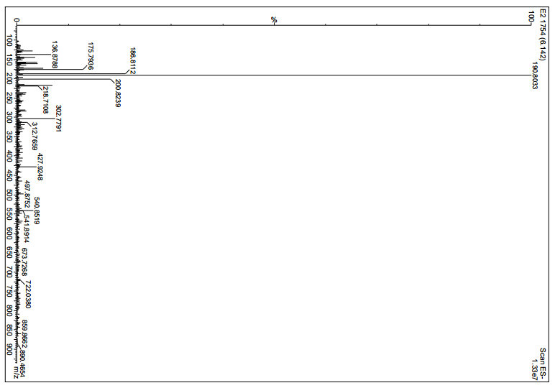
Fig. S3a: ESI⁻-MS spectrum of scopoletin (4)
[M – H]⁺

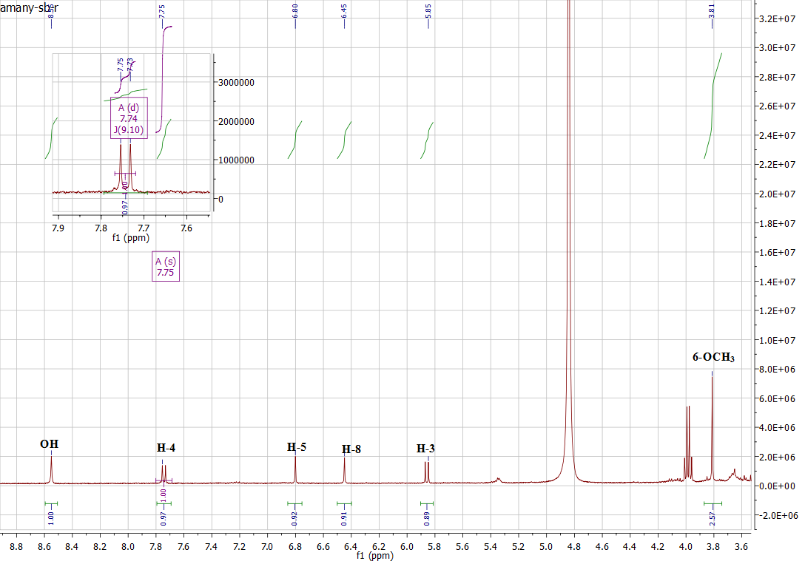
Fig. S3b: ¹H NMR spectrum of scopoletin (4)
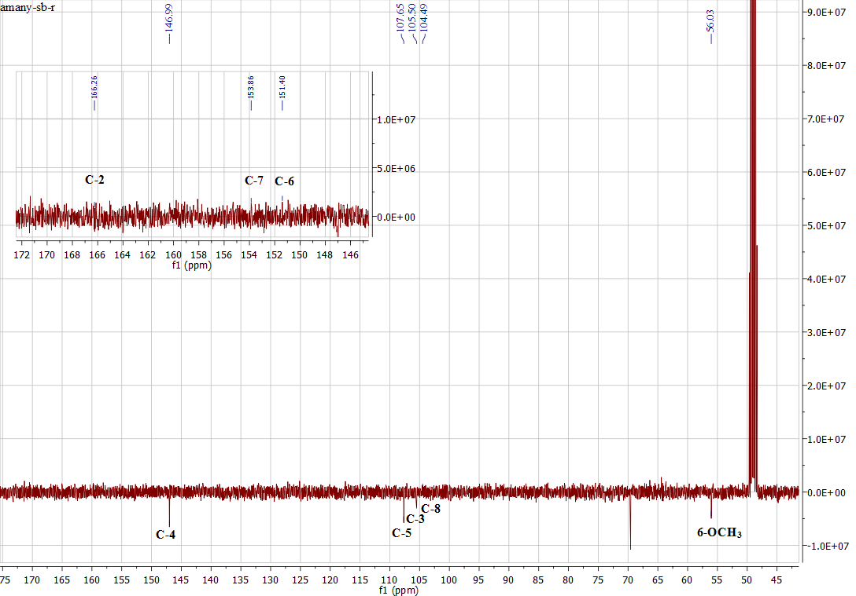
Fig. S3c: APT spectrum of scopoletin (4)
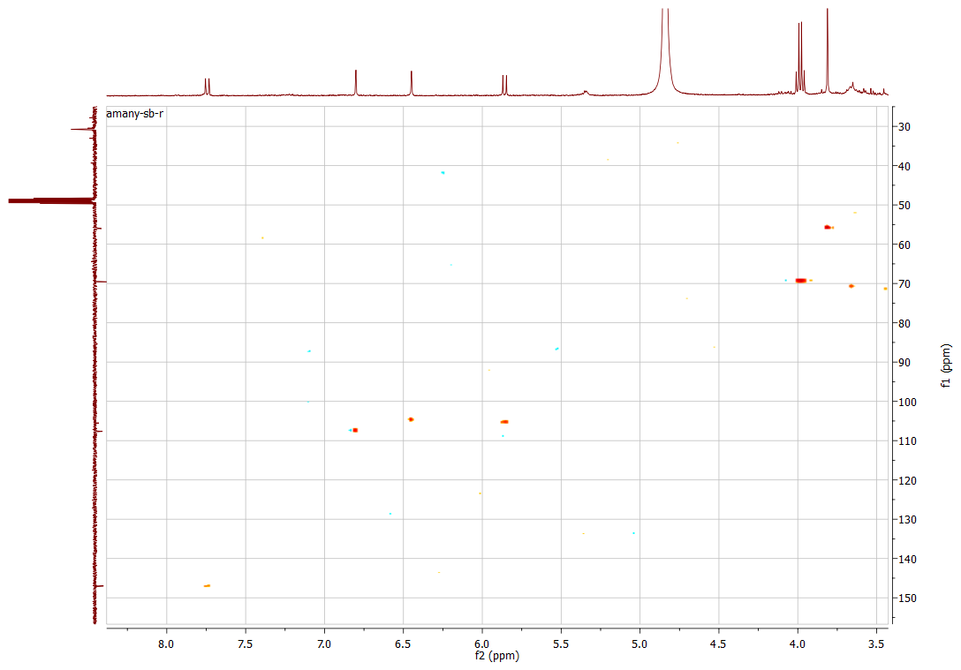
Fig. S3d: HSQC spectrum of scopoletin (4)
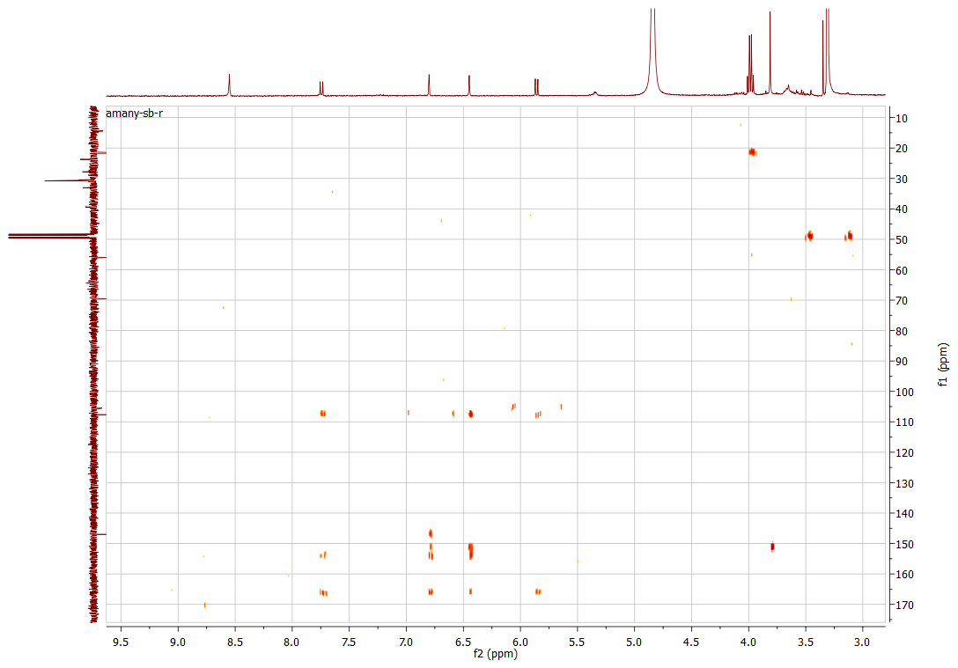
Fig. S3e: HMBC spectrum of scopoletin (4)

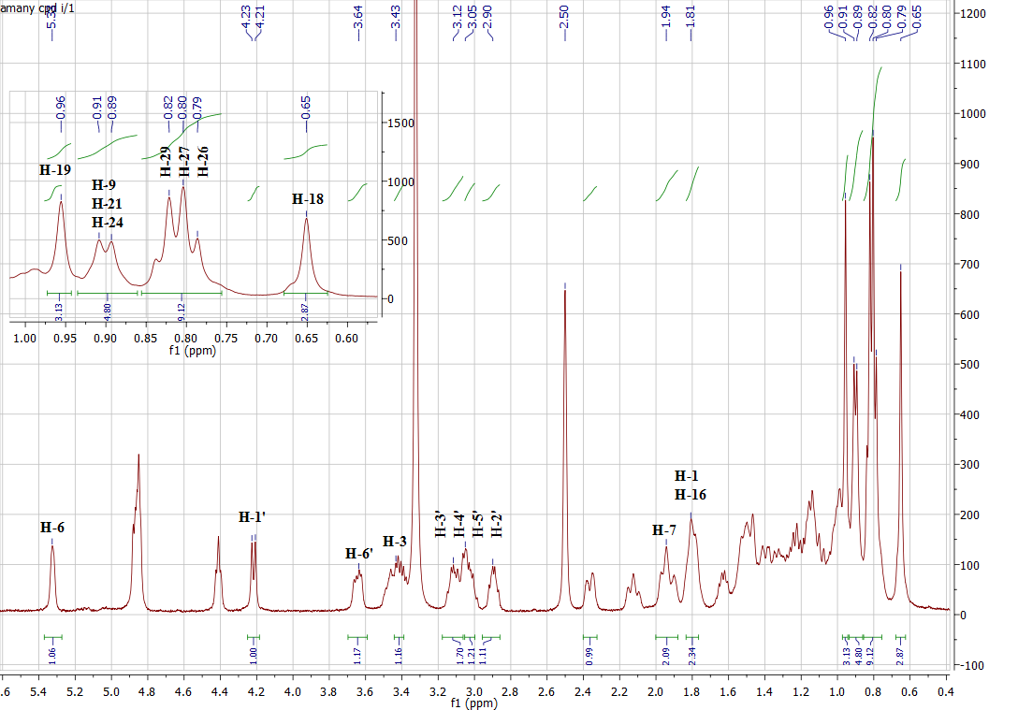
Fig. S4a: ¹H NMR spectrum of β-sitosterol-3-O-β-D-glucoside (5)

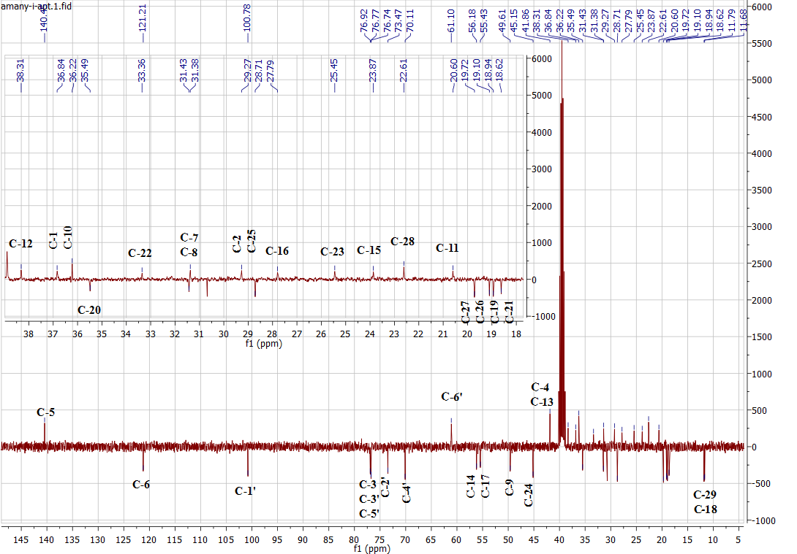
Fig. S4b: APT spectrum of β-sitosterol-3-O-β-D-glucoside (5)
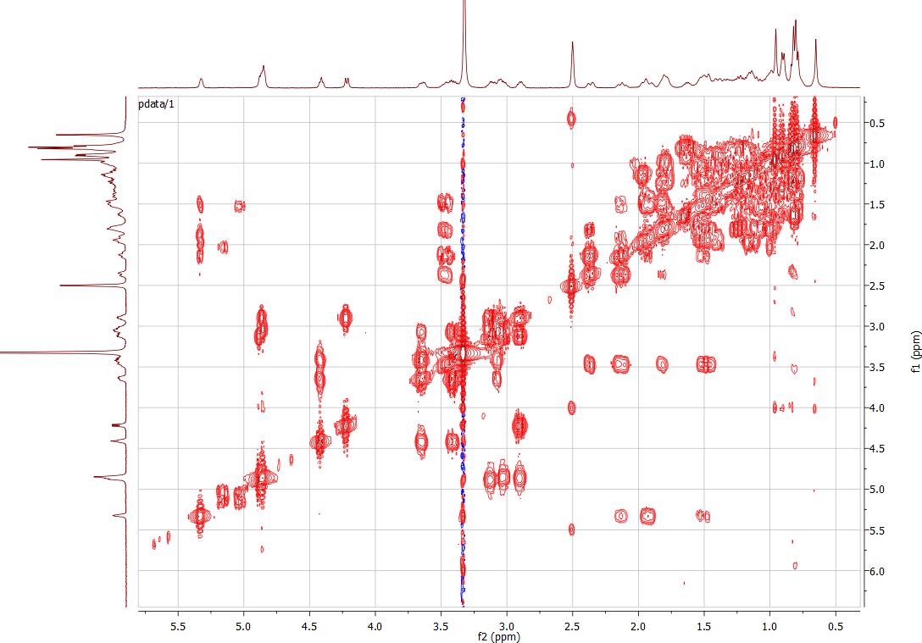
Fig. S4c: ¹H,¹H COSY spectrum of β-sitosterol-3-O-β-D-glucoside (5)
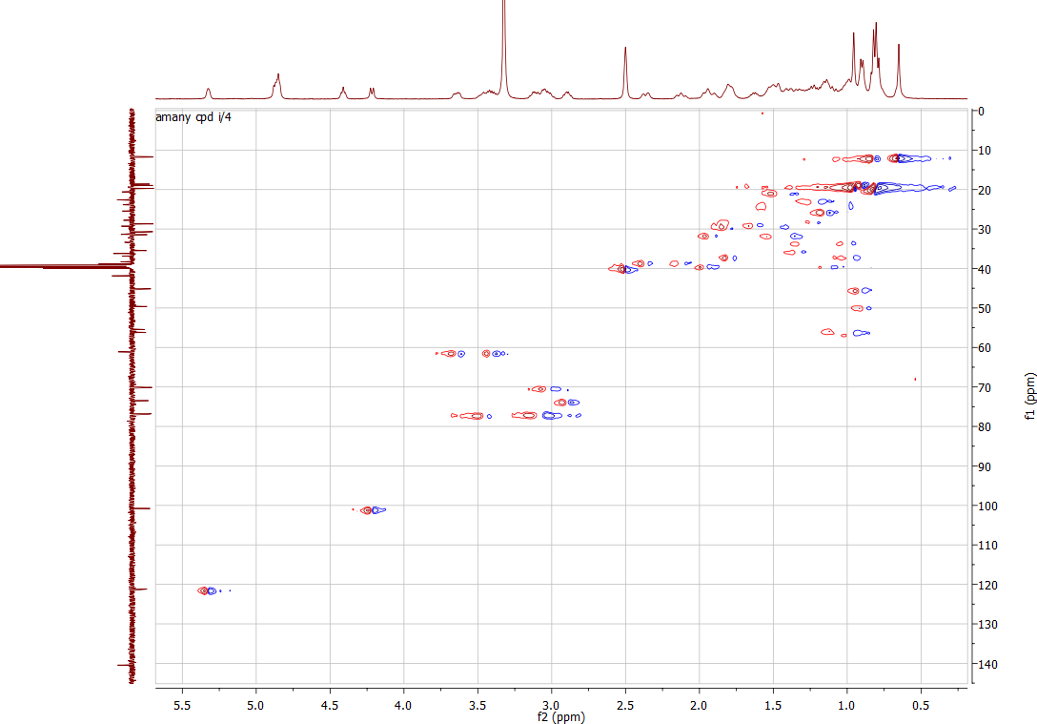
Fig. S4d: HSQC spectrum of β-sitosterol-3-O-β-D-glucoside (5)
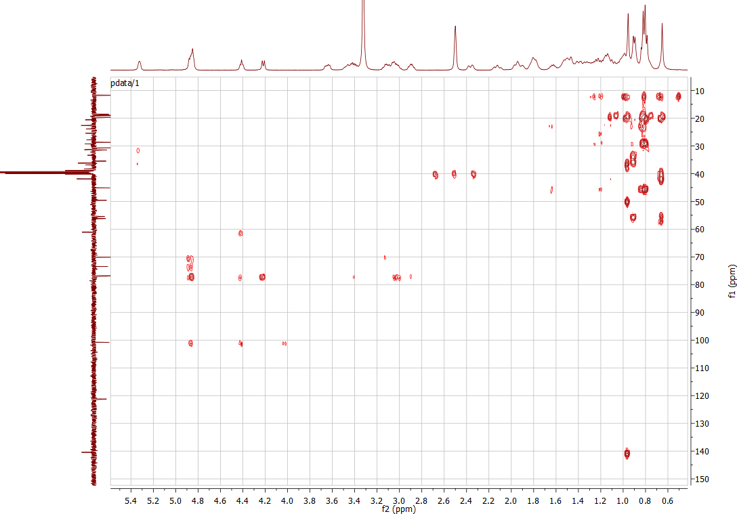
Fig. S4e: HMBC spectrum of β-sitosterol-3-O-β-D-glucoside (5)

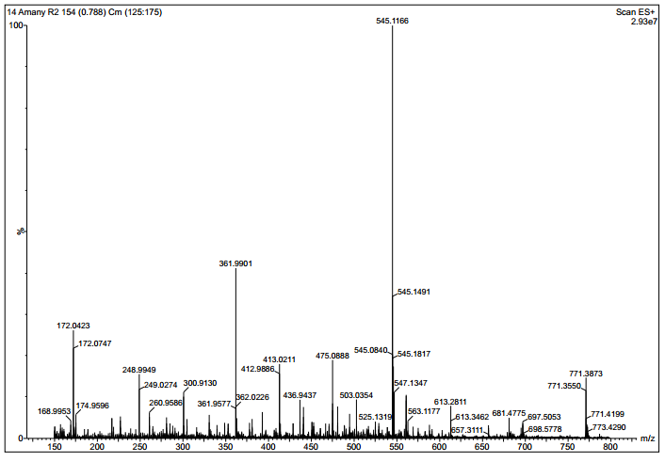
[M + Na]⁺

Fig. S5a: ESI⁺-MS spectrum of dihydrodehydrodiconiferyl alcohol 4-O-β-D-glucoside (6)

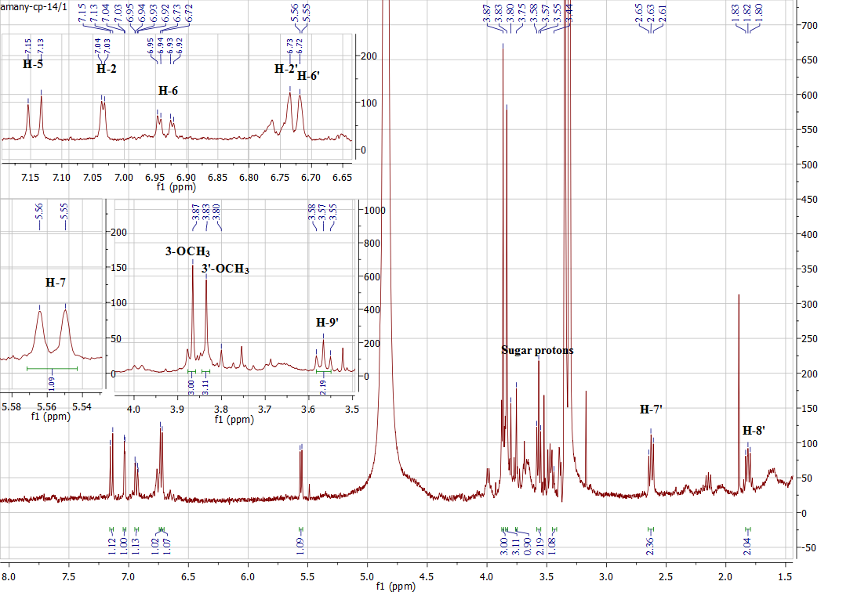

Fig. S5b: ¹H NMR spectrum of dihydrodehydrodiconiferyl alcohol 4-O-β-D-glucoside (6)
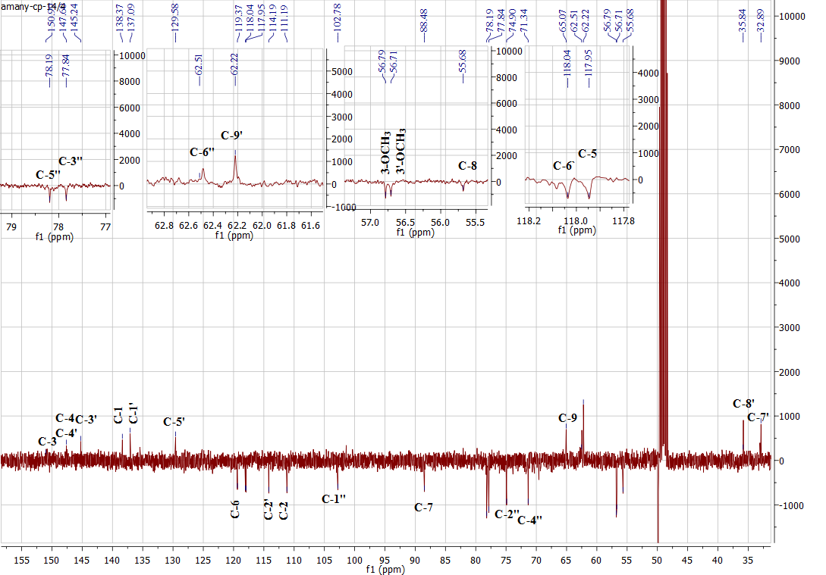
Fig. S5c: APT spectrum of dihydrodehydrodiconiferyl alcohol 4-O-β-D-glucoside (6)
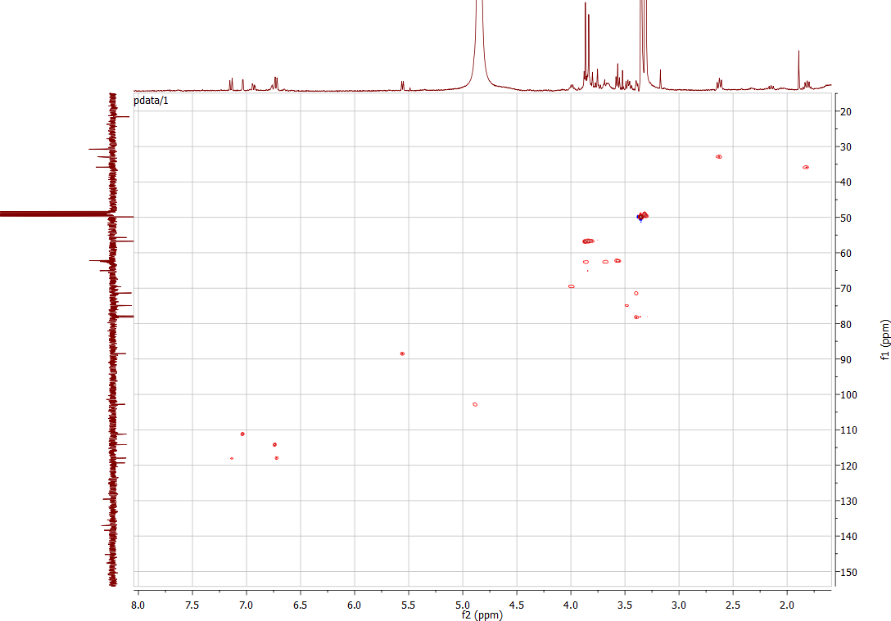
Fig. S5d: HSQC spectrum of dihydrodehydrodiconiferyl alcohol 4-O-β-D-glucoside (6)

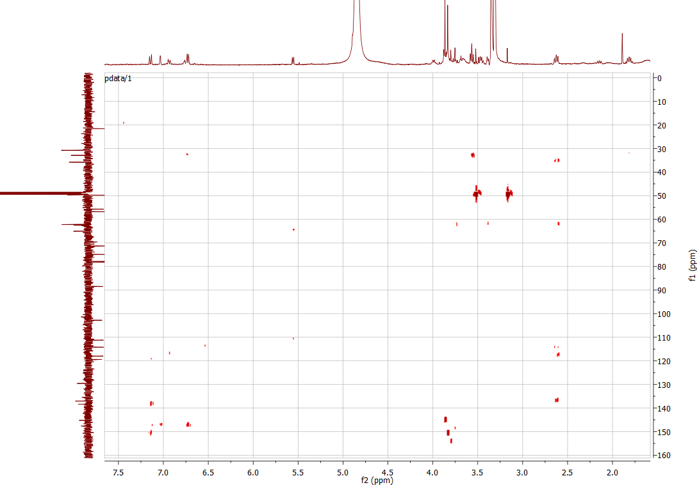
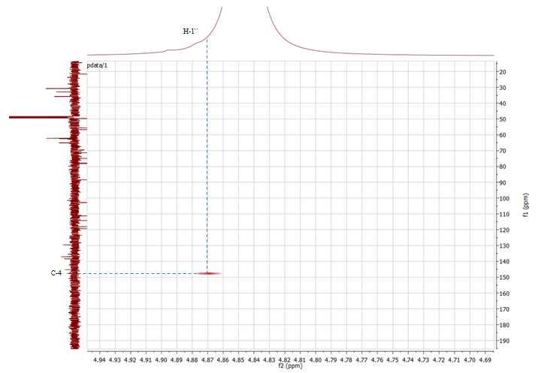
Fig. S5e: HMBC spectrum of dihydrodehydrodiconiferyl alcohol 4-O-β-D-glucoside (6)
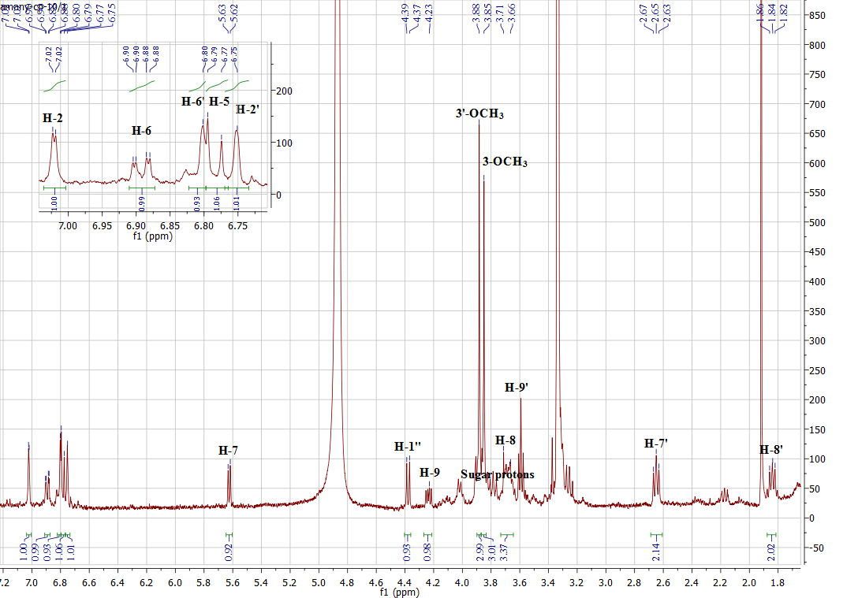
Fig. S6a: ¹H NMR spectrum of dihydrodehydrodiconiferyl alcohol 9-O-β-D-glucoside (7)
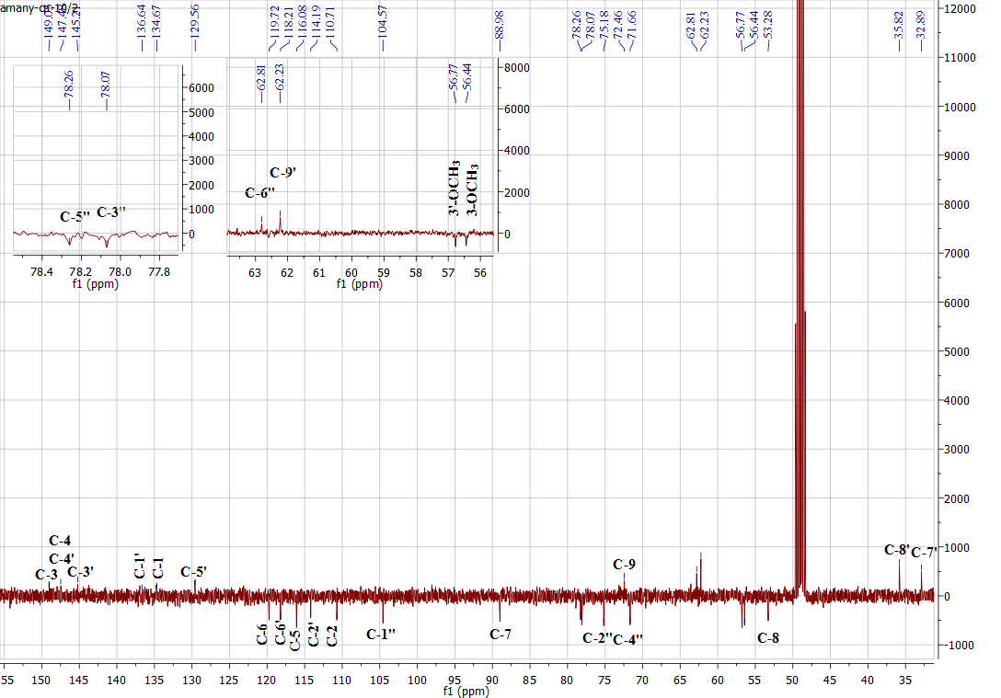
Fig. S6b: APT spectrum of dihydrodehydrodiconiferyl alcohol 9-O-β-D-glucoside (7)
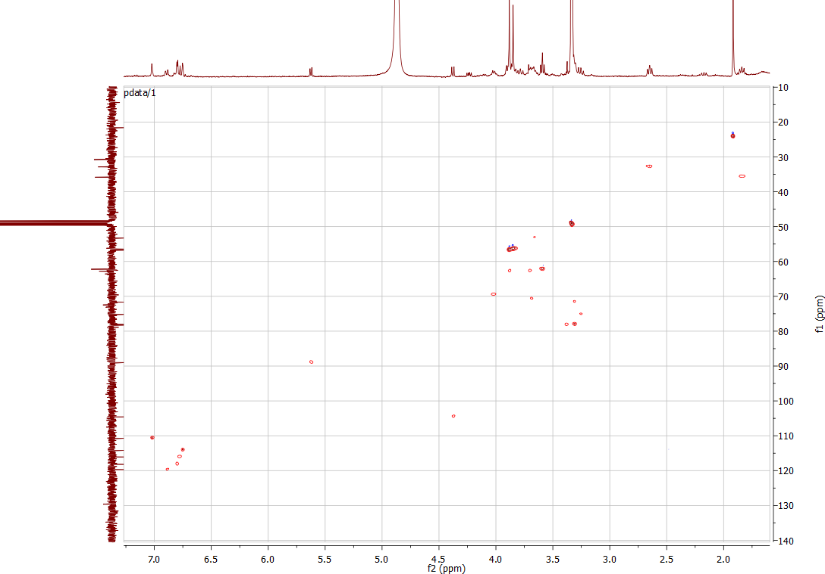
Fig. S6c: HSQC spectrum of dihydrodehydrodiconiferyl alcohol 9-O-β-D-glucoside (7)

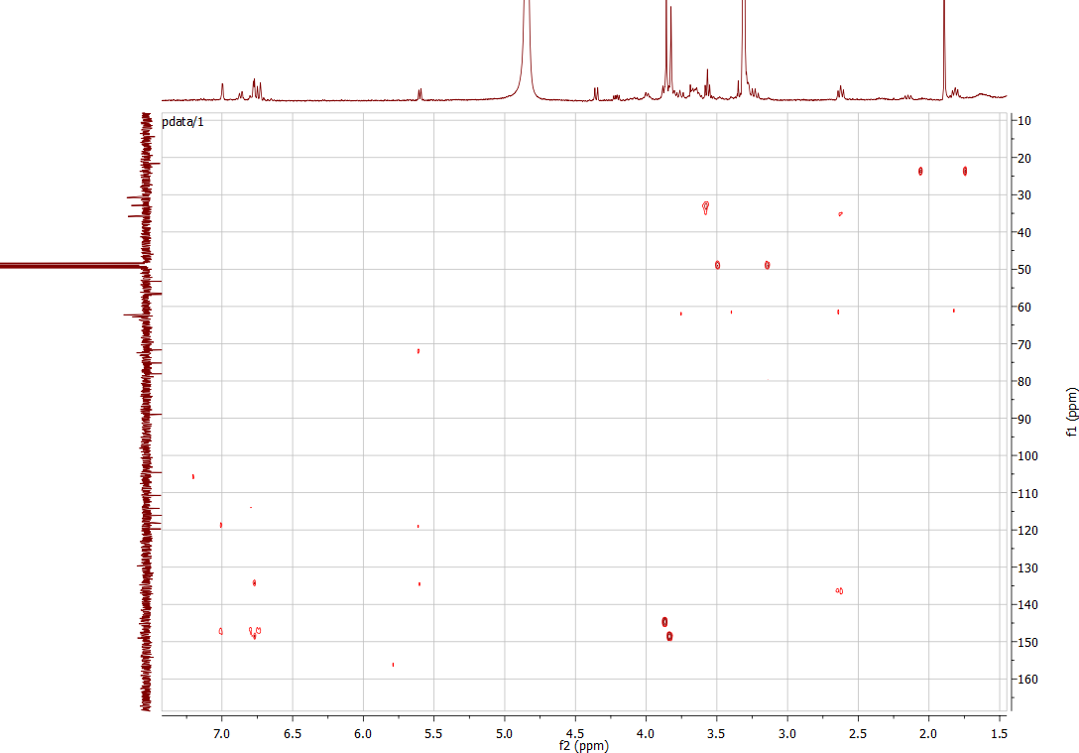
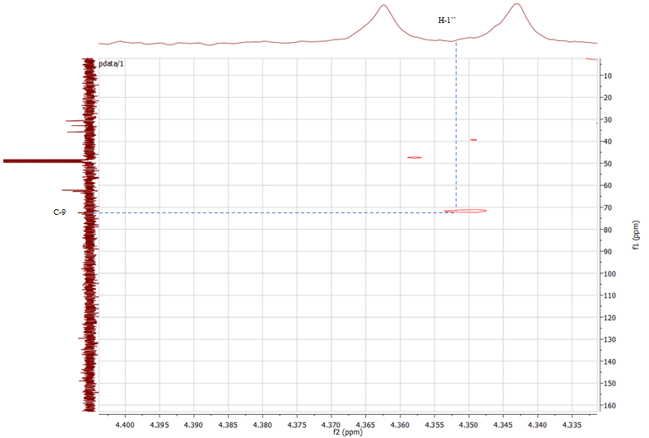

Fig. S6d: HMBC spectrum of dihydrodehydrodiconiferyl alcohol 9-O-β-D-glucoside (7)

