Supplementary Data

Table S1. Demographic and Clinical Characteristics of Patients.
 | T₂DM | T₂DM-M | Healthy Volunteers
Patients no. | 10 | 10 | 10
Male no. (%) | 8 (80) | 6(60) | 8 (80)
Mean age (year) | 64 | 62.32 | 61.11
BMI (kg/m²⁾ | 25.6±1.3* | 26.2±1.2* | 21.3±1.6
Mean duration of disease (year) | 9.27±3.18 | 12.15±2.35
Mean medication(Metformin) (year) |  | 8.69±1.77
FPG (mmol/L) | 9.6±1.9** | 9.4±1.7** | 4.8±0.7
HbA1c (%) | 8.2±1.2** | 8.1±1.4** | 4.5±0.6
Diabetes-related complications no. (%)
Diabetic Foot | 1 (10) | 2 (20)
Diabetic nephropathy | 3 (30) | 3 (30)
Diabetic peripheral neuropathy | 7 (70) | 6 (60)
Diabetic retinopathy | 3 (30) | 4 (40)
Diabetic ketoacidosis | 1 (10) | 1 (10)
T₂DM: type 2 diabetes mellitus. BMI: body mass index. FPG: fasting plasma glucose. Data are presented as mean±SD. P-values were obtained by ANOVA. *=P<0.05. **=P<0.01. All comparisons were against Healthy Volunteers.

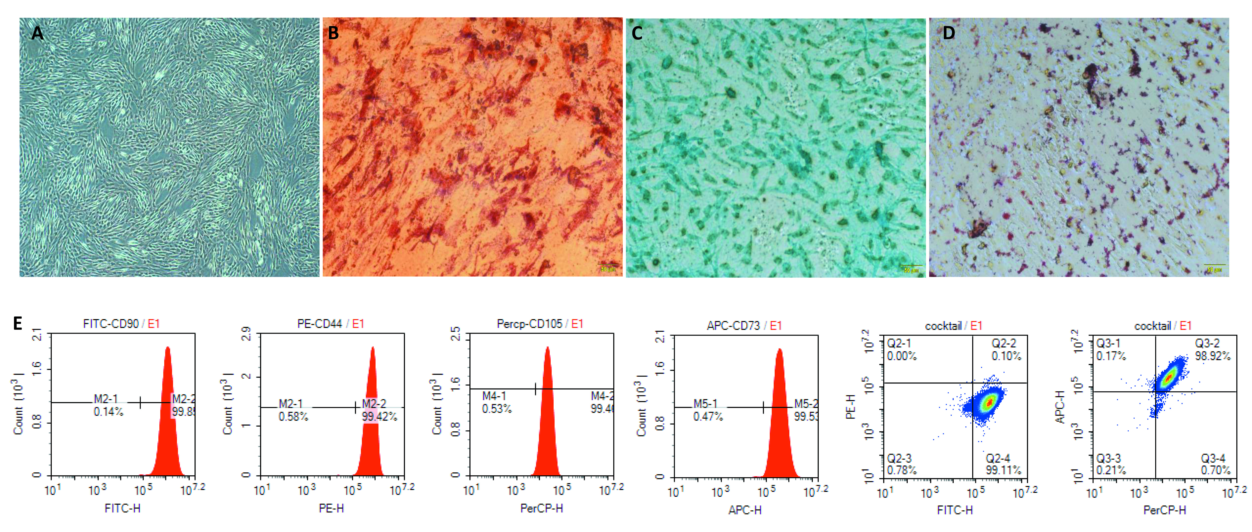
Figure S1. Identification of MSCs. A hUC-MSC in normal condition （40×）； B Osteogenic differentiation of hUC-MSC；C Chondrognic differentiation of hUC-MSC；D. Adipogenic differentiation of hUC-MSC；E. Detection of surface markers of hUC-MSC by flow cytometry.

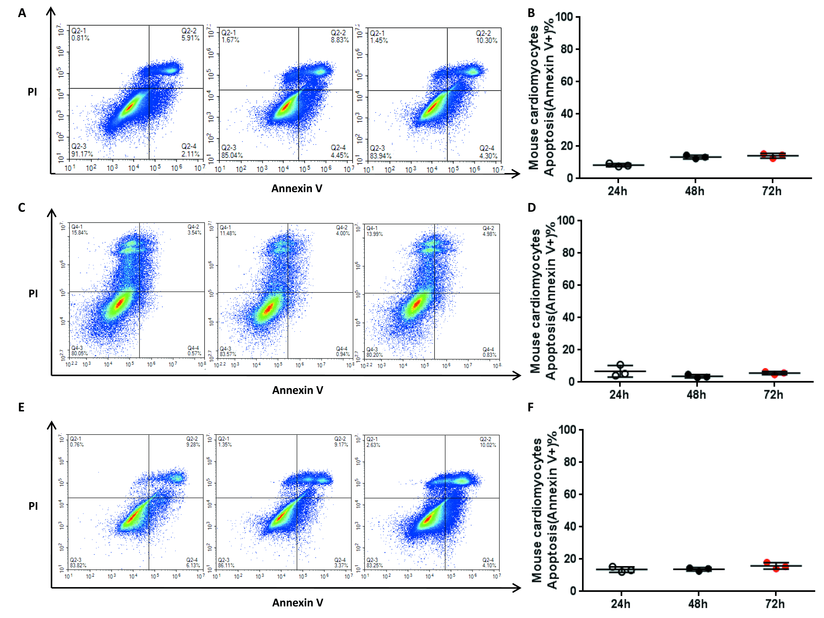
Figure S2. Metformin has no effect on mouse cardiomyocytes, human endothelial cells and human fibroblasts survival. A and B, The ratio of mouse cardiomyocytes apoptosis (Annexin V+) induced by 2 mM metformin at 24h, 48h, 72h; C and D, The ratio of human endothelial cells apoptosis (Annexin V+) induced by 2 mM metformin at 24h, 48h, 72h; E and F, The ratio of human fibroblasts apoptosis (Annexin V+) induced by 2 mM metformin at 24h, 48h, 72h. Bars in B , D and F represent the mean±SEM (n=3 per group). statistical test applied by one-way ANOVA.

