Additional file 7 – Forest plots of DTA by different index test human resources

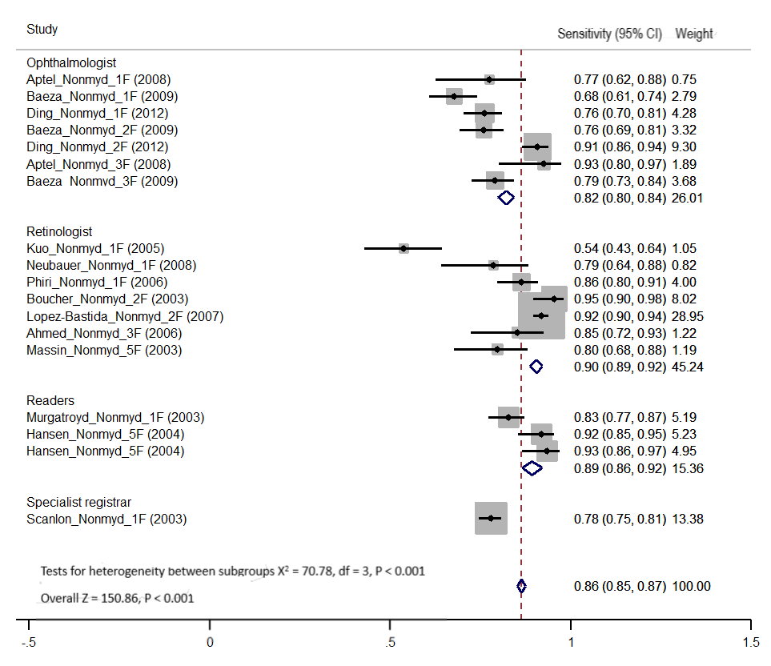

Figure 1. Forest plot of summary estimates of sensitivity of non-mydriatic imaging by different index test graders

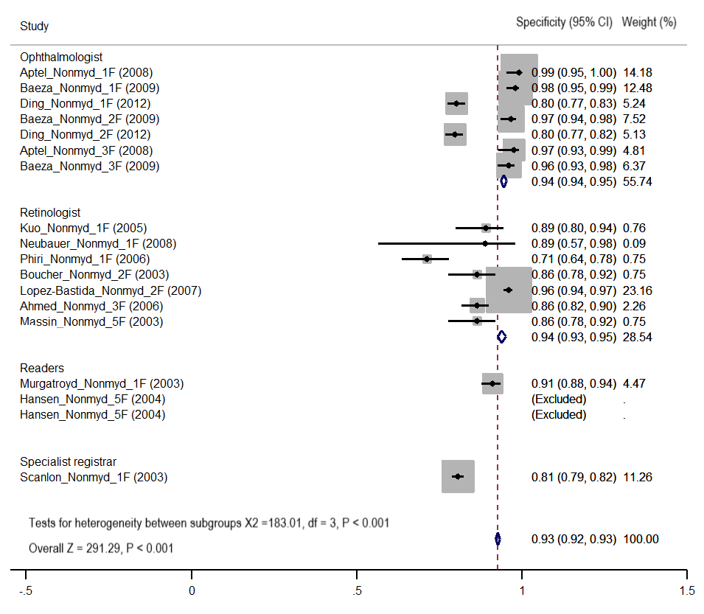
Figure 2. Forest plot of summary estimates of specificity of non-mydriatic imaging by different index test graders

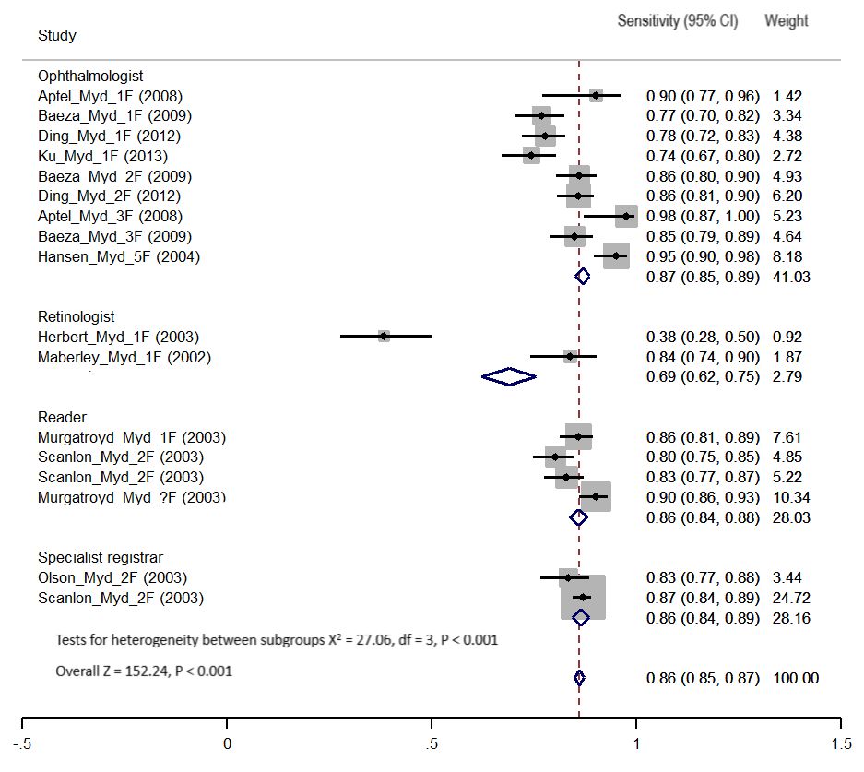

Figure 3. Forest plot of summary estimates of sensitivity of mydriatic imaging by different index test graders

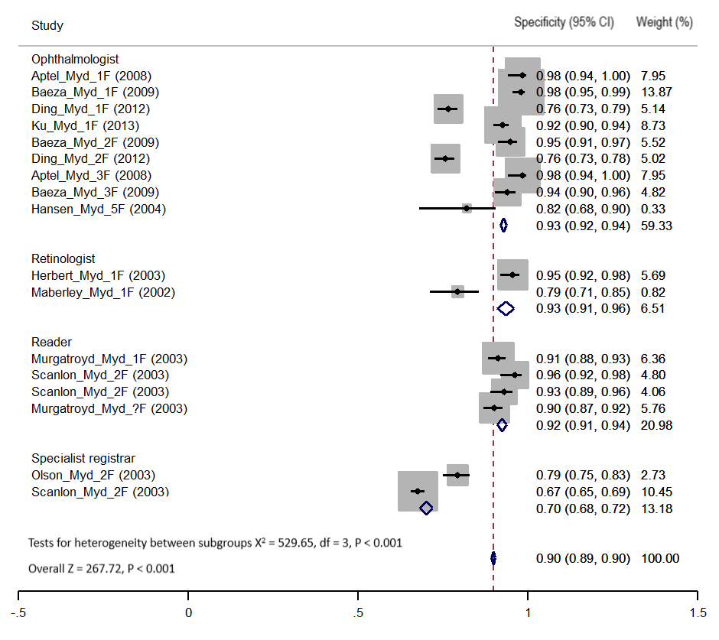

Figure 4. Forest plot of summary estimates of sensitivity of mydriatic imaging by different index test graders

