Suplementary file

Suplementary Table 1. Comparison between clinical stage of disease (TNM) a year of diagnoses according to Population-Based Cancer Registry of Barretos Cancer Hospital, São Paulo, Brazil, years 2000-2015.
Clincial stage of disease  at Diagnosis (TNM)* | Breast cancer |  |  |  |  | Cervical cancer
 | 2000-2004 | 2005-2009 | 2010-2015 | p |  | 2000-2004 | 2005-2009 | 2010-2015 | p
In situ | 32 (8.1) | 103 (17.7) | 203 (19.1) | <0.001 |  | 118 (51.3) | 93 (52.8) | 408 (76.5) | <0.001
I and II | 237 (59.7) | 333 (57.2) | 547 (51.4) |  |  | 58 (25.2) | 41 (23.3) | 76 (14.3)
III and IV | 128 (32.2) | 146 (25.1) | 314 (29.5) |  |  | 54 (23.5) | 42 (23.9) | 49 (9.2)
Total | 397 (100.0) | 582 (100.0) | 1,064 (100.0) |  |  | 230 (100.0) | 176 (100.0) | 533 (100.0)
* Numbers in these variables do not add up the overall total number of cases due to the missing values.

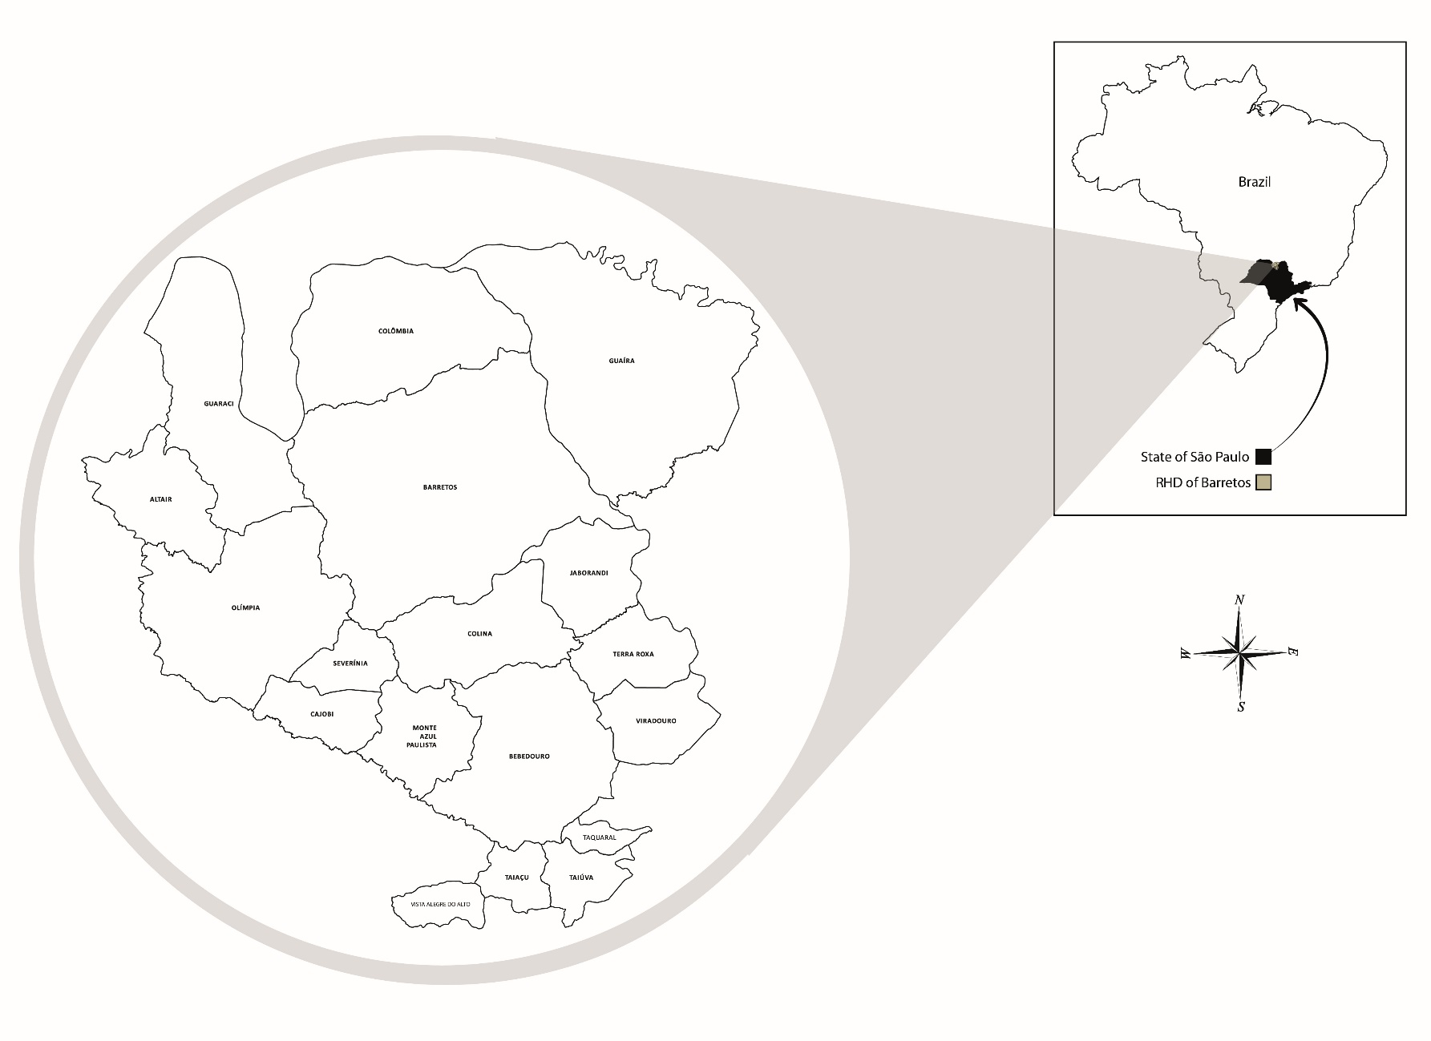
Suplementary Figure 1. Area of coverage of the RHD of Barretos (RHD-V).
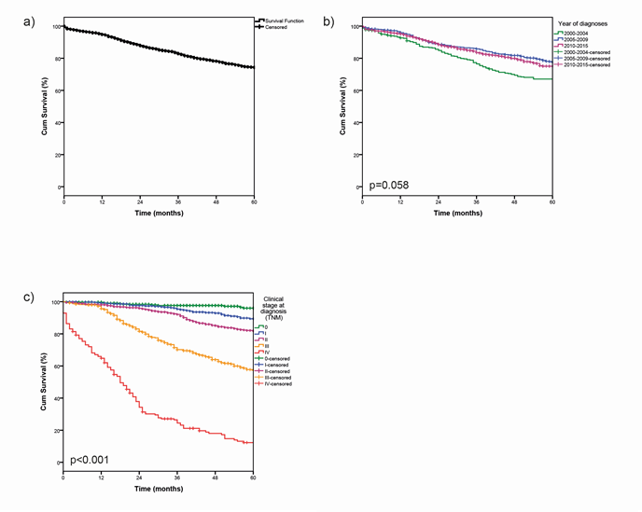
Suplementary Figure 2. Breast cancer overall survival. (a). Overall survival; (b). Overall survival by year of diagnoses; (c). Overall survival by clinical stage.
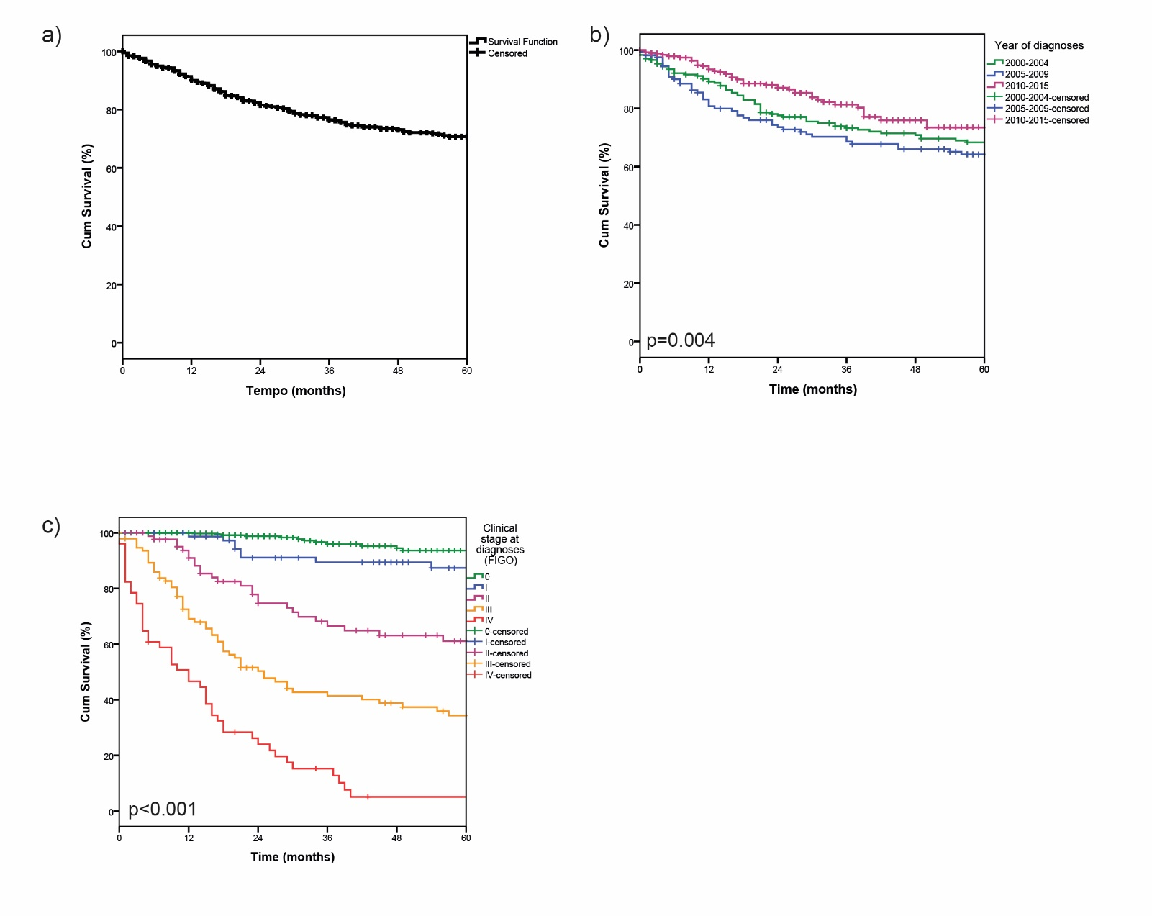
Suplementary Figure 3. Cervical cancer overall survival. (a). Overall survival; (b). Overall survival by year of diagnoses; (c). Overall survival by clinical stage.

