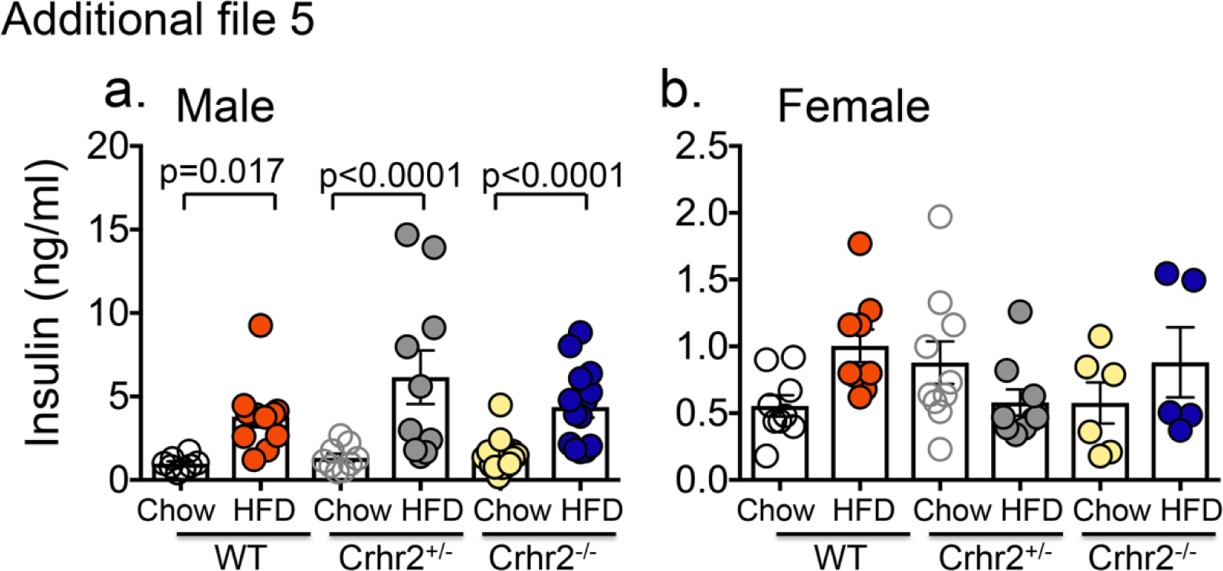
Additional File 5 legend. Male mice have increased plasma insulin levels on HFD. Column graphs showing plasma insulin levels in chow- and HFD-fed male and female mice. (a) Significant increases in insulin levels were seen in male WT, Crhr2^{-/-}, and Crhr2^{+/-} mice (HFD vs. chow, n= 9/group). (b) HFD intake did not significantly increase plasma insulin levels in female WT, Crhr2^{-/-}, and Crhr2^{+/-} mice (n=9/group). 3-Way ANOVA and post hoc Tukey’s multiple comparisons.

