Supplemental Material for:

Title: Blood handling and leukocyte isolation methods impact the global transcriptome of immune cells

Authors: Brittany Goods^{1,}*, Jacqueline M. Vahey¹†, Arthur S. Steinschneider²†, Michael H. Askenase², Lauren Sansing²‡, J. Christopher Love^{1,3,4}‡*

¹Department of Biological Engineering, Koch Institute for Integrative Cancer Research at MIT, Cambridge, Massachusetts 02139, USA.
²Department of Neurology, Yale School of Medicine, New Haven, Connecticut 06520, USA.
³Department of Chemical Engineering, Koch Institute for Integrative Cancer Research at MIT Cambridge, Massachusetts 02139, USA.
⁴The Broad Institute of MIT and Harvard, Cambridge, MA 02142, USA.

† These authors contributed equally to this work.
‡ These authors contributed equally to this work.

*Correspondence to: clove@mit.edu, bagoods@mit.edu

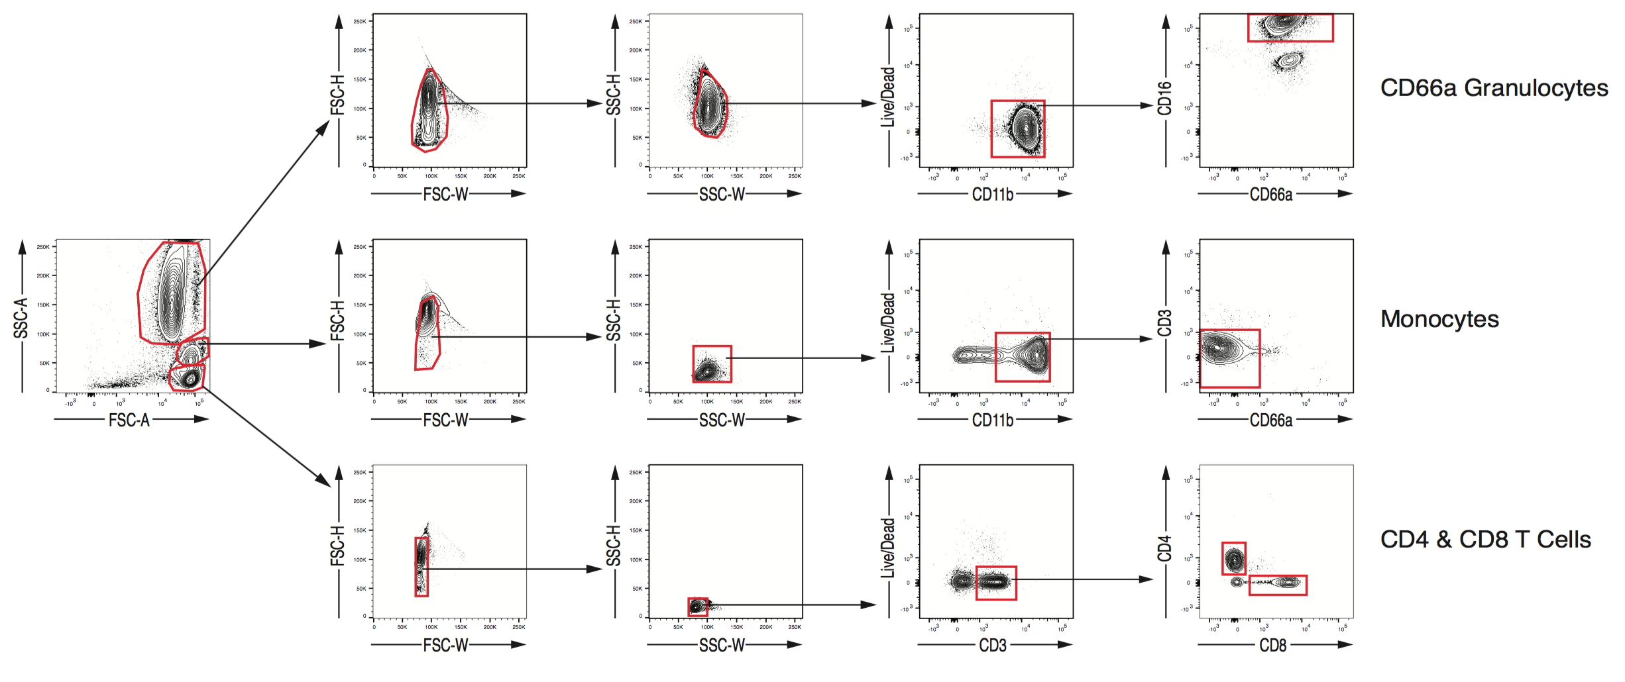
Supplemental Figure 1. Sorting strategy used to profile peripheral blood mononuclear cells (PBMCs) from blood of healthy donors across all conditions tested. Antibodies are listed in Table 1.

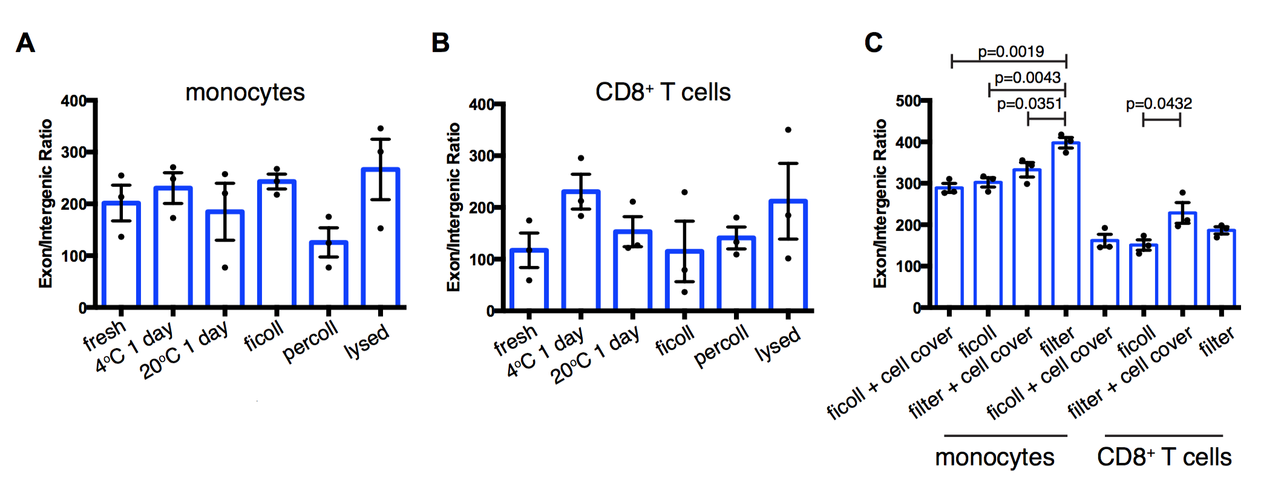

Supplemental Figure 2. Exon/intergenic ratios are plotted for each indicated condition for (A) monocytes, (B) T cells and (C) for filtration as compared to ficoll. Statistically significant comparisons are indicated and were calculated by one-way ANOVA with Tukey’s multiple comparisons test.

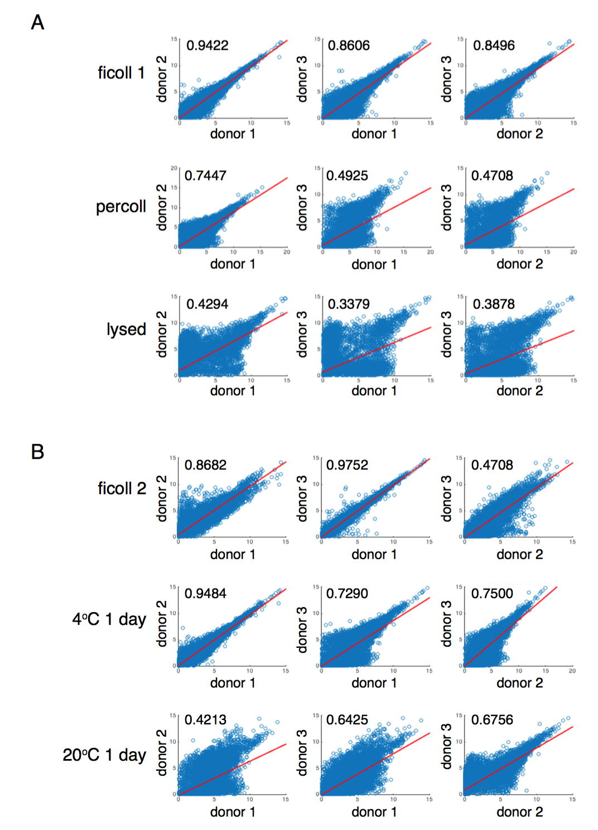

Supplemental Figure 3. Pairwise scatter plots of coding transcriptomes generated from monocytes for each indicated comparison. Regression lines and R² values are shown on each plot for (A) ficoll, percoll and lysis processing conditions, and (B) ficoll, 4°C for 1 day or 20°C for 1 day conditions.

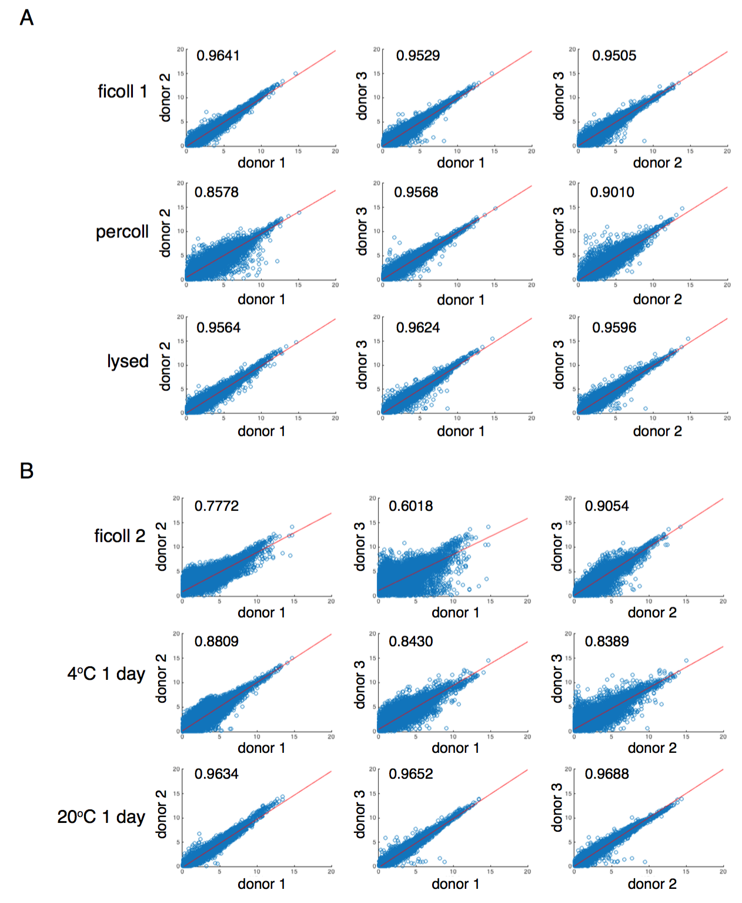

Supplemental Fig 4. Pairwise scatter plots of coding transcriptomes generated from CD8⁺ T cells for each indicated comparison. Regression lines and R² values are shown on each plot for (A) ficoll, percoll and lysis processing conditions, and (B) ficoll, 4°C for 1 day or 20°C for 1 day conditions.

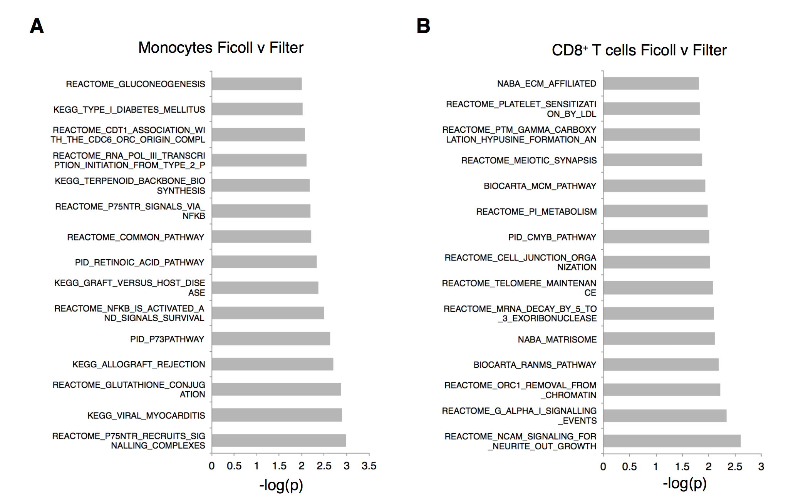
Supplemental Figure 5. ssGSEA results for ficoll and filter methods for isolation of PBMCs. Forest plots of top 15 significantly altered gene sets when PBMCs are isolated using filters for monocytes (A) and CD8⁺ T cells (B).

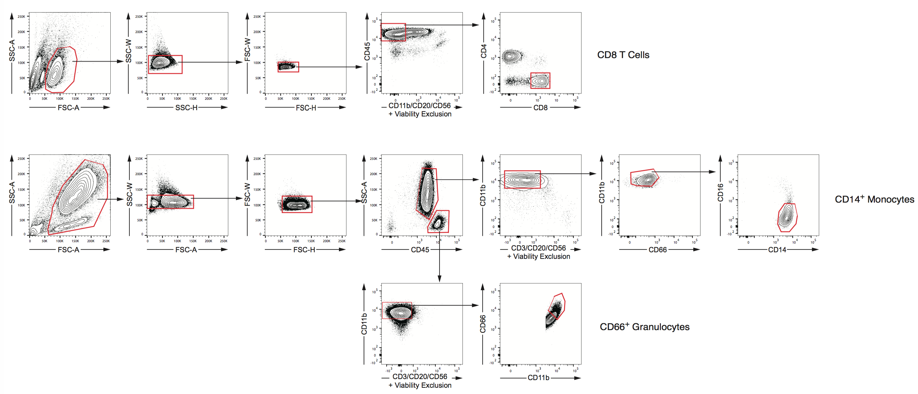
Supplemental Figure 6. Flow cytometry isolation scheme for sequencing data generated from cells isolated from intracerebral hemorrhage (ICH) and matched healthy donors (HD).

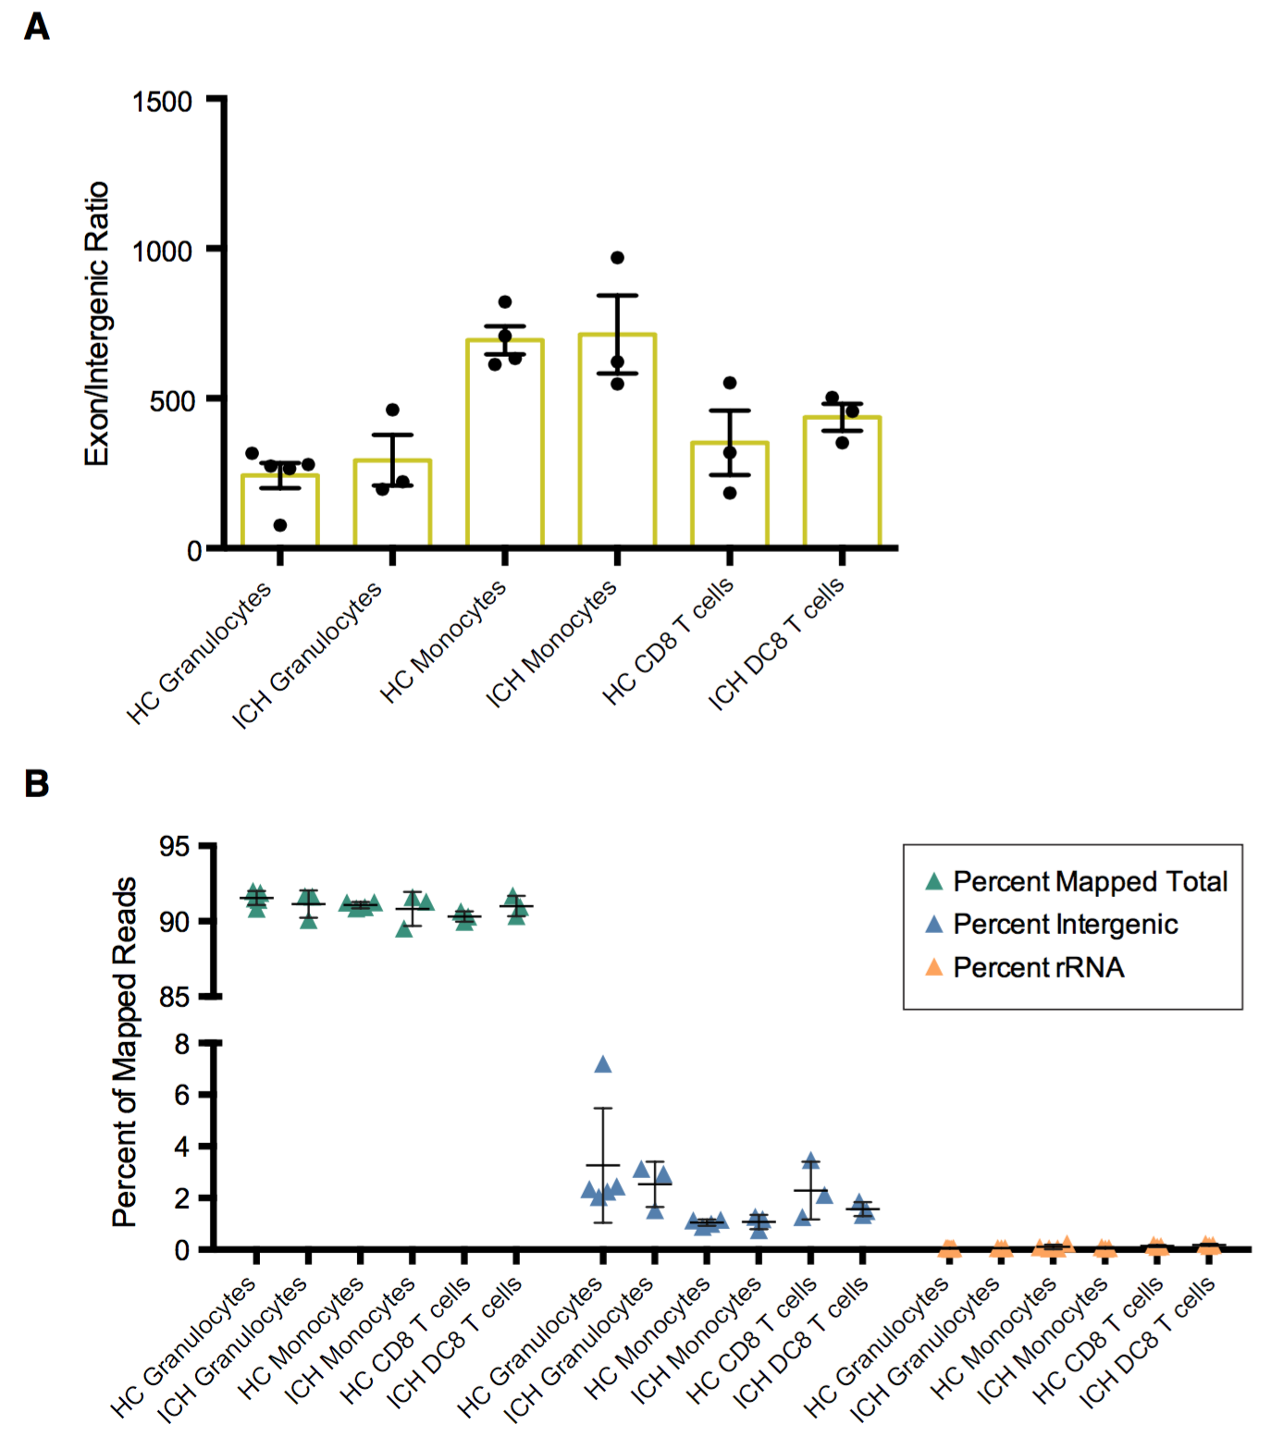

Supplemental Figure 7. Quality control metrics for sequencing data generated from cells isolated from intracerebral hemorrhage (ICH) and matched healthy donors (HD). (A) Exon/intergenic ratio for each indicated condition. No statistically significant differences were found when comparing healthy to ICH within each cell type by students t test. (B) Percent mapped reads for each indicated condition. No statistically significant differences were found when comparing healthy to ICH within each cell type by students t test for each percent metric plotted.

Supplemental Table 1. Antibodies used for cell sorting in this study.

Supplemental Table 1: Antibodies used for the cell sorting
- Sort panel I
Marker | Label | Clone | Supplier | Catalog #
CD3 | APC/H7 | SK7 | BD | 560176
CD4 | V450 | RPA-T4 | BD | 560345
CD8 | V500 | RPA-T8 | BD | 560774
CD11b | FITC | ICRF44 | eBioscience | 11-0118-42
CD16 | PE/Cy7 | 3G8 | BD | 557744
CD25 | PE | M-A251 | BD | 555432
CD45 | PerCP/Cy5.5 | H130 | Tonbo | 65-0459-T100
CD66a | PE | B1.1 | BD | 564105
CD127 | AF 647 | HIL-7R-M21 | BD | 558598
Live/Dead | Fixable red dye |  | Life Technologies | L34972
- Sort panel II – T cells
Marker | Label | Clone | Supplier | Catalog #
CD2 | APC/H7 | RPA-2.10 | BD | 562638
CD4 | violetFluor 450 | RPA-T4 | Tonbo | 75-0049-T100
CD8 | PE/Cy7 | RPA-T8 | Tonbo | 60-0088-T100
CD11b | Biotin | M1/70 | Tonbo | 30-0112-U500
CD20 | Biotin | 2H7 | Biolegend | 302350
CD25 | PE | M-A251 | BD | 555432
CD45 | FITC | HI30 | Tonbo | 35-0459-T100
CD56 | Biotin | HCD56 | Biolegend | 318320
CD127 | APC | R34-34 | Tonbo | 20-1278-T100
Streptavidin | PE-CF594 |  | BD | 562318
Live/Dead | Fixable red dye |  | Life Technologies | L34972
- Sort panel II – Innate cells
Marker | Label | Clone | Supplier | Catalog #
CD2 | Biotin | RPA-2.10 | Biolegend | 300204
CD11b | FITC | ICRF44 | Tonbo | 35-0118-T100
CD14 | APC/Cy7 | M5E2 | Biolegend | 301820
CD16 | v450 | 3G8 | BD | 560474
CD20 | Biotin | 2H7 | Biolegend | 302350
CD45 | PE | HI30 | Tonbo | 50-0459-T100
CD56 | Biotin | HCD56 | Biolegend | 318320
CD66a/c/e | PE/Cy7 | ASL-32 | Biolegend | 342310
Streptavidin | BV510 |  | Biolegend | 405234
Live/Dead | Fixable red dye |  | Life Technologies | L34972

Supplemental Table 2. Summary statistics performed by one-way ANOVA with Tukey’s multiple comparisons test for data shown in Figure 2.
Figure | Cell Type | Tukey's multiple comparisons test | Mean Diff. | 95.00% CI of diff. | Significant? | Summary | Adjusted P Value
2A | CD4 T cells | Freshly Isolated vs. 1 Day 20C | 14.31 | -1.799 to 30.42 | No | ns | 0.0767
 | CD4 T cells | Freshly Isolated vs. 1 Day 4C | 20.44 | 4.336 to 36.55 | Yes | * | 0.0188
 | CD4 T cells | 1 Day 20C vs. 1 Day 4C | 6.134 | -9.974 to 22.24 | No | ns | 0.5118
 | CD8 T cells | Freshly Isolated vs. 1 Day 20C | 6.237 | -3.844 to 16.32 | No | ns | 0.2193
 | CD8 T cells | Freshly Isolated vs. 1 Day 4C | 7.647 | -2.434 to 17.73 | No | ns | 0.1272
 | CD8 T cells | 1 Day 20C vs. 1 Day 4C | 1.41 | -8.671 to 11.49 | No | ns | 0.905
 | Monocytes | Freshly Isolated vs. 1 Day 20C | 2.31 | -5.792 to 10.41 | No | ns | 0.6743
 | Monocytes | Freshly Isolated vs. 1 Day 4C | 3.249 | -4.852 to 11.35 | No | ns | 0.4798
 | Monocytes | 1 Day 20C vs. 1 Day 4C | 0.9396 | -7.162 to 9.041 | No | ns | 0.9333
 | Granulocytes | Freshly Isolated vs. 1 Day 20C | -3.483 | -9.523 to 2.556 | No | ns | 0.2573
 | Granulocytes | Freshly Isolated vs. 1 Day 4C | -14.86 | -20.89 to -8.816 | Yes | *** | 0.0007
 | Granulocytes | 1 Day 20C vs. 1 Day 4C | -11.37 | -17.41 to -5.333 | Yes | ** | 0.0028
2B | CD4 T cells | Ficoll Gradient vs. Whole Blood Lysis | 21.83 | 8.283 to 35.37 | Yes | ** | 0.0062
 | CD4 T cells | Ficoll Gradient vs. Collagenase + Percoll Gradient | 26.84 | 13.3 to 40.39 | Yes | ** | 0.0022
 | CD4 T cells | Whole Blood Lysis vs. Collagenase + Percoll Gradient | 5.019 | -8.523 to 18.56 | No | ns | 0.5283
 | CD8 T cells | Ficoll Gradient vs. Whole Blood Lysis | 10.18 | 1.301 to 19.06 | Yes | * | 0.0291
 | CD8 T cells | Ficoll Gradient vs. Collagenase + Percoll Gradient | 10.79 | 1.914 to 19.68 | Yes | * | 0.0227
 | CD8 T cells | Whole Blood Lysis vs. Collagenase + Percoll Gradient | 0.6132 | -8.268 to 9.494 | No | ns | 0.9757
 | Monocytes | Ficoll Gradient vs. Whole Blood Lysis | 9.179 | -4.263 to 22.62 | No | ns | 0.1711
 | Monocytes | Ficoll Gradient vs. Collagenase + Percoll Gradient | -11.97 | -25.41 to 1.471 | No | ns | 0.076
 | Monocytes | Whole Blood Lysis vs. Collagenase + Percoll Gradient | -21.15 | -34.59 to -7.708 | Yes | ** | 0.007
 | Granulocytes | Ficoll Gradient vs. Whole Blood Lysis | -38.12 | -54.85 to -21.39 | Yes | ** | 0.001
 | Granulocytes | Ficoll Gradient vs. Collagenase + Percoll Gradient | -17.54 | -34.27 to -0.8039 | Yes | * | 0.0418
 | Granulocytes | Whole Blood Lysis vs. Collagenase + Percoll Gradient | 20.58 | 3.853 to 37.32 | Yes | * | 0.0216
2C | CD4 T cells | Ficoll vs. Ficoll + Cellcover | -2.658 | -14.36 to 9.04 | No | ns | 0.8834
 | CD4 T cells | Ficoll vs. Whole Blood Filtration | 10.22 | -1.474 to 21.92 | No | ns | 0.0884
 | CD4 T cells | Ficoll vs. Whole Blood Filtration + Cellcover | 10.08 | -1.622 to 21.77 | No | ns | 0.0936
 | CD4 T cells | Ficoll + Cellcover vs. Whole Blood Filtration | 12.88 | 1.184 to 24.58 | Yes | * | 0.0318
 | CD4 T cells | Ficoll + Cellcover vs. Whole Blood Filtration + Cellcover | 12.73 | 1.036 to 24.43 | Yes | * | 0.0336
 | CD4 T cells | Whole Blood Filtration vs. Whole Blood Filtration + Cellcover | -0.1481 | -11.85 to 11.55 | No | ns | >0.9999
 | CD8 T cells | Ficoll vs. Ficoll + Cellcover | -0.7315 | -7.549 to 6.086 | No | ns | 0.985
 | CD8 T cells | Ficoll vs. Whole Blood Filtration | -0.4832 | -7.301 to 6.334 | No | ns | 0.9955
 | CD8 T cells | Ficoll vs. Whole Blood Filtration + Cellcover | -0.3196 | -7.137 to 6.498 | No | ns | 0.9987
 | CD8 T cells | Ficoll + Cellcover vs. Whole Blood Filtration | 0.2484 | -6.569 to 7.066 | No | ns | 0.9994
 | CD8 T cells | Ficoll + Cellcover vs. Whole Blood Filtration + Cellcover | 0.412 | -6.406 to 7.229 | No | ns | 0.9972
 | CD8 T cells | Whole Blood Filtration vs. Whole Blood Filtration + Cellcover | 0.1636 | -6.654 to 6.981 | No | ns | 0.9998
 | Monocytes | Ficoll vs. Ficoll + Cellcover | 4.604 | -3.839 to 13.05 | No | ns | 0.3625
 | Monocytes | Ficoll vs. Whole Blood Filtration | 12.23 | 3.782 to 20.67 | Yes | ** | 0.0073
 | Monocytes | Ficoll vs. Whole Blood Filtration + Cellcover | 13.91 | 5.47 to 22.36 | Yes | ** | 0.0033
 | Monocytes | Ficoll + Cellcover vs. Whole Blood Filtration | 7.621 | -0.8225 to 16.06 | No | ns | 0.0777
 | Monocytes | Ficoll + Cellcover vs. Whole Blood Filtration + Cellcover | 9.309 | 0.8657 to 17.75 | Yes | * | 0.0316
 | Monocytes | Whole Blood Filtration vs. Whole Blood Filtration + Cellcover | 1.688 | -6.755 to 10.13 | No | ns | 0.916
 | Granulocytes | Ficoll vs. Ficoll + Cellcover | 0.1653 | -15.45 to 15.78 | No | ns | >0.9999
 | Granulocytes | Ficoll vs. Whole Blood Filtration | -39.91 | -55.52 to -24.29 | Yes | *** | 0.0002
 | Granulocytes | Ficoll vs. Whole Blood Filtration + Cellcover | -30.85 | -46.46 to -15.23 | Yes | ** | 0.001
 | Granulocytes | Ficoll + Cellcover vs. Whole Blood Filtration | -40.07 | -55.68 to -24.46 | Yes | *** | 0.0002
 | Granulocytes | Ficoll + Cellcover vs. Whole Blood Filtration + Cellcover | -31.01 | -46.63 to -15.4 | Yes | *** | 0.001
 | Granulocytes | Whole Blood Filtration vs. Whole Blood Filtration + Cellcover | 9.059 | -6.554 to 24.67 | No | ns | 0.3162

