Control Treated
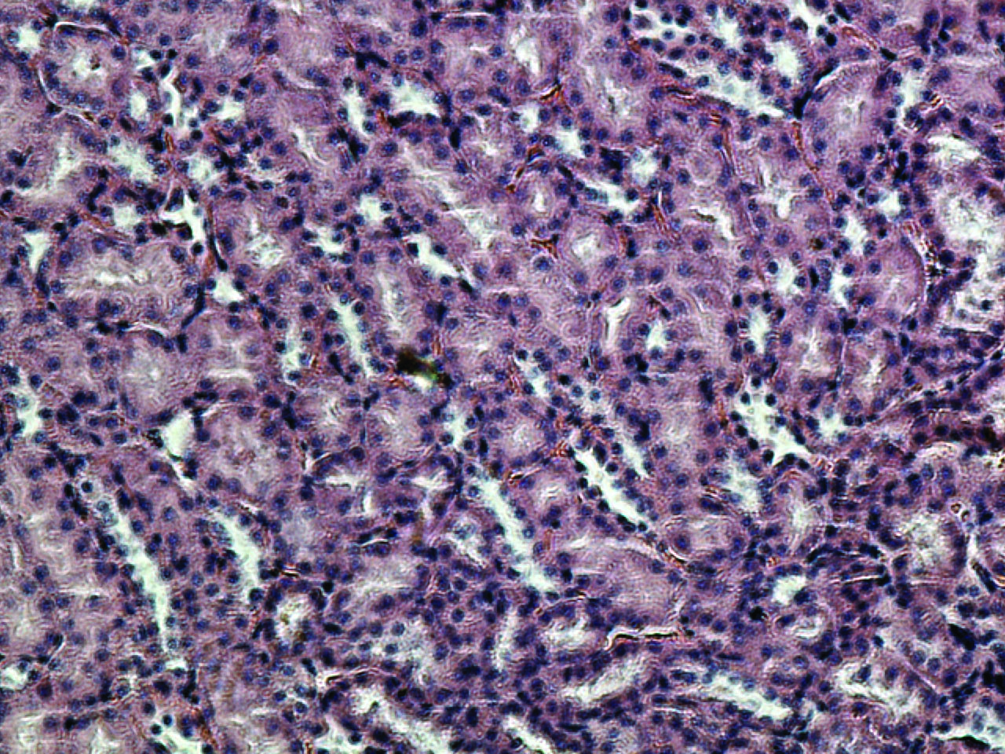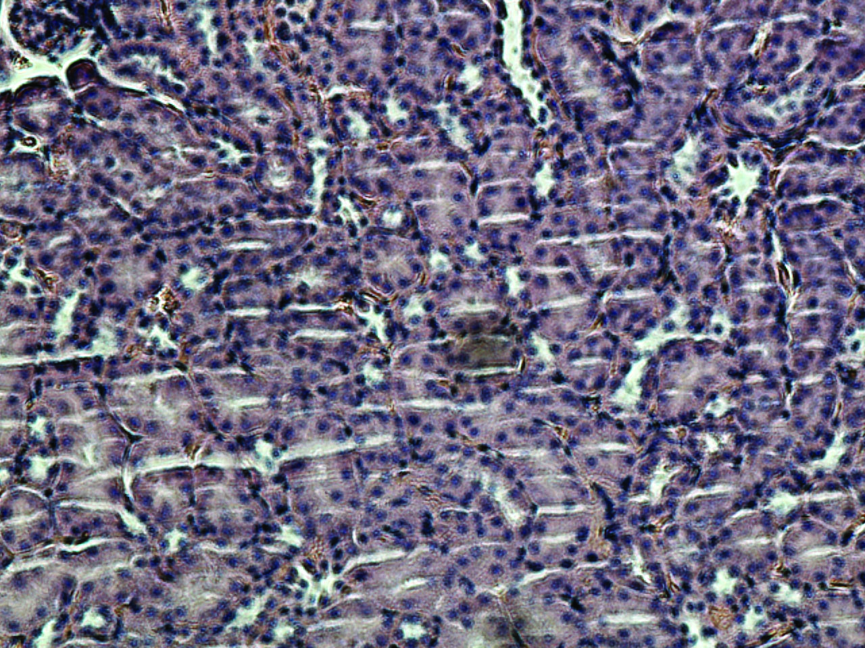
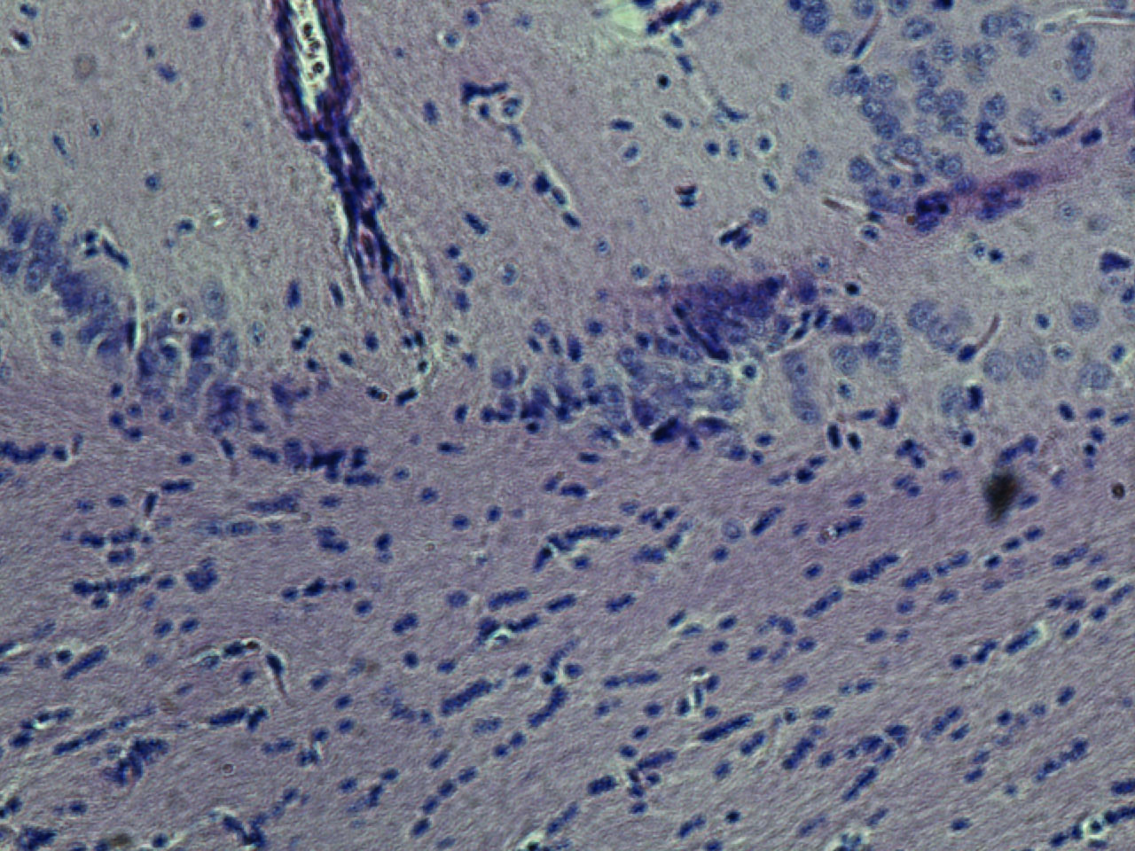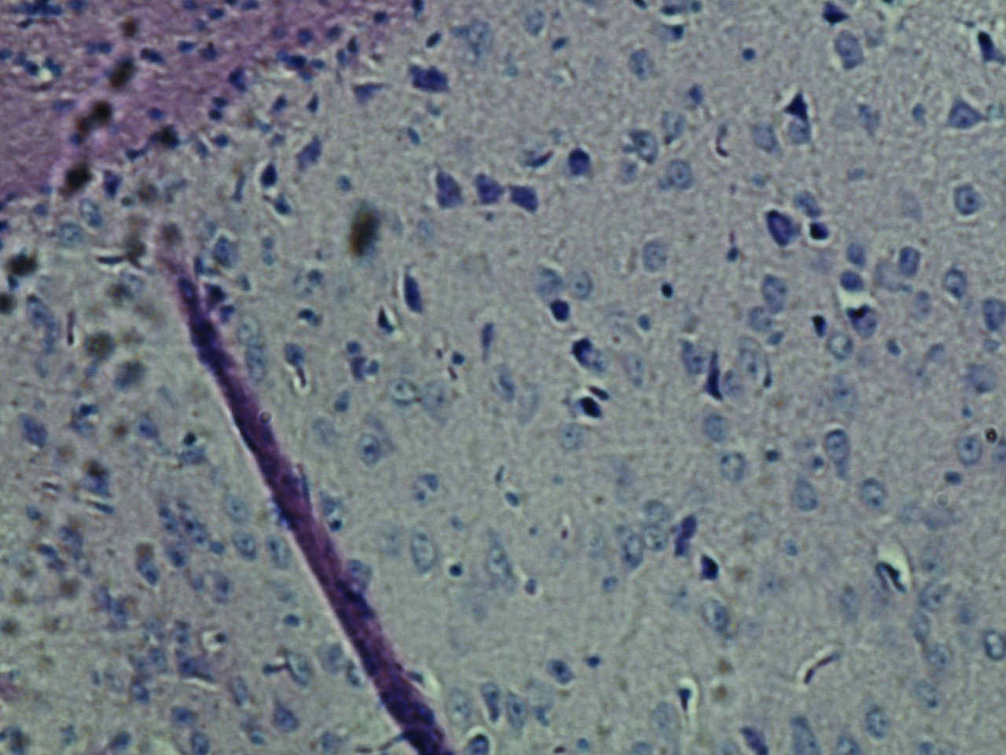

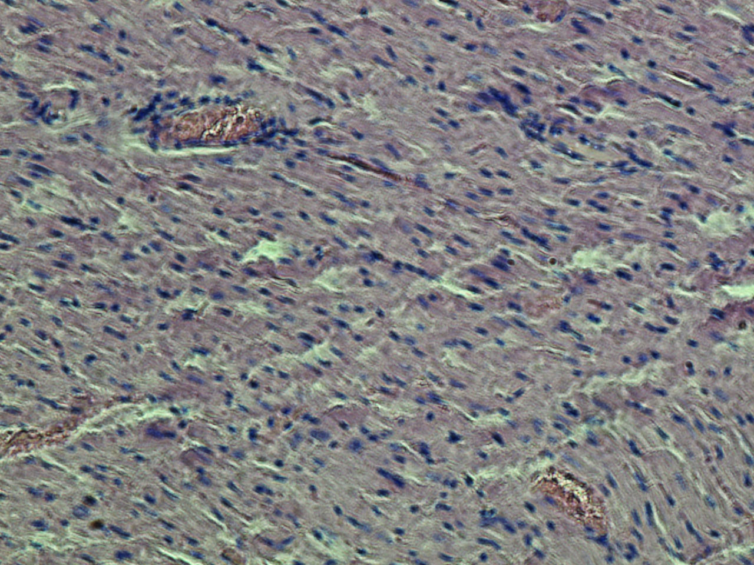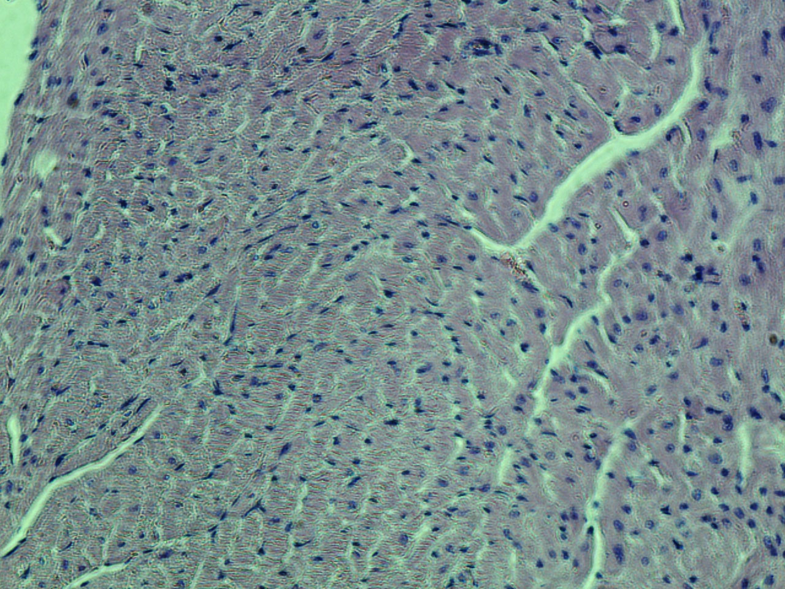
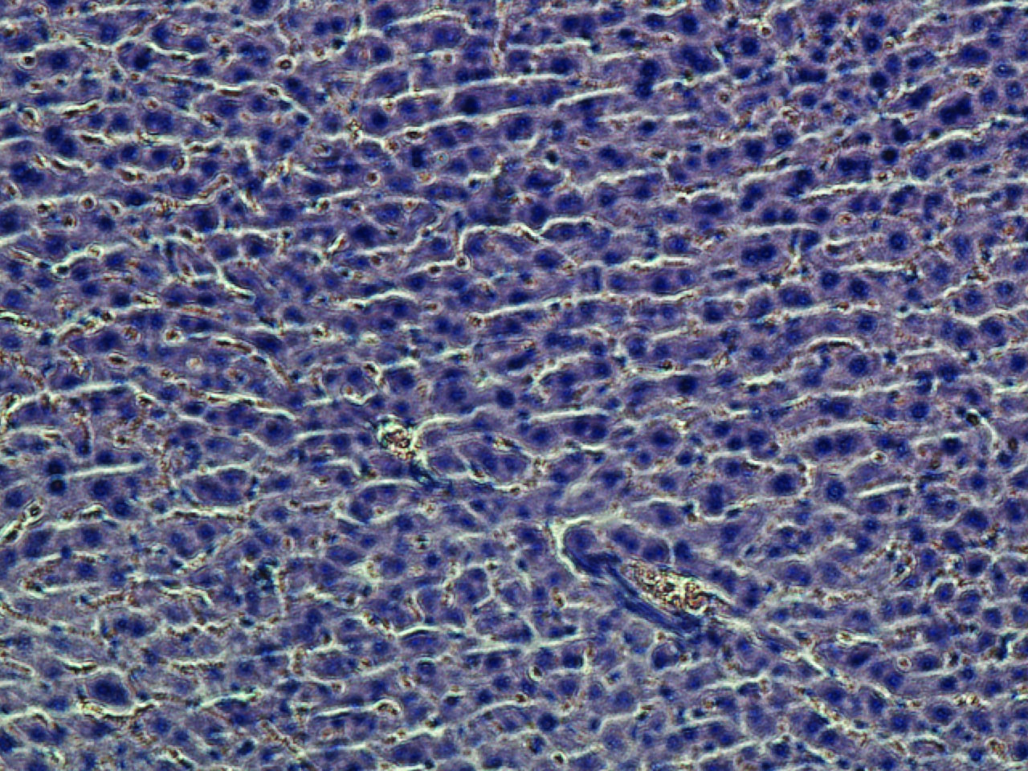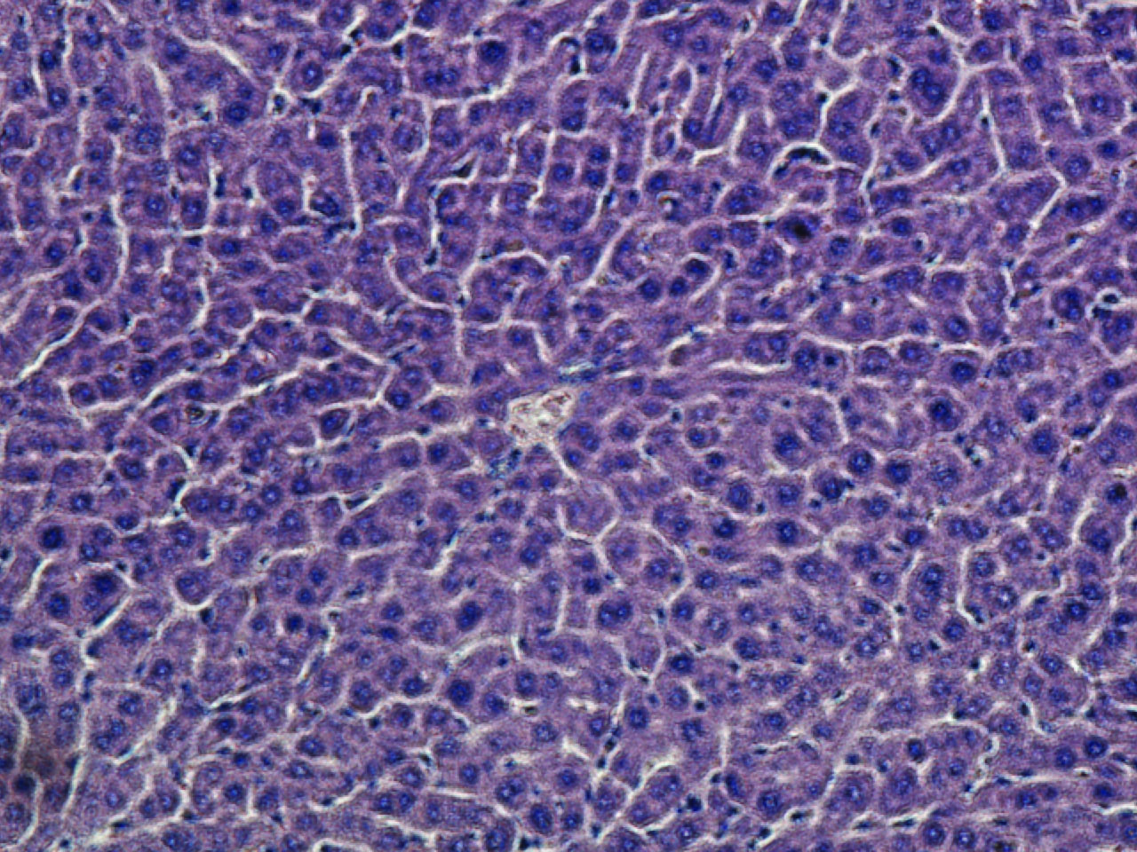
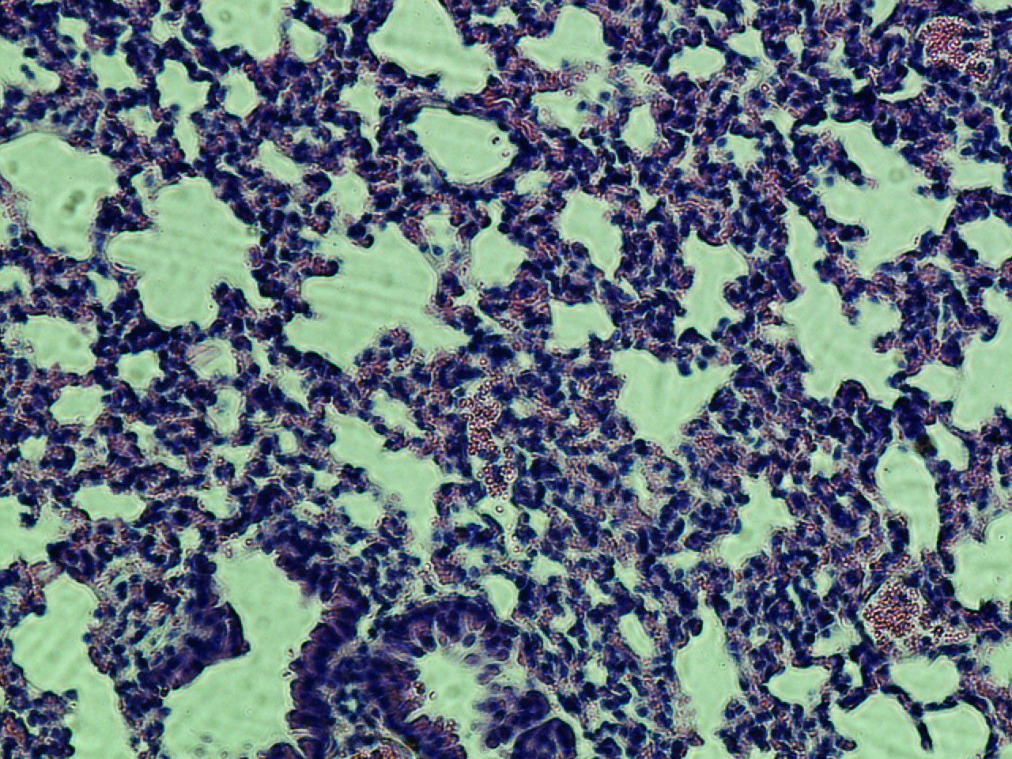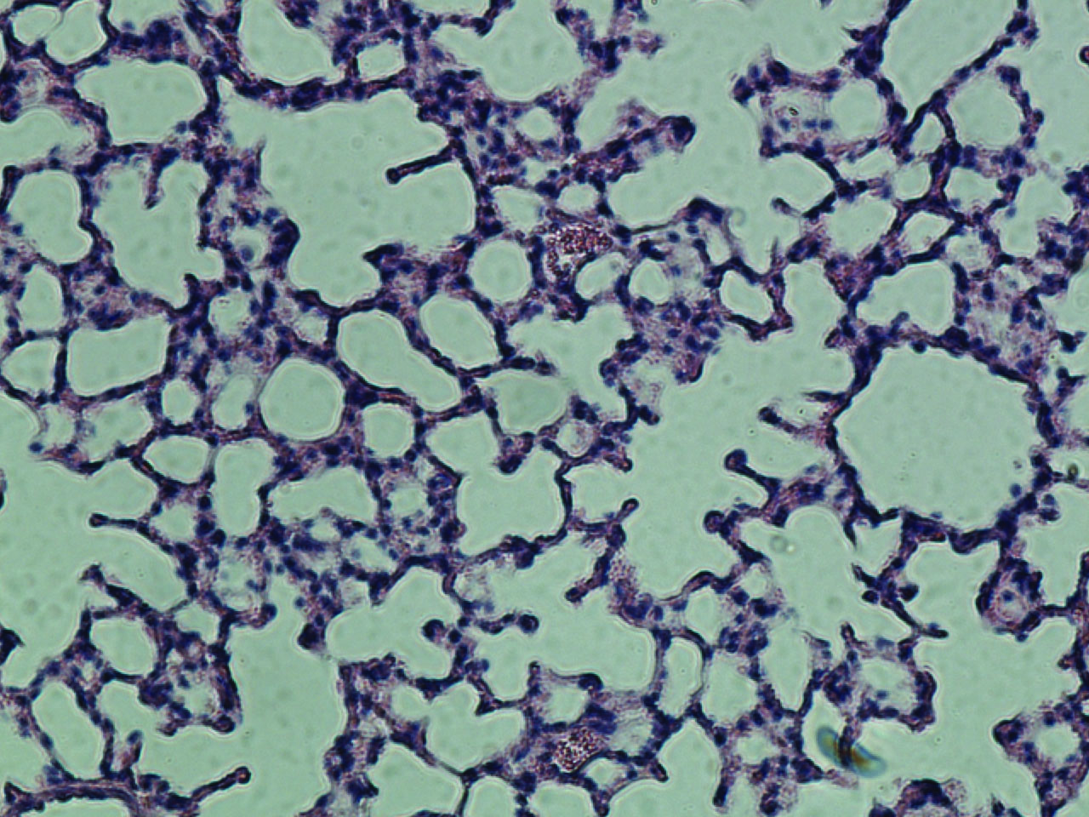

Figure: Mice weight was taken twice weekly and values represent mean±SD of six mice. **, p < 0.02 (25/kg mg),*, p < 0.01 (125/kg mg) vs control group;**, p < 0.001. (6C) H&E staining of
kidney brain, heart, liver and lung of TAX treated mice vs. control for toxicity studies.”

Report generated by pathologist
Dr. Abdul Malik Al Sheikh (Pathologist), MD, FRCPC
Slide review: Preliminary observations
Organ | Control | Taxifolin and NVD treated
Liver | 1. Minimal randomly scattered mononuclear and supportive hepatitis  2. Minimal lymphoplasmacytic and histolytic portal hepatitis.  3. Sinusoidal brown pigment accumulation interpreted as probable artifact of red blood cell staining. | 1. Capsular fibrosis and mild chronic mononuclear and mildly suppurative inflammation (suggestive of peritonitis).  2. Minimal mononuclear portal hepatitis.  3. Mildly enhanced hepatocellular mitotic rate, presumptive.  4. Locally extensive moderate accumulation of pigment laden macrophages/Kupffer cells  6. Minimal extra-medullary hematopoiesis
Brain | Extensive dark neuron artifact interpreted as an artifact of dissection. There is extremely rare mild extravasations of blood into Virchow-Robbins’ space. The habenular nuclei have a mesh-work of cells (presumptive neurons) with smudged nuclear features.  Diagnoses:  1. Locally extensive nuclear smudging in the habenular nuclei (a finding of uncertain significance).  2. Minimal extravasations of blood into Virchow-Robbins’ space. | There is fairly extensive dark neuron artifact (presumptive secondary to dissection).
Heart | There is rare individual cardiac myocytes with increased cytoplasmic eosinophilia and bland darkly staining contracted nuclei.  Diagnoses:  1. Minimal individual myocytes change, interpreted as probable degerative change. | There are rare individual cardiac myocytes with slightly more darkly eosinophilic cytoplasm than neighboring cells and with more homogenous and darkly eosinophilic chromatin staining in contracted and shrunken nuclei.  Diagnoses:  1. Minimal individual myocytes change, interpreted as probable degerative change.
Kidney | No significant histological lesions are noted. | The renal capsule is segmentally broadened with fibrous connective tissue that is occasionally infiltrated with small numbers of mononuclear leukocytes and neutrophils.  Diagnoses:  1. Capsular fibrosis and mild chronic mononuclear and mildly suppurative inflammation (suggestive of peritonitis)
Lung | Neutrophils are moderately numerous percolating through alveolar septal walls and occasionally within alveolar air spaces. Occasional alveolar pneumocytes have expansive cytoplasm. The pulmonary parenchyma is multifocally collapsed, presumed secondary to dissection technique.  Diagnoses:  1. Pneumonitis, suppurative, moderate | Alveolar air spaces in some areas are mildly collapsed presumed secondary to dissection technique. There are rare megakaryocytes in the pulmonary parenchyma (EMH). There is scant alveolar hemorrhage presumed secondary to euthanasia. Neutrophils are in mildly enhanced numbers in alveolar air spaces and septal walls in a few scattered regions. The tip of the lung lobe has a focal accumulation of slightly increased numbers of foamy macrophages on alveolar septal walls and occasionally in alveoli. Uncommonly, pneumocytes lining alveolar septal walls have expanded cytoplasm (pneumocyte hypertrophy). There is one focus of perivascular lymphoid cuffing at the tip of one lung lobe.  Diagnoses:  1. Pneumonitis, mild, suppurative  2. Extramedullary hematopoiesis (EMH), mild

