Physiological cyclic hydrostatic pressure induces osteogenic lineage commitment of human bone marrow stem cells: a systematic study

Elena Stavenschi^{1,2}, Michele A. Corrigan^{1,2}, Gillian P. Johnson^{1,2,3}, Mathieu Riffault^{1,2,4}, David A. Hoey^{1,2,3,4}

¹Trinity Centre for Bioengineering, Trinity Biomedical Sciences Institute, Trinity College Dublin, Dublin 2, Ireland.,
²Dept. of Mechanical and Manufacturing Engineering, School of Engineering, Trinity College Dublin, Dublin 2, Ireland.
³Dept. of Mechanical, Aeronautical and Biomedical Engineering, University of Limerick, Ireland
⁴Advanced Materials and Bioengineering Research Centre, Trinity College Dublin & RCSI, Dublin 2, Ireland

*Correspondence: stavense@tcd.ie, micorrig@tcd.ie, gjohnson@tcd.ie, riffaulm@tcd.ie, dahoey@tcd.ie

Keywords
Mesenchymal stem cell; Bone; Mechanobiology; Osteogenic Differentiation; Bioreactor
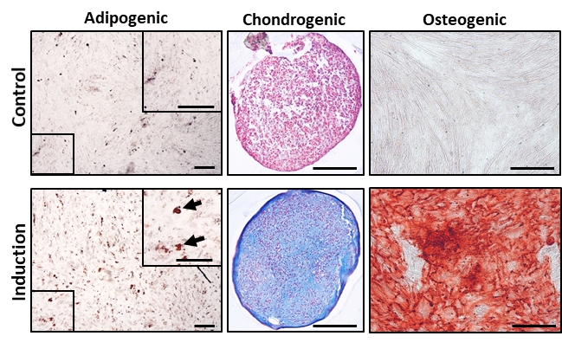
Figure S1 Validation of trilineage potential of hBMSCs for adipogenesis (Oil red O, A), chondrogenesis (Alician Blue, B) and osteogenesis (Alizarin Red S, C) after 21 days in culture. Zoomed in images point to triglyceride accumulation in adipogenic conditions. Scale bar=200 µm

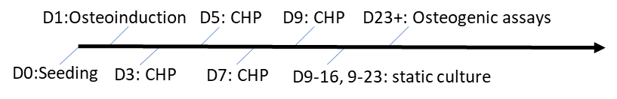
Figure S2 Schematic of long term pressure mechanical stimulation regime.

