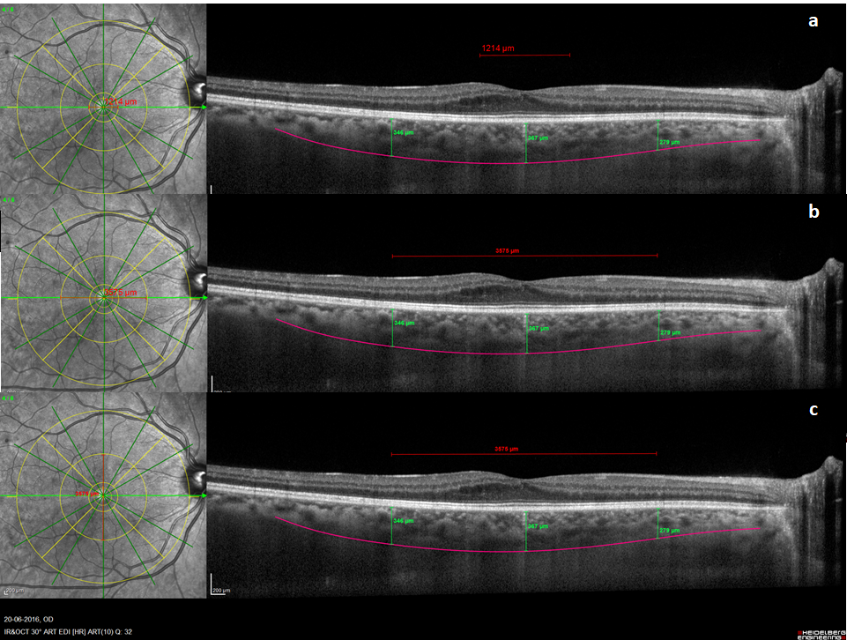
Additional file 1: Figure S1. ETDRS grid in place centered at the fovea. Note that ETDRS grid plotted (7.2 mm in diameter) is larger than the OCT-modified ETDRS grid (6 mm in diameter) plotted to access central retinal thickness CRT. a. and b. HR horizontal scans used to measure the SFCT. ETDRS grid inner circle is 1200 μm (a) and middle circle is 3600 μm wide (b). c. HR vertical scan with SFCT measured underneath the fovea.

