Supplemental figures
Additional file 1: figure S1A. Incidence rates of cancer and death stratified by age group 0-1 years post-MI in the reference and MI population.
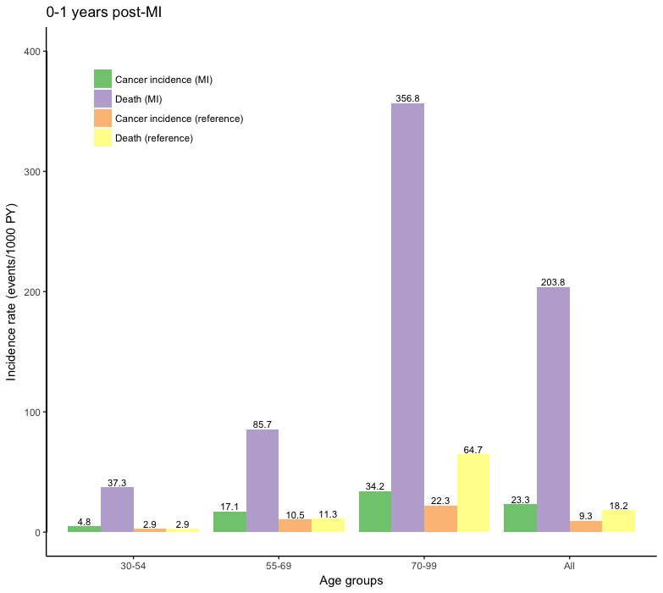
95% Confidence intervals from left to right: (4.0-5.9), (35.2-39.6), (2.8-2.9), (2.9-3.0), (16.0-18.3), (83.4-88.0), (10.5-10.6), (11.3-11.4), (32.8-35.7), (352.8-360.9), (22.2-22.4), (64.6-64.9), (22.5-24.2), (201.7-206.0), (9.3-9.3), (18.2-18.3).
MI = Myocardial infarction.
Additional file 1: figure S1B. Incidence of cancer and death stratified by age group 1-5 years post-MI in the reference and MI population.
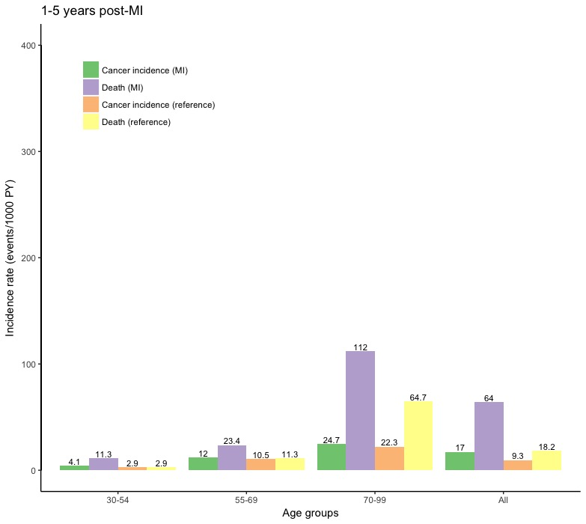
95% Confidence intervals from left to right: (3.4-4.8), (10.3-12.4), (2.8-2.9), (2.9-3.0), (11.3-13.7), (22.4-24.4), (10.5-10.6), (11.3-11.4), (23.8-25.6), (110.1-114.0), (22.2-22.4), (64.6-64.9), (16.5-17.5), (63.0-65.0), (9.3-9.3), (18.2-18.3).
MI = Myocardial infarction.

Additional file 1: figure S1C. Incidence of cancer and death stratified by age group 5-17 years post-MI in the reference and MI population.
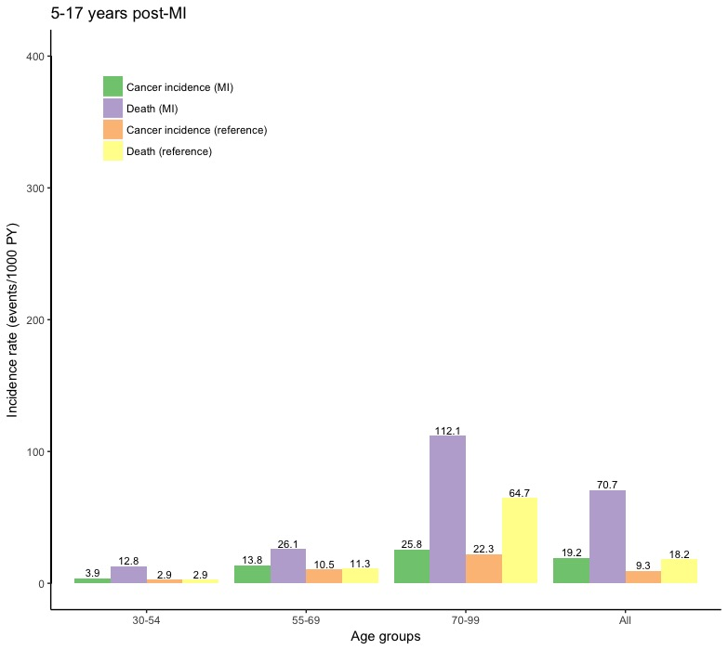
95% Confidence intervals from left to right: (3.1-4.9), (11.3-14.6), (2.8-2.9), (2.9-3.0), (13.0-14.6), (25.0-27.3), (10.5-10.6), (11.3-11.4), (24.9-26.8), (110.1-114.1), (22.2-22.4), (64.6-64.9), (18.7-19.8), (69.6-71.9), (9.3-9.3), (18.2-18.3).
MI = Myocardial infarction.

Additional file 1: figure S2. Cumulative incidence of cancer stratified by age group in the MI population.
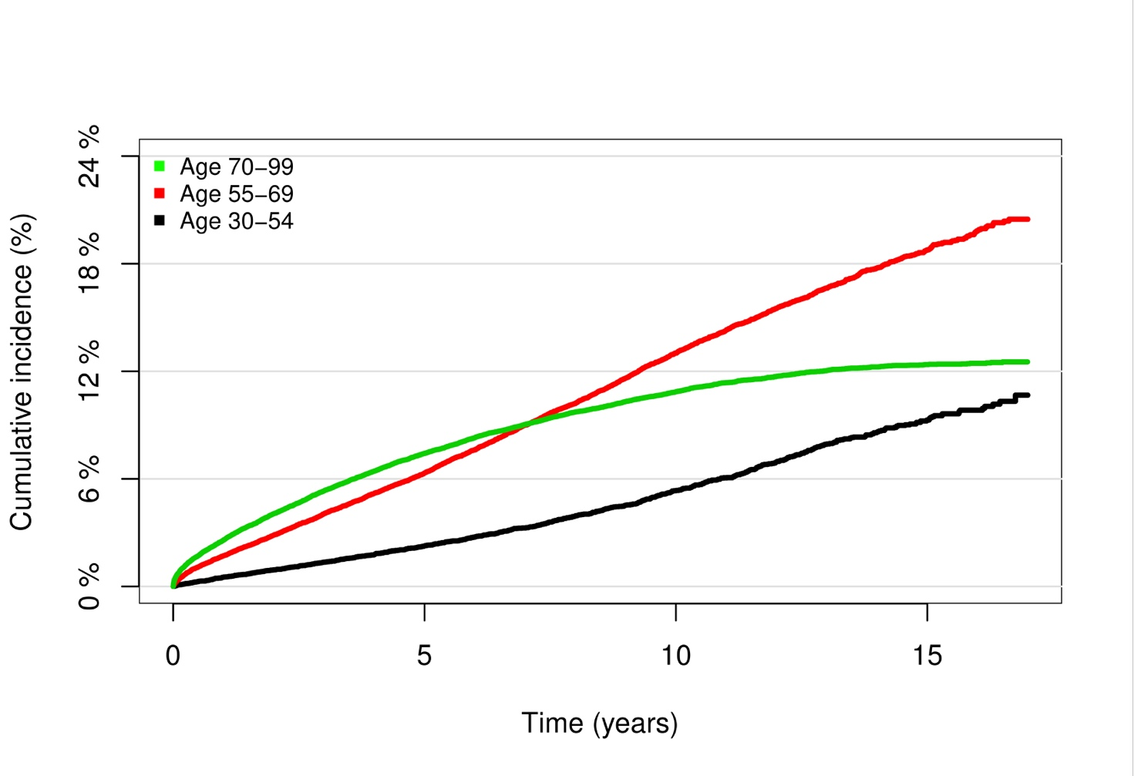
N.B. The y-axis is narrower than in Supplemental figure 3.

Additional file 1: figure S3. Cumulative incidence of death stratified by age group in the MI population.
