Distinct contributions of hyperglycemia and high-fat feeding in metabolic syndrome-induced neuroinflammation

Brooke J. Wanrooy¹, Kathryn Prame Kumar¹, Shu Wen Wen¹, Cheng Xue Qin², Rebecca Ritchie^{2, 3}, and Connie H. Y. Wong^{1,} *

¹ Centre for Inflammatory Diseases, Department of Medicine, School of Clinical Sciences at Monash Health, Monash Medical Centre, Monash University, Clayton, Victoria, Australia;
² Baker Heart and Diabetes Institute, Melbourne, Australia;
³ Department of Diabetes, Monash University, Melbourne, Australia

*Address for correspondence: Connie H. Y. Wong, PhD., Centre for Inflammatory Diseases, Department of Medicine, School of Clinical Sciences at Monash Health, Monash Medical Centre, Monash University, Clayton, VIC 3168 Australia; Email: connie.wong@monash.edu

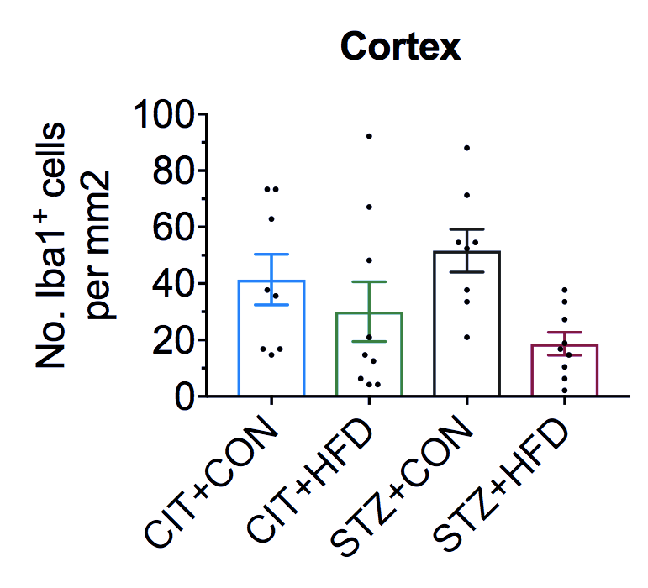

Figure S1: Microglial numbers in cortex was unchanged after 9 weeks. Cell counts of Iba1⁺ microglia in the cortex. Data represent mean ± S.E.M. of n = 8-10 per group.

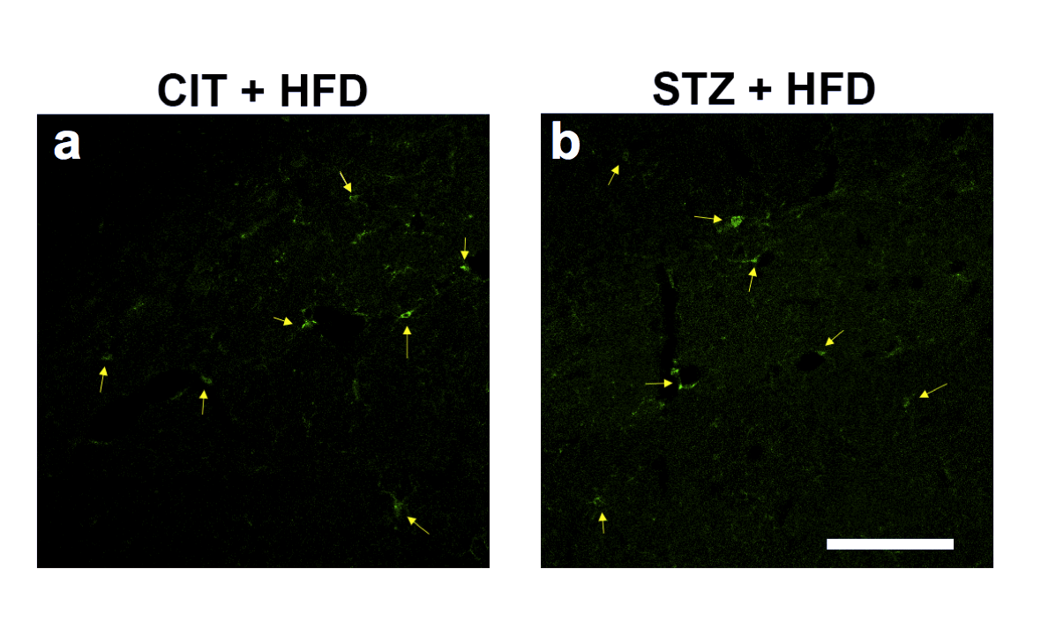
Figure S2: Representative coronal brain sections for immunofluorescence detection of Iba1⁺ microglia (green, denoted by yellow arrow) in the hippocampus of (a) CIT+HFD and (b) STZ+HFD mice. Scale bar, 100 μm.

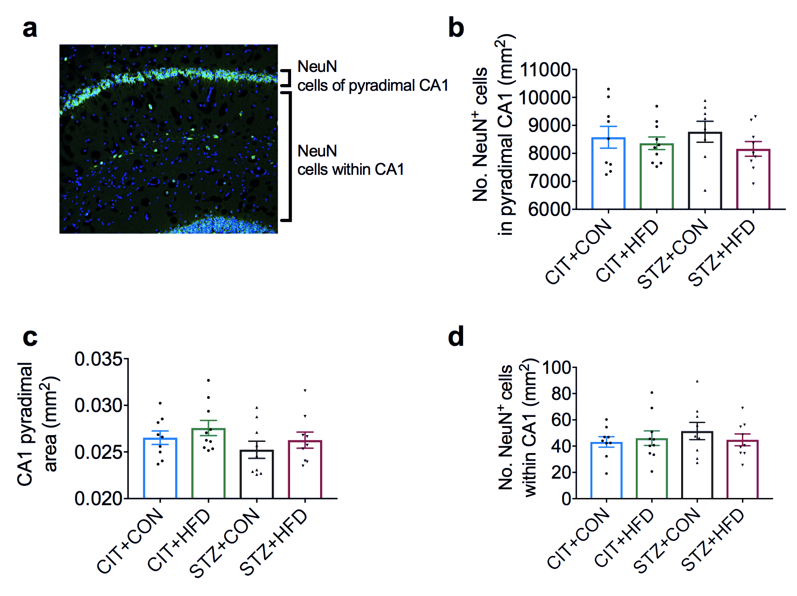

Figure S3: Neuronal numbers of CA1 hippocampus unchanged after 9-weeks of treatment. (a) Schematic diagram of the designated quantification area for neuronal counts. (b) Number of neurons in the pyramidal layer of CA1. (c) Area of pyramidal layer of CA1 (d) Number of neurons within CA1. Data represent mean ± S.E.M. of n = 8-10 per group.

