**Immunosenescence in a captive semelparous marsupial, the red-tailed phascogale (*Phascogale calura*)**

C. Letendre, E. J. Sawyer, L. J. Young and J. M. Old*

\***Correspondence:** Julie M. Old; J.Old@westernsydney.edu.au

**Table S1.** Biometric measurements

**Table S2.** Microhematocrit and plasma total protein concentration

**Table S3.** Total WBC counts and WBC differential counts

**Figure S1.** Splenic tumor of benign appearance in a 5-year-old female

**Figure S2.** Histological scorings of the splenic white pulp across different age-sex groups

**Table S1.** Biometric measurements

|  |  |  |  |  |  |
| --- | --- | --- | --- | --- | --- |
|  | **Age (months)** | **Date** | **Body weight (g)** | **Body condition score ( /5)** | **Scrotal width (mm)** |
| *Females* | | | | | |
| Juveniles | 3 | Oct | 23.0 ± 0.0 (1) | 3.0 ± 0.0 (1) | - |
| 5 | Dec | 29.7 ± 2.7 (3) | 3.0 ± 0.0 (3) | - |
| 6 | Jan | 30.3 ± 1.2 (3) | 3.0 ± 0.0 (3) | - |
| 8 | March | 38.0 ± 0.0 (1) | 3.0 ± 0.0 (1) | - |
| 9 | April | 41.0 ± 0.0 (1) | 3.0 ± 0.0 (1) | - |
| Breeding | 11  12  13 | June  July  Aug | 36.0 ± 0.0 (1)  37.4 ± 0.5 (5)  37.3 ± 1.3 (4) | 3.0 ± 0.0 (1)  3.0 ± 0.0 (5)  2.8 ± 0.1 (4) | -  -  - |
| 1+ year | 14 | Sept | 44.3 ± 1.3 (4) | 3.0 ± 0.2 (4) | - |
| 24 | July | 39.0 ± 0.0 (1) | 3.0 ± 0.0 (1) | - |
| 25 | Aug | 34.0 ± 0.0 (1) | 3.0 ± 0.0 (1) | - |
| 37 | Aug | 36.7 ± 0.8 (6) | 2.9 ± 0.2 (6) | - |
| 38 | Sept | 34.0 ± 0.0 (1) | 2.5 ± 0.0 (1) | - |
| 41 | Dec | 36.3 ± 4.9 (3) | 2.8 ± 0.2 (3) | - |
| 42 | Jan | 37.3 ± 3.5 (3) | 3.0 ± 0.0 (3) | - |
| 46 | May | 39.0 ± 1.7 (3) | 3.2 ± 0.2 (3) | - |
| 49 | Aug | 41.0 ± 0.0 (1) | 3.5 ± 0.0 (1) | - |
| 57 | April | 37.0 ± 3.0 (2) | 2.5 ± 0.5 (2) | - |
| 62 | Sept | 37.0 ± 0.0 (1) | 2.0 ± 0.0 (1) | - |
|  |  |  |  |  |  |
| *Males* | | | | | |
| Juveniles | 4 | Nov | 41.0 ± 0.0 (1) | 3.0 ± 0.0 (1) | 6.0 ± 0.0 (1) |
| 5 | Dec | 43.0 ± 3.1 (3) | 3.0 ± 0.0 (3) | 8.0 ± 0.6 (3) |
| 6 | Jan | 42.7 ± 1.5 (3) | 3.3 ± 0.2 (3) | 9.7 ± 0.3 (3) |
| 8 | March | 61.0 ± 0.0 (1) | 3.5 ± 0.0 (1) | 11.0 ± 0.0 (1) |
| Breeding | 10  12  13 | May  July  Aug | 60.8 ± 2.3 (9)  58.2 ± 3.7 (5)  55.8 ± 2.2 (17) | 3.3 ± 0.2 (9)  3.1 ± 0.2 (5)  3.5 ± 0.1 (17) | 12.4 ± 0.2 (9)  10.0 ± 0.2 (5)  10.6 ± 0.2 (17) |
| 1+ year | 16 | Nov | 60.0 ± 0.0 (1) | 3.5 ± 0.0 (1) | 12.0 ± 0.0 (1) |
| 17 | Dec | 57.7 ± 7.1 (3) | 3.3 ± 0.4 (3) | 12.0 ± 0.3 (3) |
| 18 | Jan | 59.0 ± 4.6 (4) | 3.4 ± 0.2 (4) | 11.8 ± 0.3 (4) |
| 20 | March | 64.0 ± 0.0 (1) | 3.5 ± 0.0 (1) | 12.0 ± 0.0 (1) |
| 21 | April | 58.8 ± 2.4 (5) | 3.4 ± 0.1 (5) | 11.6 ± 0.4 (5) |
| 22 | May | 59.0 ± 2.0 (2) | 3.0 ± 0.0 (2) | 10.5 ± 0.5 (2) |
| 25 | Aug | 89.0 ± 0.0 (1) | 5.0 ± 0.0 (1) | 9.5 ± 0.0 (1) |
| 26 | Sept | 56.0 ± 0.0 (1) | 3.0 ± 0.0 (1) | 9.0 ± 0.0 (1) |

**Table S2.** Microhematocrit and plasma total protein concentration

|  |  |  |  |  |
| --- | --- | --- | --- | --- |
|  | **Age (months)** | **Date** | **PCV (L/L)** | **Total proteins (g/dL)** |
| *Females* | | | | |
| Juveniles | 3 | Oct | 46.0 ± 0.0 (1) | - |
| 5 | Dec | 50.0 ± 1.5 (3) | 5.6 ± 0.2 (3) |
| 6 | Jan | 51.0 ± 1.5 (3) | 5.5 ± 0.1 (3) |
| 8 | March | 53.0 ± 0.0 (1) | 6.3 ± 0.0 (1) |
| 9 | April | 51.0 ± 0.0 (1) | 6.1 ± 0.0 (1) |
| Breeding | 11  12  13 | June  July  Aug | 56.0 ± 0.0 (1)  54.0 ± 1.5 (3)  51.0 ± 1.0 (2) | 6.3 ± 0.0 (1)  -  6.0 ± 0.1 (2) |
| 1+ year | 14 | Sept | 53.3 ± 1.0 (4) | 5.9 ± 0.0 (1) |
| 37 | Aug | 48.8 ± 1.6 (4) | 6.0 ± 0.2 (4) |
| 38 | Sept | 49.0 ± 0.0 (1) | 5.7 ± 0.0 (1) |
| 41 | Dec | 48.7 ± 0.7 (3) | 5.9 ± 0.2 (3) |
| 42 | Jan | 45.7 ± 1.7 (3) | 5.5 ± 0.2 (3) |
| 46 | May | 50.3 ± 0.7 (3) | 5.7 ± 0.1 (3) |
| 49 | Aug | 51.0 ± 0.0 (1) | 5.9 ± 0.0 (1) |
| 57 | April | 43.0 ± 0.0 (1) | 6.1 ± 0.0 (1) |
| 62 | Sept | 46.0 ± 0.0 (1) | - |
|  |  |  |  |  |
| *Males* | | | | |
| Juveniles | 5  6  8 | Dec  Jan  March | 54.7 ± 1.3 (3)  55.0 ± 1.2 (3)  58.0 ± 0.0 (1) | 6.5 ± 0.1 (3)  6.6 ± 0.1 (3)  6.8 ± 0.0 (1) |
| Breeding | 10  12  13 | May  July  Aug | 58.3 ± 1.6 (9)  61.0 ± 1.0 (2)  60.1 ± 0.9 (12) | 6.8 ± 0.1 (8)  6.6 ± 0.0 (1)  6.9 ± 0.1 (10) |
| 1+ year | 17 | Dec | 53.7 ± 0.3 (3) | 6.2 ± 0.2 (3) |
| 18 | Jan | 55.5 ± 1.0 (4) | 6.3 ± 0.0 (4) |
| 20 | March | 60.0 ± 0.0 (1) | 7.0 ± 0.0 (1) |
| 21 | April | 62.4 ± 1.5 (5) | 7.0 ± 0.1 (5) |
| 22 | May | 64.0 ± 1.0 (2) | 6.8 ± 0.1 (2) |
| 25 | Aug | 59.0 ± 0.0 (1) | - |

**Table S3.** Total WBC counts and WBC differential counts

|  |  |  |  |  |  |  |
| --- | --- | --- | --- | --- | --- | --- |
|  | **Age (months)** | **Date** | **Total WBC (109 cells/L)** | **Lymphocytes**  **(%)** | **Neutrophils**  **(%)** | **Monocytes**  **(%)** |
| *Females* | | | | | | |
| Juveniles | 3 | Oct | 5.1 ± 0.0 (1) | 90 ± 0 (1) | 6 ± 0 (1) | 3 ± 0 (1) |
| 5 | Dec | - | 85 ± 2 (3) | 11 ± 1 (3) | 4 ± 1 (3) |
| 6 | Jan | - | 83 ± 2 (3) | 12 ± 2 (3) | 4 ± 0 (3) |
| 8 | March | 5.8 ± 0.0 (1) | 83 ± 0 (1) | 10 ± 0 (1) | 5 ± 0 (1) |
| 9 | April | 3.3 ± 0.0 (1) | 81 ± 0 (1) | 16 ± 0 (1) | 3 ± 0 (1) |
| Breeding | 11  12  13 | June  July  Aug | 6.1 ± 0.0 (1)  4.3 ± 0.9 (5)  5.4 ± 1.0 (4) | 80 ± 0 (1)  81 ± 2 (5)  74 ± 4 (4) | 13 ± 0 (1)  14 ± 2 (5)  24 ± 4 (4) | 1 ± 0 (1)  5 ± 1 (5)  2 ± 0 (4) |
| 1+ year | 14 | Sept | 5.4 ± 0.8 (4) | 84 ± 2 (4) | 13 ± 1 (4) | 2 ± 1 (4) |
| 24 | July | - | 72 ± 0 (1) | 23 ± 0 (1) | 2 ± 0 (1) |
| 37 | Aug | 3.6 ± 0.4 (4) | 74 ± 4 (4) | 20 ± 2 (4) | 3 ± 1 (4) |
| 38 | Sept | 7.1 ± 0.0 (1) | 84 ± 0 (1) | 12 ± 0 (1) | 4 ± 0 (1) |
| 41 | Dec | - | 76 ± 5 (3) | 16 ± 5 (3) | 6 ± 2 (3) |
| 42 | Jan | - | 74 ± 4 (3) | 19 ± 2 (3) | 6 ± 1 (3) |
| 46 | May | 3.7 ± 0.5 (3) | 76 ± 3 (3) | 20 ± 1 (3) | 3 ± 1 (3) |
| 49 | Aug | 3.1 ± 0.0 (1) | 77 ± 0 (1) | 20 ± 0 (1) | 3 ± 0 (1) |
| 57 | April | - | 78 ± 4 (2) | 20 ± 5 (2) | 2 ± 0 (2) |
| 62 | Sept | 5.3 ± 0.0 (1) | 77 ± 0 (1) | 14 ± 0 (1) | 8 ± 0 (1) |
|  |  |  |  |  |  |  |
| *Males* | | | | | | | |
| Juveniles | 5  6  8 | Dec  Jan  March | 3.9 ± 0.0 (1)  3.6 ± 0.0 (1)  3.7 ± 0.0 (1) | 84 ± 2 (3)  84 ± 4 (3)  74 ± 0 (1) | 8 ± 1 (3)  13 ± 3 (3)  15 ± 0 (1) | 5 ± 1 (3)  3 ± 1 (3)  6 ± 0 (1) |
| Breeding | 10  12  13 | May  July  Aug | 3.6 ± 0.4 (9)  3.9 ± 0.3 (5)  3.0 ± 0.3 (12) | 50 ± 3 (9)  56 ± 6 (5)  49 ± 3 (12) | 42 ± 4 (9)  39 ± 6 (5)  43 ± 2 (12) | 6 ± 1 (9)  5 ± 1 (5)  6 ± 1 (12) |
| 1+ year | 17 | Dec | - | 65 ± 2 (3) | 26 ± 2 (3) | 7 ± 2 (3) |
| 18 | Jan | - | 63 ± 3 (4) | 28 ± 3 (4) | 7 ± 1 (4) |
| 20 | March | 2.5 ± 0.0 (1) | 64 ± 0 (1) | 24 ± 0 (1) | 5 ± 0 (1) |
| 21 | April | 2.0 ± 0.2 (3) | 60 ± 4 (5) | 32 ± 4 (5) | 7 ± 1 (5) |
| 22 | May | 2.0 ± 0.2 (2) | 54 ± 2 (2) | 29 ± 4 (2) | 17 ± 3 (2) |
| 25 | Aug | 2.2 ± 0.0 (1) | 48 ± 0 (1) | 39 ± 0 (1) | 7 ± 0 (1) |

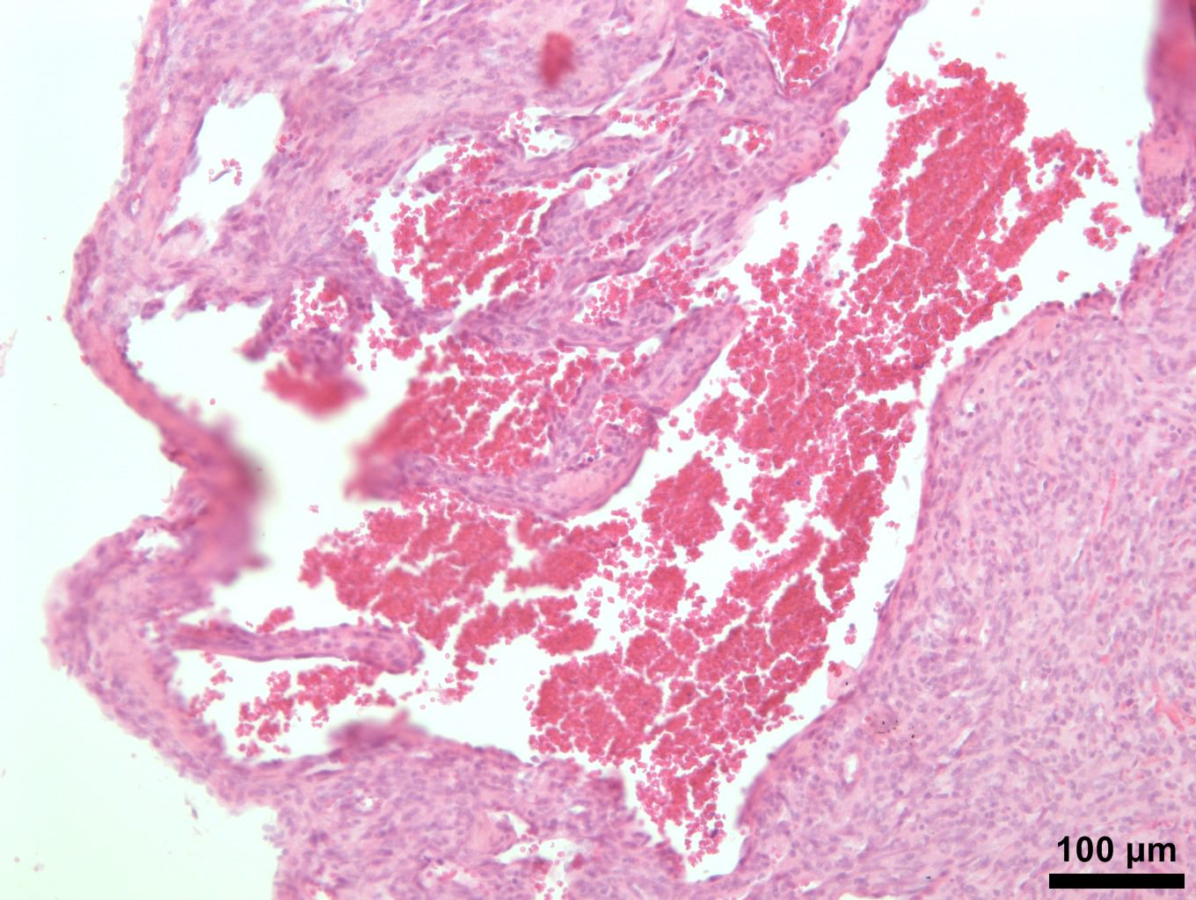

**Figure S1.** Splenic tumor of benign appearance in a 5-year-old female; 9-µm section (100X). Section shows large, dilated vascular spaces filled with RBC. Scale bar represent 100 µm.



**Figure S2.** Histological scorings of the splenic white pulp across different age-sex groups (n = 6). Spleens were evaluated using a 4-grade scale for four parameters: size of the white pulp (atrophy), presence of germinal centers, size of the follicles and width of the marginal zone. Individual data are plotted and the median for each group is illustrated. # indicate a statistically significant difference compared to juvenile animals (*P* < 0.05).