Supplementary Material
Methods
Immunoblotting for anti-cystathionine-γ-lyase (CSE; St John’s Laboratory, London, UK) was performed as described previously (Hartmann et al. 2018). Primary antibodies were detected by using horseradish peroxidase-conjugated secondary antibodies (Cell Signaling, Danvers, MA, USA or Santa Cruz, Dallas, TX, USA). Anti-β-actin (Santa Cruz, Dallas, TX, USA) served as a loading control. Densitometry measurements were performed using NIH Image J software (http://rsb.info.nih.gov/nih-image), results are presented as densitometric sum.

Supplemental Tables
Table S1: Systemic physiologic parameters, as previously published in [20].
 |  |  | baseline | 24 h | Ref. Value
NoA  (µg·kg⁻¹·min⁻¹)* | Sham | n=5 | 0.06 (0.02; 0.13) |  | n.a.
 | sepsis | n=6 | 1.23 (0.66; 3.26)^{b}
Hemoglobin (g/dl) | sham | n=5 | 8.8 (8.6; 9.4) | 9.2 (9.1; 9.8) | 12.3-15.3
 | sepsis | n=8 | 8.9 (8.5; 9.7) | 11.7 (11.1; 12.3)^{a,b}
Heart rate (bpm) | sham | n=5 | 88 (73; 104) | 102 (68; 115) | < 160
 | sepsis | n=8 | 88 (74; 106) | 156 (140; 166)^{a,b}
Mean arterial pressure (mmHg) | sham | n=5 | 100 (90; 106) | 103 (94; 119) | max. +/- 10% of baseline
 | sepsis | n=8 | 103 (91; 112) | 65 (61; 81)^{a,b}
Central venous pressure (mmHg) | sham | n=5 | 8 (7; 13) | 10 (9; 15)ª | < 18
 | sepsis | n=8 | 10 (6; 13) | 17 (14; 18)ª
Cardiac output (ml·kg⁻¹·min⁻¹) | sham | n=5 | 61 (52; 79) | 64 (42; 92) | n.a.
 | sepsis | n=8 | 64 (52; 69) | 87 (62; 130)ª
PaO₂ (mmHg) | sham | n=5 | 158 (142; 180) | 159 (138;177) | n.a.#
 | sepsis | n=8 | 170 (161; 183) | 93 (62; 155)^{a,b}
PaCO₂ (mmHg) | sham | n=5 | 35 (35; 39) | 35 (33; 36) | 35-40
 | sepsis | n=8 | 38 (34; 40) | 35 (32; 44)
arterial pH | sham | n=5 | 7.46 (7.44; 7.46) | 7.44 (7.43; 7.46) | 7.35-7.45
 | sepsis | n=8 | 7.45 (7.43; 7.48) | 7.37 (7.19; 7.43)^{a,b}
Base excess (mmol/l) | sham | n=5 | 1.1 (0.8; 1.8) | -0.1(-1.45; 0.65) | -2.0 to +2.0
 | sepsis | n=8 | 1.5 (0.4; 2.3) | -8.5 (-14.6; -3.7) ^{a,b}
Lactate (mmol/l) | sham | n=5 | 1.4 (1.0; 1.6) | 0.6 (0.6; 1.2) | < 2.0
 | sepsis | n=8 | 0.8 (0.6; 1.5) | 6.1 (2.0; 10.7) ^{a,b}
Data given as median (interquartile range). * NoA is administered based on mean arterial pressure (see Methods section) during the septic shock, # mechanical ventilation adjusted according to our previous work (if PaO₂/FiO₂ < 300mmHg = inspiratory/expiratory ratio 1:1, PEEP 12cm H₂O; if PaO₂/FiO₂ < 200mmHg = PEEP 15cm H₂O [10,19,26]), a p<0.05 in comparison to baseline, b p<0.05 in comparison to sham in two-way ANOVA

Table S2: Renal vein blood analysis, as previously published in [19,26].
 |  | baseline | 24h peritonitis
O₂ saturation (%) | sham | 83 (81; 83) | 83 (78; 84)
 | sepsis | 84 (78; 87) | 66 (45; 83)
pH | sham | 7.45 (7.44; 7.45) | 7.42 (7.42; 7.44)
 | sepsis | 7.42 (7.42; 7.44) | 7.28 (7.12; 7.36)^{a,b}
Base excess (mmol/l) | sham | 1.8 (1.8; 2.4) | 1.1 (0.7; 1.2)
 | sepsis | 1.8 (1.0; 3.1) | -4.9 (-12.0; -2.2)^{a,b}
Lactate (mmol/l) | sham | 1.1 (1.0; 1.2) | 1.0 (0.7; 1.2)
 | sepsis | 1.0 (0.7; 1.4) | 4.7 (2.5; 8.9)^{a,b}
IL6 (ng/g_{protein}) | sham | 1.7 (1.3; 1.7) | 6.9 (1.7; 7.9)
 | sepsis | 2.0 (1.8; 2.1) | 1153.4 (236.4; 2002.5)^{a,b}
TNFα (ng/g_{protein}) | sham | 0.8 (0.6; 1.2) | 1.6 (1.3; 2.0)
 | sepsis | 0.8 (0.7; 1.2) | 15.3 (5.9; 21.7)^{a,b}
Data given as median (interquartile range). a p<0.05 in comparison to baseline, b p<0.05 in comparison to sham in two-way ANOVA

Table S3: R² values for correlations with (unpooled) separate groups, respectively.
 | CrCl  (ml/min) |  | OxPhos  jO₂ (pmol·s⁻¹·mg⁻¹) |  | PGC1α expression |  | albumin extravasation |  | nitrotyrosine formation
 | sham | sepsis | sham | sepsis | sham | sepsis | sham | sepsis | sham | sepsis
NoA infusion  (µg·kg⁻¹·min⁻¹) | 0.36 | 0.49 | n.a. | 1
OxPhos  jO₂ (pmol·s⁻¹·mg⁻¹) | n.a. | 0.89
CSE expression | 0.86 | 0.20 | 0.24 | 0.62 | 0.57 | 0.09 | 0.73 | 0.02 | 0.02 | 0.47
nitrotyrosine formation |  |  | 0.85 | 0.84

Supplemental Figure S1
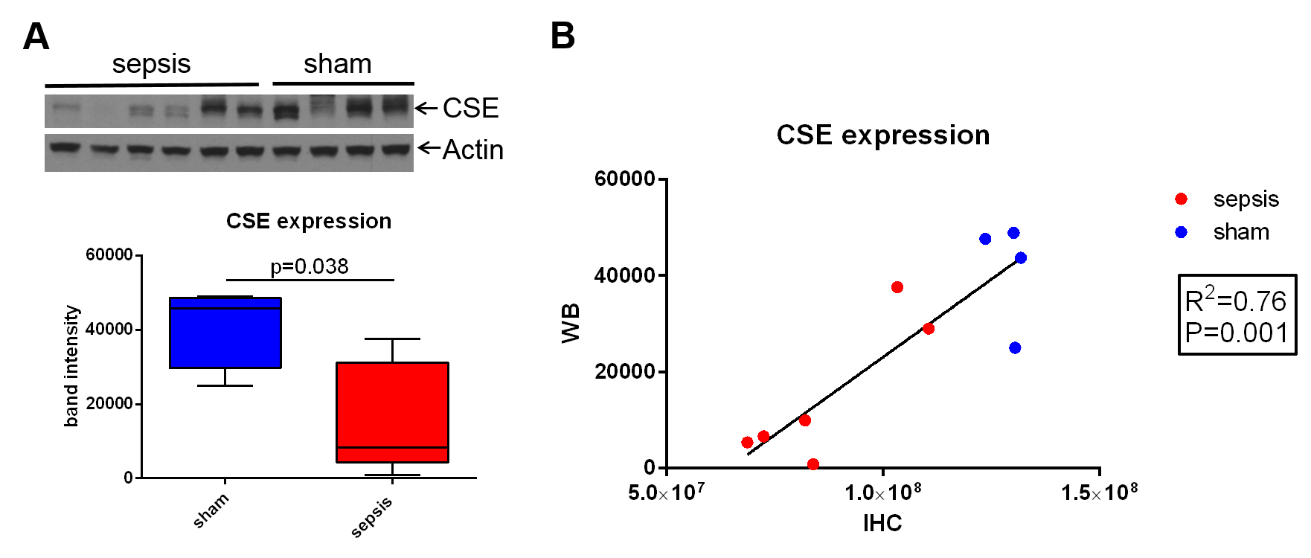
Figure S1: Kidney CSE protein expression levels for sham vs. sepsis, detected by western blot (WB, A) correlate with kidney CSE expression levels detected by immunohistochemistry (IHC, B).

References
Hartmann C, Gröger M, Noirhomme JP, Scheuerle A, Möller P, Wachter U, Huber-Lang M Nussbaum B, Jung B, Merz T, McCook O, Kress S, Stahl B, Calzia E, Georgieff M, Radermacher P, Wepler M. In-Depth Characterization of the Effects of Cigarette Smoke Exposure on the Acute Trauma Response and Hemorrhage in Mice. Shock. 2018. Volume Publish Ahead of Print.

