Supplemental Data

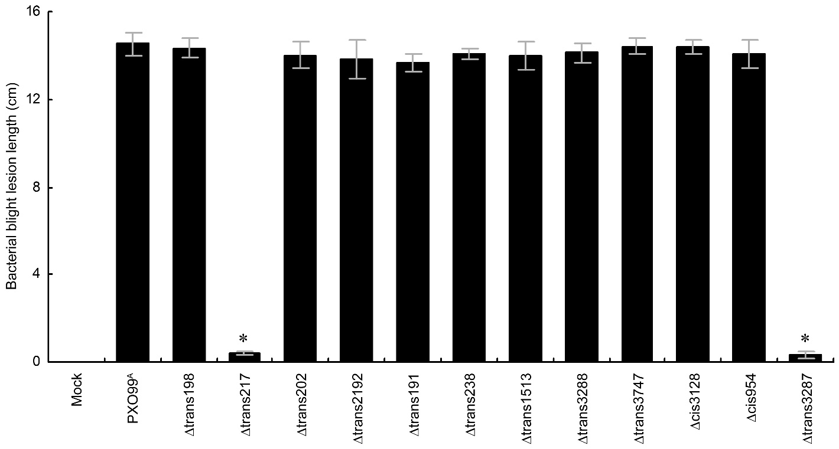
Additional file 2: Figure S1. Bacterial blight severities of the susceptible rice variety Nipponbare inoculated with sRNA-related strains. Leaves of two-month old rice plant were clipped using sterile scissors which had been dipped in the bacterial cultures (OD₆₀₀ ≈ 0.5) at a distance of about 2 cm from the leaves edge. Each strain was inoculated in 5 plants and 10 leaves of each plant were tested. Lesion length was scored two weeks after inoculation and the average was calculated. Data shown are means ± standard deviation bars of 3 independent experiments, each containing 5 plants and 10 leaves. Asterisks indicate significant differences in multiple comparison of the data (P < 0.01).

