**Quantitative analysis of the growth of individual *Bacillus coagulans* cells by microdroplets technology**

Xudong Zhu1, Xiang Shi1, Ju Chu1, Bangce Ye1, Peng Zuo1*, Yonghong Wang1*

1 State Key Laboratory of Bioreactor Engineering, College of Biotechnology, East China University of Science and Technology, Shanghai, CN

**Correspondence:** State Key Laboratory of Bioreactor Engineering, East China University of Science and Technology, P.O.Box 329, 130 Meilong Road, Shanghai 200237, China. Tel.: +86 21 64253021; Fax: +86 21 64253702.

**E-mail**: Xudong Zhu1, zhuxudonglife@163.com; Xiang Shi1, xiangshi@mail.ecust.edu.cn; Ju Chu1, [juchu@ecust.edu.cn](mailto:juchu@ecust.edu.cn);

Bangce Ye1, bcye@ecust.edu.cn;

**Corresponding author:** Peng Zuo1*, [pzuo@ecust.edu.cn](mailto:pzuo@ecust.edu.cn); Yonghong Wang1*

yhwang@ecust.edu.cn

**Additional file 1: Fig. S1**

The identification of hyphae was done manually. Pixels statistics was automatic. As shown in Fig. S3, the photos were transfer to a white-black picture by adjusting its “threshold” in Photoshop. Then hyphae in black was selected semi-manually with the help of “Wand” (a tool in Photoshop) and the pixels were automatically counted.

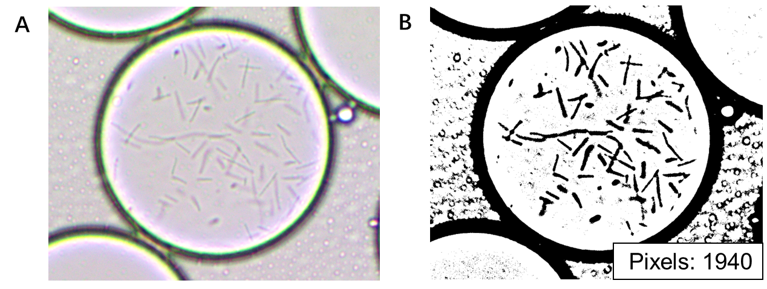

Fig. S1 The method of pixels counting. (A) Original photo of the droplets. (B) Adjusted image by adjusting the “threshold” and the pixels were automatically counted.

**Additional file 1: Fig. S2**



Fig. S2, The growth curve of *Bacillus coagulans* in shake flask without (black) and with pHrodo (red). The data was obtained from three parallel experiments for each.

**Additional file 1: Fig. S3**

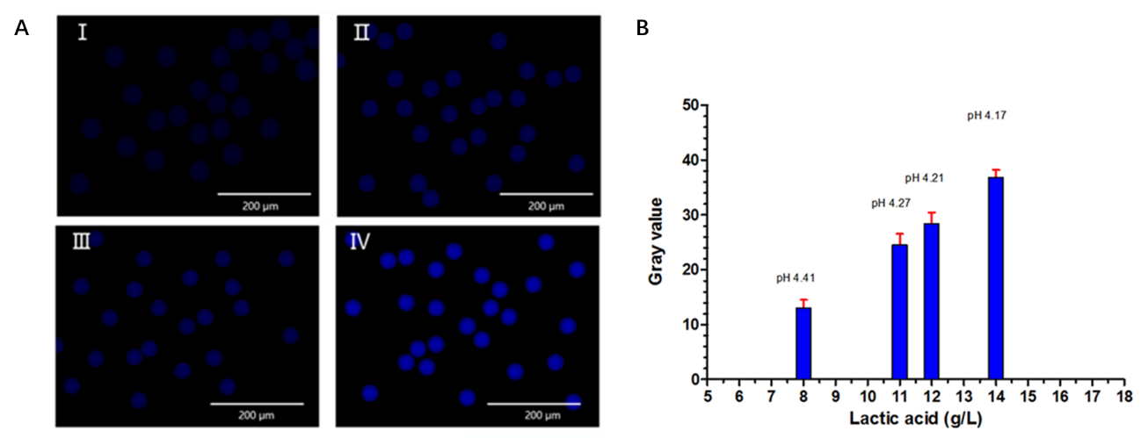

Fig. S3. Lactic acid assay in microdroplets. (A) Fluorescence imaging of microdroplets containing broth with a range of lactic acid, 8 g/L (I), 11 g/L (II), 12 g/L (III), 14 g/L (IV). (B) The corresponding average grey value derive from the fluorescence intensity of the microdroplets in the images of Fig. S1 A.