Additional file 1

Table S1 Characteristics of four embryos after in vitro fertilization. The four embryos were scored according to the Istanbul consensus. Embryo No.1 was transplanted.

Embryo | Detection results of G6PC gene |  | Results of STR loci analysis | Diagnosis result
 | c.326 G>A | chr17g.41049879_41057003
No. 1 Grade: 5BB | Heterozygous | NO | The embryo inherited the maternal risk allele, the paternal non-risk allele. | Carrier
No. 2 Grade: 5BB | Heterozygous | NO | There are three alleles in D17S760 | Partial trisomy
No. 3 Grade: 4BC | Heterozygous | NO | The embryo inherited the maternal risk allele, the paternal non-risk allele. | Carrier
No. 4 Grade: 4BB | Heterozygous | NO | The embryo inherited the maternal risk allele, the paternal non-risk allele. | Carrier

Figure S1. Sanger sequencing on the blood samples (left panel) and sperm samples (right panel) of the father, to determine whether germline mosaicism on c.326G>A is present. However, the results were inconclusive, and indeed a small peak of A allele and an even smaller peak for C allele is present at the c.326 position.
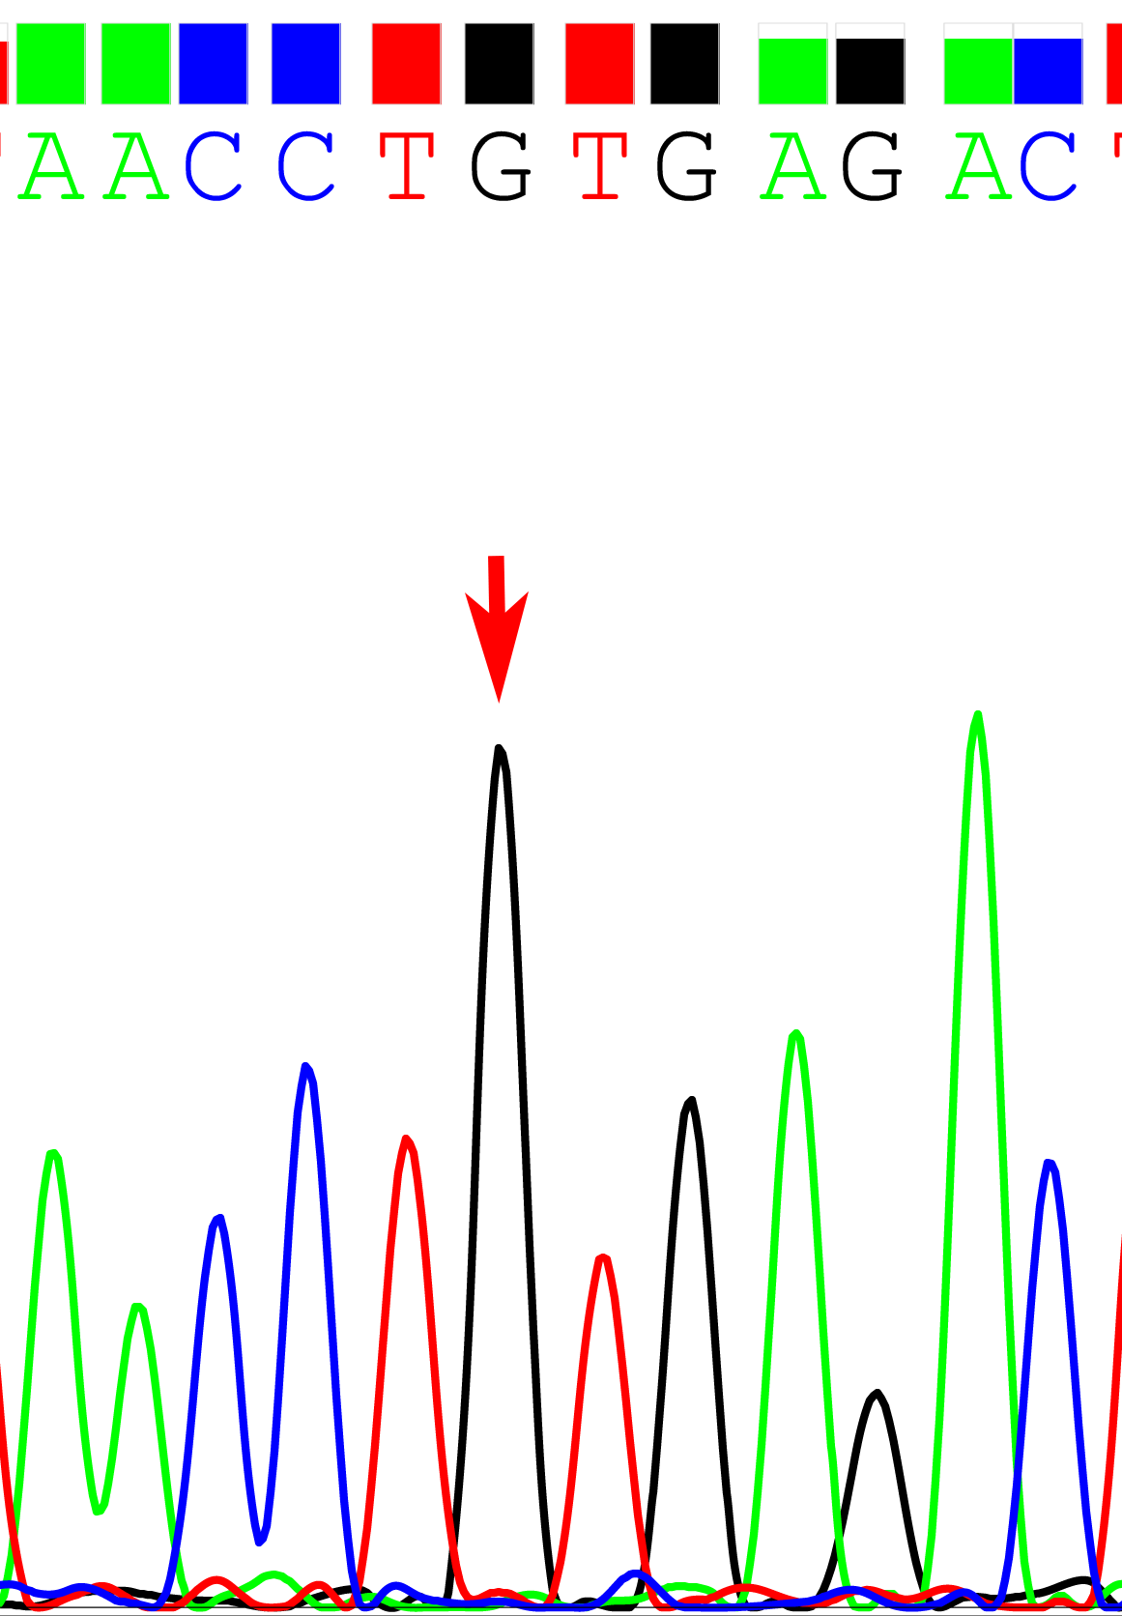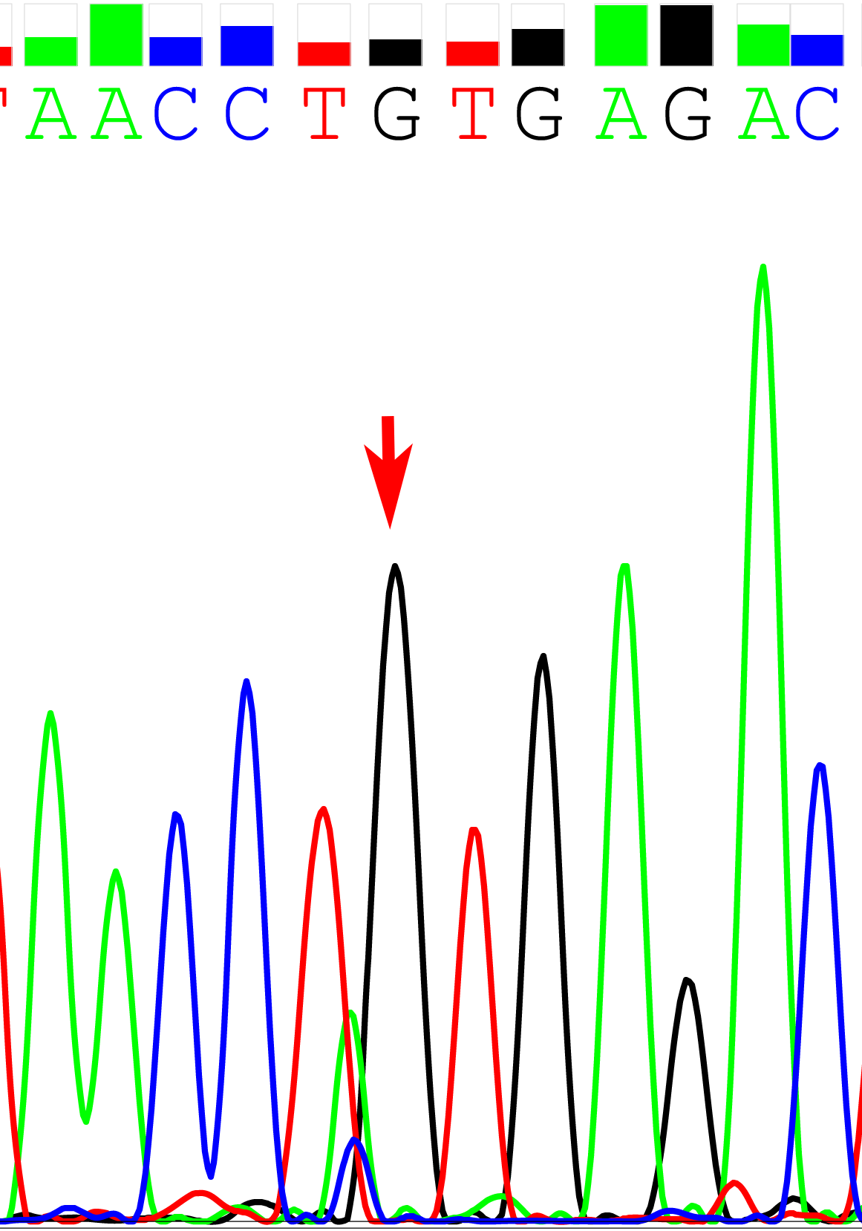

Figure S2. Image of type-B ultrasonic of liver on the newborn baby. B-ultrasonogram showed that the liver and kidneys were normal. SP: Spleen; LK: Left kidney.

