Table S1. Detailed profile of the 18F-FDG PET scanners for patients with LGI1-antibody encephalitis
Patient ID | 18F-FDG PET Scanner | Institution
1 | Discovery STE (General Electric Medical Systems, Milwaukee, WI, USA) | Seoul National University Bundang Hospital
2 | Biograph 40 (Siemens Medical Solutions USA, Knoxville, TN, USA) | Seoul National University Hospital
3 | SOMATOM Definition AS (Siemens healthcare, Erlangen, Germany) | Seoul National University Hospital
4 | SOMATOM Definition AS (Siemens healthcare, Erlangen, Germany) | Seoul National University Hospital
5 | SOMATOM Definition AS (Siemens healthcare, Erlangen, Germany) | Seoul National University Hospital
6 | SOMATOM Definition AS (Siemens healthcare, Erlangen, Germany) | Seoul National University Hospital
7 | Biograph 40 (Siemens Medical Solutions USA, Knoxville, TN, USA) | Seoul National University Hospital
8 | Allegro (Philips Medical Systems, Cleveland, OH, USA) | Korea University Ansan Hospital
9 | Biograph 40 (Siemens Medical Solutions USA, Knoxville, TN, USA) | Seoul National University Hospital
10 | Biograph 64 (Siemens Medical Solutions USA, Knoxville, TN, USA) | Seoul National University Hospital
11 | Biograph 40 (Siemens Medical Solutions USA, Knoxville, TN, USA) | Seoul National University Hospital
12 | SOMATOM Definition AS (Siemens healthcare, Erlangen, Germany) | Seoul National University Hospital
13 | Biograph 64 (Siemens Medical Solutions USA, Knoxville, TN, USA) | Seoul National University Hospital
18F-FDG PET=18F-fluorodeoxyglucose positron emission tomography;

Table S2. Detailed profile of the autopsy samples
Sample ID | Institution | Age | Sex | Handedness | Neuropathology | Autolysis time (hours)
1 | Sepulveda Research | 61 | M | N/A | Normal | 19.5
2 | Sepulveda Research | 77 | M | Right | Hypoxic change, intermediate, cerebrum | 15.5
3 | Sepulveda Research | 59 | M | N/A | Normal | 20.3
4 | Sepulveda Research | 72 | M | Right | Aging, incidental changes consistent with aging | 12.2
5 | University of Miami | 50 | M | N/A | Normal | 16.5
6 | University of Miami | 75 | M | Right | Normal | 14.2
7 | University of Miami | 71 | F | N/A | Normal | 16.4
8 | University of Miami | 79 | F | Right | Normal | 17.8
9 | University of Miami | 30 | M | Right | Normal | 20.8

Table S3 Semiology of the patients with LGI1-antibody encephalitis
Patient ID | Semiology | Hemisphere Localization
1 | Ictal speech
2 | Secondary GTCS, starting with left eyeball deviation | Right
3 | Secondary GTCS, starting with right hand tonic posture | Left
4 | Myoclonus at both legs (Right>Left) | Bilateral
5 | Déjà vu, gelastic seizure
6
7 | Right eyeball deviation, Right neck version | Left
8 | Goose bump at whole body
9
10 | Dystonic posture at both hands | Bilateral
11 | Lip smacking, febrile sensation at face
12
13

Table S4 Overall literature review of asymmetric abnormality in patients with ADPEAF
 | EEG (No./No.) | MRI (No./No.)
Di Bonaventura et al. (2009) | Left (3/3, 100%)
Ottman et al. (2008) |  | Left*
Tessa et al. (2007) |  | Left†
Brodtkorb et al. (2005) | Left (8/8, 100%)‡
Pizzuti et al. (2003) | Left (2/4, 50%) vs Bilateral (1/4, 25%) vs Normal (1/4, 25%)
Kobayashi et al. (2003) |  | Left (10/22, 45.5%) vs Normal (12/22, 54.5%)
Left and right indicate the abnormal hemisphere. ADPEAF=autosomal dominant partial epilepsy with auditory features; EEG=electroencephalography; MRI=magnetic resonance imaging; No.= number of subjects; Empty cells indicate non-lateralized result or not available data; *functional MRI analysis during auditory description decision task in 8 patients compared with 20 healthy control subjects; †voxel-based analysis in 8 patients compared with 24 healthy control subjects; ‡Auditory evoked potentials analysis.

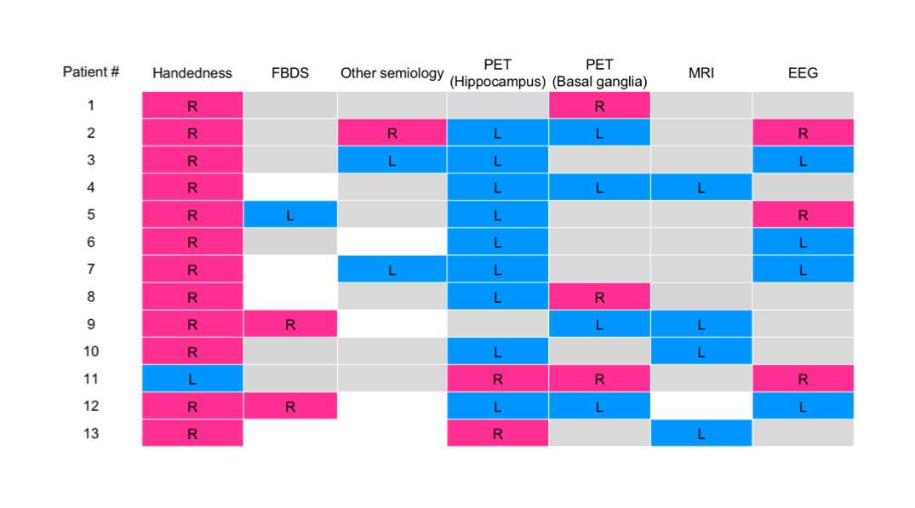
Figure S1 Summary of pre-treatment clinical and laboratory laterality in patients with LGI1-antibody encephalitis. Each row indicates patients with LGI1-antibody encephalitis, and each column indicates the clinical and diagnostic information of the patients. Colour indicates the laterality of each item in the column: pink=right side; blue=left side; grey=no laterality; white=no symptoms or not available. R=right; L=left; FBDS=faciobrahial seizure.

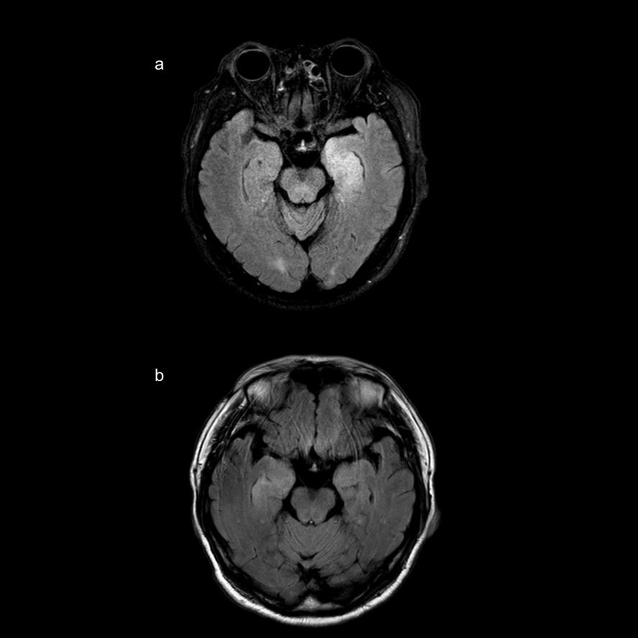

Figure S2 T2-weighted FLAIR MRI of Patient 13. (A) Patient 13 initially showed high signal intensity in the left hippocampus. (B) After 8.5 months without immune therapy (at the time point of FDG-PET), the follow-up images revealed atrophy of the left hippocampus and newly developed high signal intensity in the right hippocampus.

