Additional files 1: Appendix

Dexmedetomidine in Prevention and Treatment
of Postoperative and Intensive Care Unit Delirium

A Systematic Review and Meta-Analysis

Julian Flükiger, MD^{1*}, Alexa Hollinger, MD^{1,2,3*}, Benjamin Speich, PhD^{4,5}, Vera Meier¹, Janna Tontsch¹, Tatjana Zehnder¹, Martin Siegemund, MD¹

¹Department for Anesthesia, Surgical Intensive Care, Prehospital Emergency Medicine and Pain Therapy, University Hospital Basel, Basel, Switzerland
²Department of Anaesthesiology, Burn and Critical Care Medicine, AP-HP, Saint Louis and Lariboisière University Hospitals, 2 rue Ambroise Paré, 75010 Paris, France
³Inserm 942 Paris, Biomarqueurs et maladies cardiaques, Hôpital Lariboisière - Bâtiment Viggo Petersen, 41, boulevard de la Chapelle, 75475 Paris Cedex 10, France
⁴Basel, Institute for Clinical Epidemiology and Biostatistics, Department of Clinical Research, University of Basel and University Hospital Basel, Basel, Switzerland
⁵Centre for Statistics in Medicine, Nuffield Department of Orthopaedics, Rheumatology and Musculoskeletal Sciences, University of Oxford, United Kingdom

*Both authors contributed equally to study design and writing of the manuscript.

TABLE S1 Basis of clinical outcome results for placebo-controlled RCTs.
Dexmedetomidine vs. placebo
ICU Length of Stay
Study | Values
Deiner 2017 | Median + IQR
Li X 2017 | Median + 95% CI
Su 2016 | Median + 95% CI
Devlin 2014 | Median + IQR
Time to extubation or duration of MV
Study | Values
Li X 2017 | Median + 95% CI
Su 2016 | Median + 95% CI
Priye 2015 | Mean + SD
Devlin 2014 | Median + IQR
Abbreviations: CI, confidence interval, ICU, intensive care unit; IQR, interquartile range; MV, mechanical ventilation; SD, standard deviation

TABLE S2 Basis of clinical outcome results for standard sedative-controlled RCTs.
Dexmedetomidine vs. standard sedatives
ICU length of stay
Study | Values
Kawazoe 2017 | Median + IQR
Li Y 2017 | Mean + SD
Djaiani 2016 | Median + range
Huang 2012 | Mean + SD
Jakob 2012 | Median + IQR
Maldonado 2009 | Mean + SD
Ruokonen 2009 | Median + range
Pandharipande 2007 | Median + IQR
Corbett 2005 | Median + IQR
Time to extubation or duration of MV
Study | Values
Li Y 2017 | Mean + SD
Djaiani 2016 | Median + range
Liu X 2016 | Median + IQR
Jakob 2012 | Median + IQR
Maldonado 2009 | Mean + SD
Ruokonen 2009 | Median + range
Corbett 2005 | Mean + SD
Abbreviations: ICU, intensive care unit; IQR, interquartile range; MV, mechanical ventilation; SD, standard deviation

TABLE S3 Basis of clinical outcome results for opioid-controlled RCTs.
Dexmedetomidine vs. opioids
ICU length of stay
Study | Values
Park 2014 | Mean + SD
Shehabi 2009 | Median + IQR
Time to extubation or duration of MV
Study | Values
Park 2014 | Mean + SD
Shehabi 2009 | Median + IQR
Abbreviations: ICU, intensive care unit; IQR, interquartile range; MV, mechanical ventilation; SD, standard deviation

TABLE S5 Adverse events in incidence comparison.
Adverse events | Dexmedetodimine vs. placebo |  |  |  | Dexmedetodimine vs. standard sedatives |  |  |  | Dexmedetodimine vs. opioids
 | Data sets (n) | Patients (n) | Random effects risk ratio | I² | Data sets (n) | Patients (n) | Random effects risk ratio | I² | Data sets (n) | Patients (n) | Random effects risk ratio | I²
Mortality | 5 | 1508 | 0.92 (0.51-1.64) | 0% | 10 | 1907 | 0.97 (0.77-1.29) | 11% | 1 | 299 | 0.48 (0.09-2.60) | -
Bradycardia | 6 | 1587 | 1.35 (1.11-1.64) | 0% | 9 | 1829 | 2.05 (1.31-3.22) | 36% | 2 | 441 | 2.03 (1.07-3.83) | 22%
Tachycardia | 2 | 733 | 0.34 (0.30-0.76) | 0% | 4 | 1124 | 1.06 (0.70-1.62) | 75% | - | - | - | -
Hypotension | 6 | 1587 | 1.19 (1.03-1.38) | 0% | 8 | 1614 | 1.26 (1.04-1.54) | 9% | - | - | - | -
Hypertension | 2 | 1090 | 0.62 (0.49-0.80) | 0% | 2 | 998 | 1.18 (0.88-1.57) | 23% | - | - | - | -
Circulatory insufficiency | 1 | 700 | 0.80 (0.32-2.00) | - | - | - | - | - | - | - | - | -
*Risk ratio for the following outcomes: mortality, bradycardia, tachycardia, hypotension, hypertension, circulatory insufficiency. Mean difference for the following outcomes: ICU length of stay (days), time to extubation or duration of mechanical ventilation (hours).
ªMaldonado et al. 2009 had three treatment arms. Using the propofol- or the midazolam-arm in the control group did not significantly change the result for ICU length of stay (-1.23; 95% CI -2.17 to -0.29 and -1.24; 95% CI -2.24 to -0.23, respectively) and time to extubation or duration of mechanical ventilation (-5.53; 95% CI -10.45 to -0.62 and -6.75; 95% CI -12.16 to -1.33, respectively).
Abbreviations: CI = confidence interval; ICU=Intensive care unit.

TABLE S6 Clinical outcomes of incidence comparison.
Clinical outcome | Dexmedetodimine vs. placebo |  |  |  | Dexmedetodimine vs. standard sedatives |  |  |  | Dexmedetodimine vs. opioids
 | Data sets (n) | Patients (n) | Random effects mean difference (95% CI) | I² | Data sets (n) | Patients (n) | Random effects mean difference (95% CI) | I² | Data sets (n) | Patients (n) | Random effects mean difference (95% CI) | I²
ICU length of stay (days) | 5 | 1508 | -0.03 (-0.08 to 0.01) | 0% | 11 | 1983 | -1.29 (-2.15 to -0.42)ª | 82% | 2 | 441 | 0.03 (-0.26 to 0.33) | 0%
Time to extubation or duration of mechanical ventilation (hours) | 5 | 864 | -0.47 (-1.31 to 0.38) | 43% | 9 | 1618 | -3.95 (-7.61 to -0.28)ª | 81% | 2 | 441 | -0.01 (-4.92 to 4.90) | 49%
ªMaldonado et al. 2009 had three treatment arms. Using the propofol- or the midazolam-arm in the control group did not significantly change the result for ICU length of stay (-1.29; 95% CI -2.15 to -0.42 and -1.29; 95% CI -2.21 to -0.37, respectively) and time to extubation or duration of mechanical ventilation (-3.95; 95% CI -7.61 to -0.28 and -4.51; 95% CI -8.32 to -0.70, respectively).

TABLE S7 Clinical outcomes of treatment comparison.
Study | Clinical outcome | Intervention | Control | P-value
Reade 2016 | Resolution of delirium (hr), median (IQR) | 23.3 (13.0-54.0) | 40 (25.3-76.0) | 0.01
Yapici 2010 | CAM-ICU ≥ 3 36 hr postoperative, n | 38 of 38 patients | 34 of 34 patients | >0.05
 | CAM-ICU ≥ 3 60 hr postoperative, n | 1 of 38 patients | 7 of 34 patients | <0.05
Reade 2009 | Proportion of time with ICDSC<4, %: median (IQR) | 95.5 (51-100) | 31.5 (17-97) | 0.122
 | Proportion of time with ICDSC<1, %: median (IQR) | 61 (0-100) | 0 (0-0) | 0.134
Abbreviations: hr, hours; ICDSC, Intensive Care Delirium Screening Checklist; IQR, interquartile range.

FIGURE S1 Funnel plot for standard sedative-controlled RCTs.

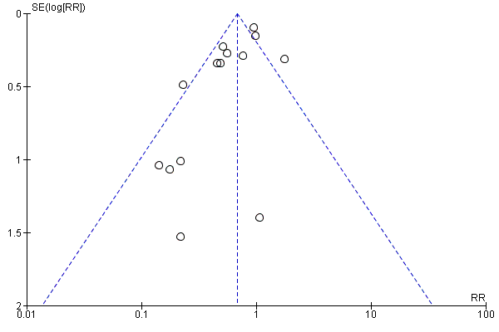

FIGURE S2 Funnel plot for placebo-controlled RCTs

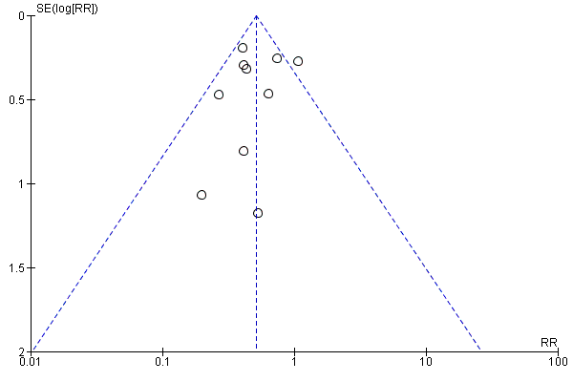

SEARCH STRATEGY

Detailed search strategy:

CENTRAL:
#1: MeSH descriptor: [Dexmedetomidine] explode all trees
#2: MeSH descriptor: [Delirium] explode all trees
#3: MeSH descriptor: [Respiration] explode all trees
#4: #2 or #3
#5: #1 and #4

PubMed:
((((delirium) AND dexmedetomidine)) OR ((dexmedetomidine[MeSH Terms]) AND ((Respiration, Artificial[MeSH Terms]) OR delirium[MeSH Terms]))) AND ((((randomized controlled trial[pt] OR controlled clinical trial[pt] OR randomized[tiab] OR placebo[tiab] OR clinical trials as topic[mesh:noexp] OR randomly[tiab] OR trial[ti] NOT (animals[mh] NOT humans [mh])))))

