Supplementary Table 1 Plasmids and strains used in the present study.
Strain or plasmid | Relevant characteristics | Source
Strains
E. coli DH5α | F−, φ80d lacZΔM15, Δ(lacZYA-argF)U169, recA1, endA1, hsdR17(rk−, mk+), phoA, supE44λ−, thi−1, gyrA96, relA1 | Novagen
C. glutamicum ATCC 13032 | Host strain | ATCC
Plasmids
pEC-XK99E | A E. coli-C. glutamicum shuttle vector, pGA1 ori, Kan^{R} | [1]
pZ8-Ptac | A E. coli-C. glutamicum shuttle vector, pHM1519 ori, Kan^{R} | Addgene
pZ8-1 | A E. coli-C. glutamicum shuttle vector, pHM1519 ori, Kan^{R} | [2]
pCDF-3A | E. coli expression plasmid containing Arabidopsis 3GT fused to N-terminus of Petunia ANS (3A) | [3]
pEC-3AO | pEC-XK99E carrying 3A | This study
pZ8-3AO | pZ8-1 carrying 3A | This study
pZM1 | ePathBrick vector features, modified from pZ8-Ptac | This study
pEC-o3GT-oANS | Wild-type 3GT and ANS in operon form | This study
pEC-oSUMO-3GT-  oANS | SUMO tag-fused wild-type 3GT and ANS in operon form | This study
pEC-oMBP-3GT-  oANS | MBP tag-fused wild-type 3GT and ANS in operon form | This study
pEC-o3GT’-oANS’ | Codon-optimized 3GT and ANS in operon form | This study
pEC-oSUMO-3GT’-  oANS’ | SUMO tag-fused codon- optimized 3GT and codon-optimized ANS in operon form | This study
pEC-oMBP-3GT’-  oANS’ | MBP tag-fused codon- optimized 3GT and codon-optimized ANS in operon form | This study
pEC-m3GT-mANS | Wild-type 3GT and ANS in monocistronic form | This study
pEC-mSUMO-3GT-  mANS | SUMO tag-fused wild-type 3GT and wild-type ANS in monocistronic form | This study
pEC-mMBP3GT-  mANS | MBP tag-fused wild-type 3GT and wild-type ANS in monocistronic form | This study
pEC-m3GT’-mANS’ | Codon-optimized 3GT and ANS in monocistronic form | This study
pEC-mSUMO-3GT’-  mANS’ | SUMO tag-fused codon- optimized 3GT and codon-optimized ANS in moncistronic form | This study
pEC-mMBP-3GT’-  mANS’ | MBP tag-fused codon- optimized 3GT and codon-optimized ANS in monocistronic form | This study
pZM1-mSUMO-  3GT-mANS | SUMO tag-fused wild-type 3GT and wild-type ANS with monocistronic form in pZM1 | This study
pZM1-eftuSUMO-  3GT-eftuANS | SUMO-3GT and ANS both under the control of the promoter eftu in monocistronic form | This study
pZM1-eftuSUMO-  3GT-sodANS | SUMO-3GT and ANS under the control of the promoters eftu and sod in monocistronic form | This study
pZM1-sodSUMO-  3GT-sodANS | SUMO-3GT and ANS both under the control of the promoter sod in monocistronic form | This study
pZM1-sodSUMO-  3GT-eftuANS | SUMO-3GT and ANS under the control of the promoter sod and eftu separately in monocistronic form | This study
pZM1-mPgm-mYcjU-mGalU-mSUMO-3GT-mANS | Expression of pgm, ycjU and galU from E. coli, SUMO-3GT and ANS in monocistronic form | This study
pZM1-mCmk-mNdk-  mPgm-mYcjU-mGalU-mSUMO-3GT-mANS | Expression of cmk, ndk, pgm, ycjU and galU from E. coli, SUMO-3GT and ANS in monocistronic form | This study
pZM1-mCmk-mNdk- mGalU-mSUMO-  3GT-mANS | Expression of cmk, ndk and galU from E. coli, SUMO-3GT and ANS in monocistronic form | This study
pZM1-mCmk-mNdk-  mPgm-mYcjU-mSUMO-3GT-mANS | Expression of cmk, ndk, pgm and ycjU from E. coli, SUMO-3GT and ANS in monocistronic form | This study
pZM1-mcgGalU1-  mcgPgm-mSUMO-3GT-mANS | Expression of C. glutamicum-derived galU1 and pgm, SUMO-3GT and ANS in monocistronic form | This study
pZM1-mCsF3H-  mCsDFR-mDuLAR | Expression of F3H, DFR and LAR in monocistronic form | This study

Supplementary Table 2 Primers used in this study.
Primer | Sequence (5’-3’)
3GT-F-EcoRI | CCGGAATTCAAAGGAGGACAACCATGACCAAACCCTCCGAC
3GT-R-SalI | ACGCGTCGACGGTACCTCAAATAATGTTTACAACTGCATC
ANS-F-KpnI | CGGGGTACCAAAGGAGGACAACCATGGTGAATGCAGTAGTTACAAC
ANS-R-PstI | AAAACTGCAGCTATTTAGATTCTTCAGCAGCAA
ANS-R-SalI | ACGCGTCGACCTATTTAGATTCTTCAGCAGCAA
SUMO-3GT-F1-MfeI | CCGCAATTGGAGCTCAAAGGAGGACAACCATGGGTTCTTCTATGGCTAGCATG
SUMO-3GT-R1 | GGAGGGTTTGGTCATTGCATTGGATTGGAAGTACAGGTT
SUMO-3GT-F2 | TGTACTTCCAATCCAATGCAATGACCAAACCCTCCGAC
SUMO-3GT-R2-kpnI | CGGGGTACCTCAAATAATGTTTACAACTGCATC
MBP-3GT-F1-EcoRI | CCGGAATTCAAAGGAGGACAACCATGAAAATCGAAGAAGGTAAACT
MBP-3GT-R1 | GGTTTGGTCATCCTTCCCTCGATCCCG
MBP-3GT-F2 | GATCGAGGGAAGGATGACCAAACCCTCCGAC
MBP-3GT-R2-KpnI | CGGGGTACCTCAAATAATGTTTACAACTGCATC
cgANS-F-EcoRI | CCGGAATTCCTAGTCTAGAAAGGAGGACAACCATGGTGAACGCCGTCGT
cgANS-R-BamH | CGCGGATCCTTATTACTTGCTTTCTTCAGCCG
cg3GT-F-EcoRI | CCGGAATTCAAAGGAGGACAACCATGACCAAGCCGTCAGATCC
cg3GT-R-XbaI | CTAGTCTAGATTATTAAATGATGTTCACCACTGCG
SUMO-cg3GT-F1-  MfeI | CCGCAATTGCCCGGGAAAGGAGGACAACCATGGGTTCTTC
SUMO-cg3GT-R1 | GGCTTGGTCATTGCATTGGATTGGAAGTACAGGTT
SUMO-cg3GT-F2 | CAATCCAATGCAATGACCAAGCCGTCAGATCC
MBP-cg3GT-F1-  EcoRI | CCGGAATTCAAAGGAGGACAACCATGAAAATCG
MBP-cg3GT-R1 | GCTTGGTCATCCTTCCCTCGATCCCGAGG
MBP-cg3GT-F2 | GATCGAGGGAAGGATGACCAAGCCGTCAGATCC
MBP-cg3GT-R2-XbaI | CTAGTCTAGATTATTAAATGATGTTCACCACTGCG
T1T2-Ptac-KpnI-F1 | CGGGGTACCTGCCTGGCGGCAGTAG
T1T2-Ptac-R1 | GTCAACAGCTCAAAAGGCCATCCGTCAGG
T1T2-Ptac-F2 | GGATGGCCTTTTGAGCTGTTGACAATTAATCATCG
T1T2-Ptac-KpnI-R2 | CGGGGTACCGTGTGAAATTGTTATCCGCTCA
T1T2-Ptac-XbaI-F1 | CTAGTCTAGATGCCTGGCGGCAGTAG
T1T2-Ptac-XbaI-R2 | CTAGTCTAGAGTGAAATTGTTATCCGCTCA
EMK-F-NdeI | ACGCCATATGACGGCAATTGCCC
EMK-R-BamH | CGCGGATCCTTATGCGAGAGCCAATTTCTG
PGM-F-NdeI | ACGCCATATGGCAATCCACAATCGTG
PGM-R-BamH | CGCGGATCCTTACGCGTTTTTCAGAACTTCG
ycjU-F-NdeI | ACGCCATATGAAACTGCAAGGGGTAAT
ycjU-R-BamH | CGCGGATCCCTATACGTTTTGCCAGAAGGC
GalU-F-XbaI | CTAGTCTAGAAAGGAGGACAACCATGGCTGCCATTAATACGAAAG
GalU-R-BamH | CGCGGATCCTTACTTCTTAATGCCCATCTCTTC
NDK-F-NdeI | ACGCCATATGGCTATTGAACGTACTTTTTCC
NDK-R-BamH | CGCGGATCCTTAACGGGTGCGCGG
ANS-F-AseI | acgcATTAATATGGTGAATGCAGTAGTTACAAC
CsF3H-F-NdeI | TATACATATGGCACCGACCACC
CsF3H-R-BamHI | CGCGGATCCTTAGGCGAAGATTTCATCGGTG
CsDFR-F-NdeI | TATACATATGAAAGATAGCGTTGCA
CsDFR-R-BamHI | CGCGGATCCTTACACTTTGTTGCCATTAACCG
DuLAR-F-NdeI | TATACATATGACCGTTAGCGGTG
DuLAR-R-BamHI | CGCGGATCCTTAACCCATTGCGCTAATCGG
eftu-F-XmaJ1 | GAAATCCTAGGTGGCCGTTACCCTGCGAATG
eftu-R-NdeI | TATACATATGATGTCCTCCTGGACTTCGTGGTGG
sod-F-XmaJ1 | GAAATCCTAGGTAGCTGCCAATTATTCCGGG
sod-R-NdeI | TATACATATGTAAAAAATCCTTTCGTAGGTTTCC
cgGalU-F-NdeI | TATACATATGAGTTTGCCTATCGATGAGC
cgGalU-R-BamHI | CGGGGTACCCTATTTTACTTGAGAATCGTCTGCA
cgPGM-F-NdeI | TATACATATGGCACATGAACGCGC
cgPGM-R-BamHI | CGGGGTACCTTACTGTCCGAGTACTTCGCTGAC
Underlined sequences are restriction sites; sequences in bold include ribosome binding sites and spacer sequences applied in this study.
Supplementary Table 3 C3G production using concentrated cells in different conditions. Cells grown in AMM (pH7.0) were induced with IPTG (0.5 mM) for 6 hours and harvested. Then 5 ml of cells were resuspended in 1 ml of different buffers with 500 mg/L catechin and necessary supplements, including citrate buffer, potassium phosphate buffer, AMM (pH 5.0) and AMM (pH 7.0), respectively. The conversion process was conducted at 30 °C and 220 rpm for 48 h.
Conditions | C3G Production (mg/L)
Citrate Buffer (0.1M, pH 5.0) | 2.45 ± 0.09
AMM (pH 5.0) | 1.26 ± 0.15
Phosphate Buffer (0.1 M, pH 7.0) | 1.58 ± 0.28
AMM (pH 7.0) | 43.67 ± 0.61

Supplementary Figure 1. SDS-PAGE (10% gel) analysis of proteins ANS and 3GT by recombinant C. glutamicum expressing ANS and 3GT in various media. The E. coli strain expressing ANS and 3GT was used as a positive control. E. coli was cultivated in AMM with 2% glucose and induced by 1 mM IPTG for 4 h before harvested for protein extraction. The C. glutamicum strain was grown in BHIS, AMM or CGXII medium and was induced by 1 mM IPTG at mid-exponential phase for 12 h. Red arrows indicate bands for ANS (48.5 kD) and 3GT (50.5 kD) (their molecular weight is too close, and only one merged band could be seen in the gel).

Supplementary Figure 2. Mass Spectrum identification of C3G in the fermentation products of recombinant C. glutamicum strains. TIC (A) and EIC (B) for mass range of C3G of the standard C3G; TIC(C) and EIC (D)for mass range of C3G for the fermentation products; Mass spectrum for C3G peak in the standard (E) and the fermentation products (F).

Supplementary Figure 3. Time course study of mCherry expression in C. glutamicum. The mCherry gene was cloned into the plasmid pZM1, and the expression of mCherry was indicated by the fluorescence intensity at an excitation wavelength of 588 nm and an emission wavelength of 618 nm.
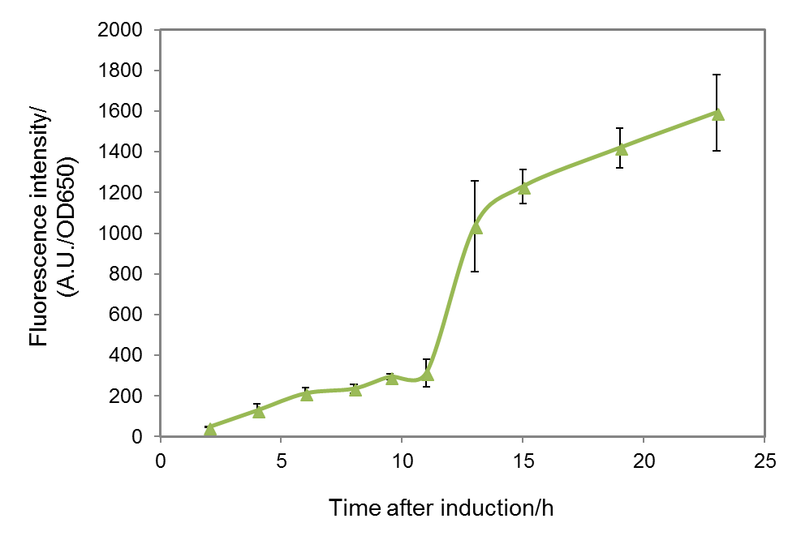

References

1. Kirchner O, Tauch A. Tools for genetic engineering in the amino acid-producing bacterium Corynebacterium glutamicum. J Biotechnol. 2003;104:287-99.
2. Cleto S, Jensen JVK, Wendisch VF, Lu TK. Corynebacterium glutamicum metabolic engineering with CRISPR interference (CRISPRi). ACS Synth Biol. 2016;5:375-85.
3. Yan Y, Li Z, Koffas MA. High-yield anthocyanin biosynthesis in engineered Escherichia coli. Biotechnol Bioeng. 2008;100:126-40.

