Additional file 5

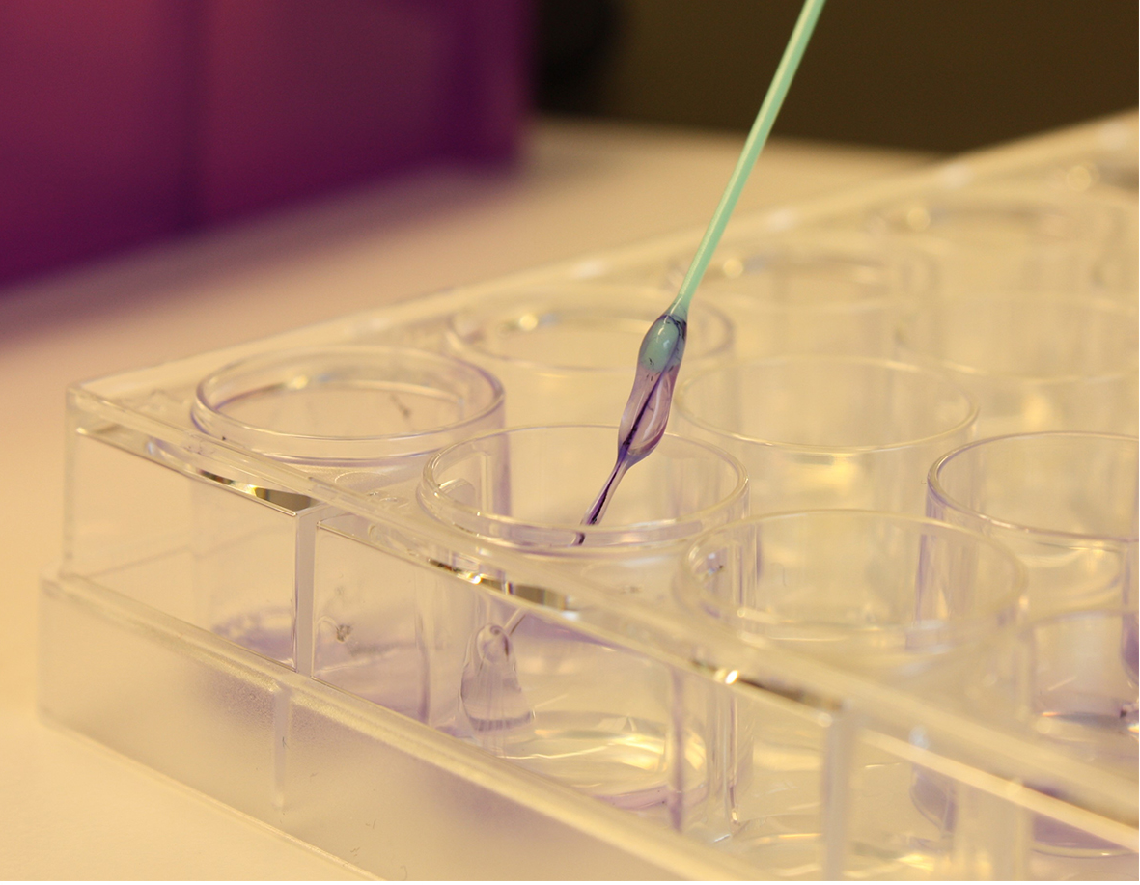

Figure S4. The extracellular slimy substance of the ΔrpoQ biofilm. ΔrpoQ was allowed to form biofilm in SWT medium. After 72 hours incubation a small amount of crystal violet was added into the well to improve the visualization. The picture shows the slimy substance lifted from the well using a plastic-loop. Images were photographed using a Canon camera.

