Additional file 2: Figure S2 Linear correlation of sleep quality with the number of children
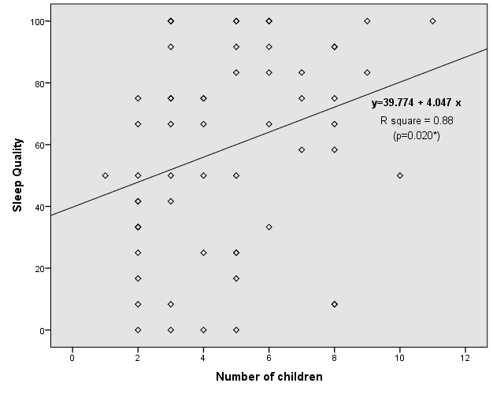

- Surprisingly, number of children showed to be a positive factor for sleep quality (β=0.297; p=0.020).

