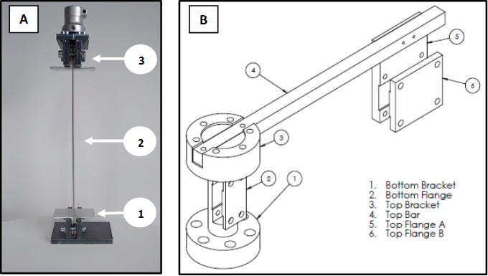
Figure 4: In 4A the side view of the CalibrAFO:1. bottom clamp; 2. inox steel sheet; 3. top clamp. In 4B the mounting frame for the Instron Electropuls E10000 testing machine.

