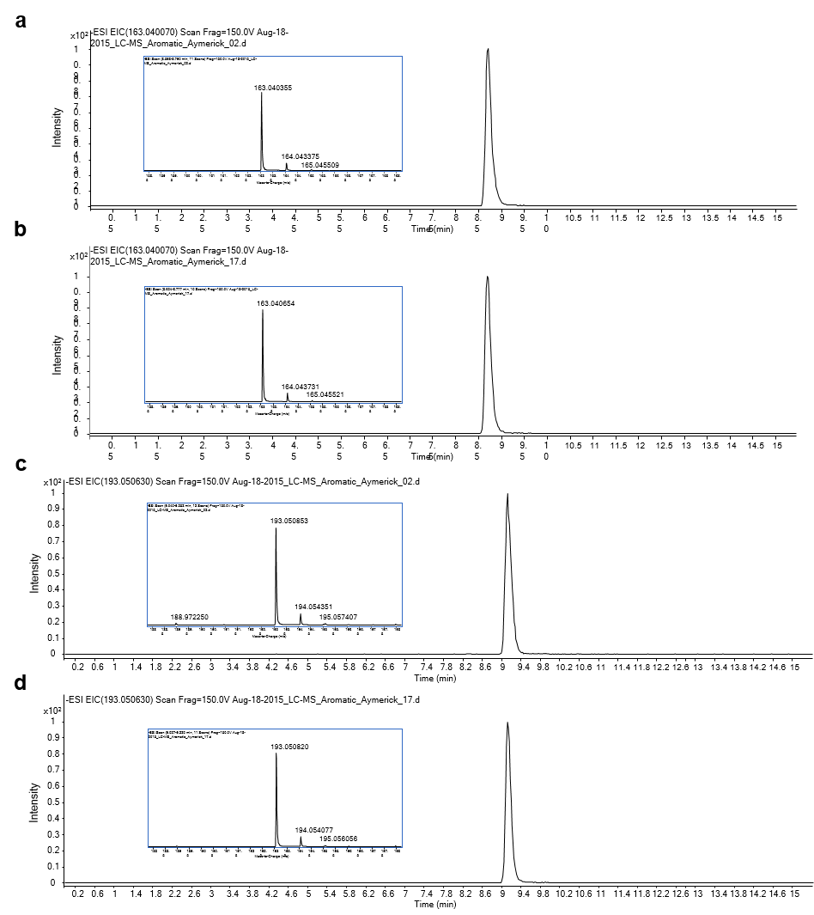
Additional file 4: Fig. S4. Representative LC-MS chromatograms of p-coumarate (a, b) and ferulate (c, d) obtained from a plant extract (a, c) and authentic standards (b, d).

