Additional file 1: Table S1: Composition of Plasma Bile Acids detected by LC-MS

Sub Pathway | Biochemical Name | Mean Pairs Ratio PostWL/PreWL | p-value*
Primary Bile Acid Metabolism | cholate | 0.45 | 0.0069
 | glycocholate | 0.98 | 0.2694
 | taurocholate | 1.24 | 0.6578
 | glycochenodeoxycholate | 0.90 | 0.1562
 | taurochenodeoxycholate | 1.13 | 0.5756
Secondary Bile Acid Metabolism | glycodeoxycholate | 3.70 | 0.4889
 | taurodeoxycholate | 3.26 | 0.1237
 | glycolithocholate sulfate* | 8.76 | 0.0263
 | taurolithocholate 3-sulfate | 3.11 | 0.0014
 | glycocholenate sulfate* | 1.08 | 0.8788
 | taurocholenate sulfate* | 2.36 | 0.0618

*p-value calculated as paired t-tests accounting for multiple comparisons.

Additional file 1: Table 2: Urinary Metabolite Ratios following VLCD-Induced Weight Loss

Urinary Metabolite | Mean Pairs Ratio PostWL/PreWL | PostWL vs PreWL (OPLS correlation coefficient)
1, 3-methyl-2-oxovalerate | 1.54 | 0.77
2, pantothenate | 1.60 | 0.89
3, 2-aminobutyrate | 1.53 | 0.85
4, isoleucine | 1.30 | 0.83
5, unknown 1 | 1.64 | 0.85
6, 3-hydroxyisovalerate | 1.30 | 0.59
7, lactate | 1.21 | 0.87
8, unknown 2 | 1.77 | 0.88
9, alanine | 0.81 | -0.71
10, acetone | 2.89 | 0.76
11, acetoacetate | 2.50 | 0.49
12, succinate | 1.77 | 0.88
13, citrate | 1.73 | 0.66
14, unknown 3 | 0.52 | -0.76
15, methylguanidine | 0.74 | -0.78
16, dimethylglycine | 0.75 | -0.82
17, creatine | 0.61 | -0.67
18, malonate | 0.70 | -0.60
19, trimethylamine-N-oxide | 0.71 | -0.59
20, unknown 4 | 0.37 | -0.90
21, unknown 5 | 0.71 | -0.75
22, 3-methylhistidine | 0.20 | -0.85
23, guanidinoacetic acid | 0.64 | -0.88
24, tartrate | 1.76 | 0.76
25, 4-cresyl sulfate | 1.75 | 0.62
26, phenylacetylglutamine | 1.42 | 0.66
27, salicylurate | 1.79 | 0.78
28, N-methyl-2-pyridone-5-carboxamide | 1.45 | 0.56
29, N-methylnicotinamide | 1.57 | 0.68

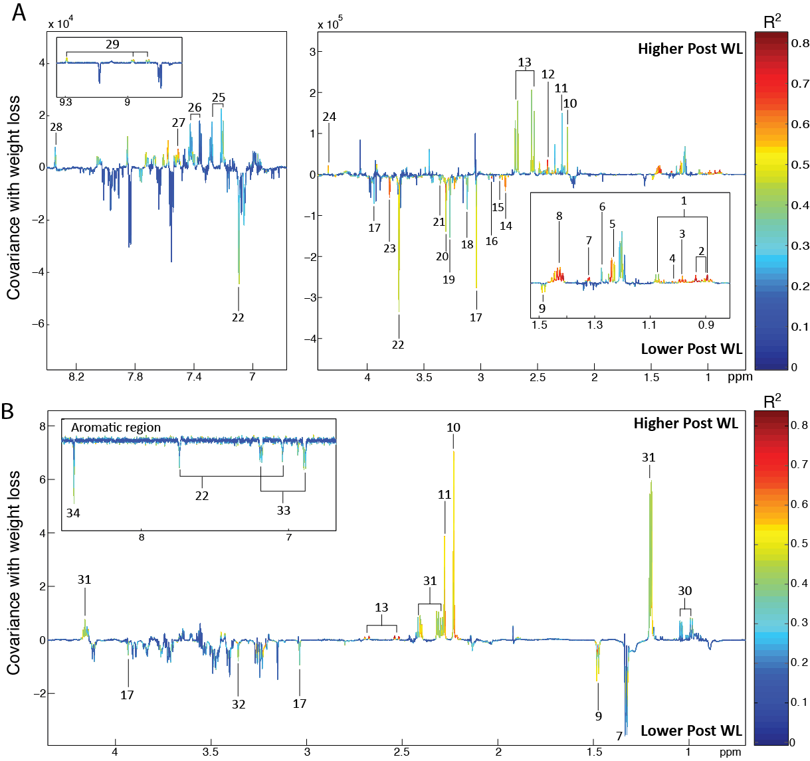

Additional file 1: Figure S1: Urine metabolomic orthogonal projection to latent structures-discriminant analysis (OPLSDA) identifying the metabolic variation associated with weight loss. Coefficient plots extracted from the OPLSDA models built on the urinary metabolome (Q²Y = 0.56). The spectra identify 29 compounds with upward (indicating increase with weight loss) or downward deflection (decrease with weight loss). A. NMR Spectra from PPM 8.4-6.8. B. NMR Spectra from PPM 4.5-0.5. The corresponding compounds are: Key: 1, 3-methyl-2-oxovalerate; 2, pantothenate; 3, 2-aminobutyrate; 4, isoleucine; 5, unknown 1; 6, 3-hydroxyisovalerate; 7, lactate; 8, unknown 2; 9, alanine; 10, acetone; 11, acetoacetate; 12, succinate; 13, citrate; 14, unknown 3; 15, methylguanidine; 16, dimethylglycine; 17, creatine; 18, malonate; 19, trimethylamine-N-oxide; 20, unknown 4; 21, taurine; 22, 3-methylhistidine; 23, guanidinoacetic acid; 24, tartrate; 25, 4-cresyl sulfate; 26, phenylacetylglutamine; 27, salicylurate; 28, N-methyl-2-pyridone-5-carboxamide; 29, N-methylnicotinamide

