**Additional file 1: Methods and Figures**

**Liver cancer cell lines distinctly mimic the metabolic gene expression pattern of the corresponding human tumours**

Nwosu et al.

**Methods**

**Compounds used to target metabolism in the HCC cell lines**

|  |  |  |  |
| --- | --- | --- | --- |
| Name | Catalogue # | Mol. wt (g/mol) | Supplier |
| (−)-Epigallocatechin Gallate | E4143-50MG | 458,37 | Sigma |
| BPTES | SML0601-5mg | 524,68 | “ |
| 2-Deoxy-D-Glucose | D6134-1G | 164,16 | “ |
| Aminooxyacetate (AOA) | C13408-1G | 109,3 | “ |
| Asparaginase | A3809-100UN | - | “ |
| Dichloroacetic acid | 36545-1g | 128,94 | “ |
| Metformin | Phr1084-500MG | 165.62 | “ |
| Methionine sulfoximine | M5379-250MG | 180.23 | “ |
| Simvastatin | S6196-5mg | 418,57 | “ |
| UK5099 | PZ0160-5MG | 288.30 | “ |
| Oligomycin | 75351-5MG | 791.06 | “ |
| Rotenone | R8875 | 394.42 | “ |
| CB-839 | 22038 | 571.57 | Bertin Pharma |

**RNA isolation and quantitative PCR**

Total RNA was isolated using InviTrap Spin Universal RNA Mini Kit according to manufacturer’s instruction (Stratec Biomedical AG, Germany). RNA concentration was quantified using Infinite 200 NanoQuant Plate (Tecan GmbH, Austria). Thereafter, RNA (0.5 or 1 μg) was reverse transcribed to cDNA using SuperScript II First Strand Kit (Invitrogen, USA). Quantitative PCR analysis was performed in a 10µl total reaction volume using SYBR Green PCR Master Mix on the Agilent Mx3005P QPCR Systems or AB StepOnePlus. Experiments were performed in triplicates with peptidylprolyl isomerase A (*PPIA*) as control and expression values calculated by delta CT method. The gene primer sequences used are listed below:

**Gene primer sequences used for qPCR**

|  |  |  |  |
| --- | --- | --- | --- |
| Primer | Amplicon size | Forward | Reverse |
| *CDH1* | 157 | CTCTCACGCTGTGTCATCCA | CTCCATCACAGAGGTTCCTGG |
| *MMP2* | 112 | GATACCCCTTTGACGGTAAGGA | CCTTCTCCCAAGGTCCATAGC |
| *MMP9* | 127 | CGCTGGGCTTAGATCATTCCT | TCAGGGCGAGGACCATAGAG |
| *PPIA* | 98 | GACTGAGTGGTTGGATGGCA | TGCCATTCCTGGACCCAAAG |
| *VIM* | 86 | CACGTCTTGACCTTGAACGC | CTCCTGGATTTCCTCTTCGTGG |
| *BASP1* | 90 | TTCAGACTCAAAACCCGGCA | GCCTTGGGTGTGGAACTAGG |
| *CRIP2* | 79 | GTGCGACAAGACCGTGTACT | CTCGCACTTGAGGCAGAACT |
| *CPT1A* | 73 | GTACGCCAAGATCGACCCC | CATGCAGTTGGCCGTTTCC |
| *CD59* | 88 | CACAACCCGCTTGAGGGAA | CCCACCATTTTCAAGCTGTTCG |
| *GCHFR* | 70 | GCATCTGGGGGCTTCAAAGA | GGGAGGGTCATCGACGTAGT |
| *ADA* | 78 | TCCATCAAGCCTGAAACCATCT | CAGCCCCTCTGCTGTGTTAG |
| *MBOAT7* | 83 | GACCATCCGCAACATCGACT | GATATACTGCGCCAGCCACC |
| *PFKP* | 96 | GACCTTCGTTCTGGAGGTGATG | GATTCTGGAAGGAACACCCAGT |
| *GATM* | 80 | GGACTGCCCTGTCTCTTCTTAC | GAACACAGGCGTTTTCTGCTC |
| *LCN1* | 73 | CATGCTGATAAGTGGCCGGT | CGTGTATTTTCCCGGCTCGT |
| *LACRT* | 139 | CCCTGGTCTATGCTGAAGATGC | TGGGCTGTTGTGGTTGTCTC |
| *SLC25A12* | 96 | ACCCCAGAAGACTTTGTTCAGC | TTGATCAGCTACTCCTGCCAAG |
| *MPC1* | 185 | CATGAGTACGCACTTCTGGGG | GGCATGCAAACAGAAGCCAG |
| *PDHA1* | 114 | ATGGAATGGGAACGTCTGTTG | CCTCTCGGACGCACAGGATA |
| *PC* | 115 | GAGGTGAGATTGCCATCCGT | GCTTCATCTGCTTTCTGCCG |
| *HK1* | 139 | CCAACATTCGTAAGGTCCATTCC | CCTCGGACTCCATGTGAACATT |
| *PGK1* | 137 | GAACAAGGTTAAAGCCGAGCC | GTGGCAGATTGACTCCTACCA |
| *LDHA* | 91 | TTGACCTACGTGGCTTGGAAG | GGTAACGGAATCGGGCTGAAT |
| *PKM2* | 108 | ATAACGCCTACATGGAAAAGTGT | TAAGCCCATCATCCACGTAGA |
| *CS* | 118 | GCATGAGAGGCATGAAGGGA | CCCTTAGCCTTGGGTAGCAG |
| *IDH1* | 129 | CACCAAATGGCACCATACGAA | CCCCATAAGCATGACGACCTAT |
| *SDHA* | 182 | TGATGGGAACAAGAGGGCATC | ACCTGGTAGGAAACAGCTTGG |
| *SDHC* | 176 | TCCTCTGTCTCCCCACATTACT | CCAGACACAGGGACTTCACAA |
| *ME1* | 85 | TCTTGGCTTGGGAGACCTTG | ATTCATCCCTCCGCAAGCTG |
| *ME2* | 177 | CGACGGTTGGTCTTGCCTG | CCAGATCTCCAAGACCCAGAAT |
| *PCK1* | 116 | GCAAGACGGTTATCGTCACCC | GGCATTGAACGCTTTCTCAAAAT |
| *GLS* | 114 | AGGGTCTGTTACCTAGCTTGG | ACGTTCGCAATCCTGTAGATTT |
| *GLS2* | 92 | TCTCTTCCGAAAGTGTGTGAGC | CCGTGAACTCCTCAAAATCAGG |
| *GLUD1* | 197 | AAGGTGGCATGGTCCTCAAG | GGCATTCACTGTTTGAGTCAAGG |
| *GLUL* | 137 | TCATCTTGCATCGTGTGTGTG | CTTCAGACCATTCTCCTCCGG |
| *GOT1* | 72 | CAACTGGGATTGACCCAACT | GGAACAGAAACCGGTGCTT |
| *GOT2* | 138 | TTACGTTCTGCCTAGCGTCC | ACTTCGCTGTTCTCACCCAG |
| *GPT1* | 75 | GGTCTTGGCCCTCTGTGTTA | TCCGCCCTTTTCTTGGCATC |
| *GPT2* | 103 | GACCCCGACAACATCTACCTG | TCATCACACCTGTCCGTGACT |
| *MDH2* | 134 | GCAGCCACTTTCACTTCTCCT | CGAGGTAGCCTTTCACAGCG |
| Sources: *GOT1* - Son et al., 2013; *GLUL -* Chiu et al., 2014; *PCK1* - Foretz et al. 2010; PGK1 – Zieker et al., 2010; *PKM2* - Li et al., 2013; others - Harvard primer bank or designed with NCBI Primer Blast. | | | |

**Intracellular metabolite profiling, glucose and glutamine isotope tracing**

Sub-confluent HUH7 and HLE cells were each cultured overnight (o/n) in triplicates in 12-well plates. Next day, the culture medium was replaced with DMEM containing 10% dialysed Fetal bovine serum, 25 mM glucose and 4 mM Gln (Sigma-Aldrich). For isotope tracing, the DMEM was instead supplemented with 25mM uniformly labeled (U-13C6) glucose (Cambridge Isotope Laboratories) for glucose tracing, or 4 mM uniformly labeled (U-13C5) glutamine for glutamine tracing. The experiments were terminated after 24h. Extraction of intracellular metabolites, quantification by GC-MS and mass isotopomer distribution analysis was performed as previously described (Battello et al., 2016).

**MTT proliferation assay**

Cell proliferation was measured by 3-(4,5-dimethylthiazol-2-yl)-2,5-diphenyltetrazolium bromide (MTT) assay. Briefly, 2.5 – 7.5 x 103 cells per well were seeded in quadruplicates in 96-well plates and incubated o/n. The next day, the cells were treated with the indicated compounds. At the end of the experiment, MTT reagent was added to each well, followed by 3 – 4 h incubation at 37 °C. Media was then aspirated off and the formed formazan crystals were dissolved with 200 µl of solubilisation reagent (4 parts DMSO, 4 parts 10% SDS, 2 parts phosphate buffered saline, and acetic acid at 0.012% of the total reagent volume). Thereafter, the plate was incubated o/n at 37 °C. Absorbance was read at 560 nm using Infinite 200 Spectrophotometer (Tecan GmbH, Austria), with background correction at 670 nm. Experiments for HUH7 versus HLE were performed in parallel. Results were normalized to untreated/control group.

**ATP determination assays**

Cellular ATP content was measured using ATP Determination kit (Invitrogen, USA) according to manufacturer’s instruction. The results were normalized to total protein concentration of the cell lysates.

**Western blotting**

Following culture, adherent cells were washed, placed on ice, and cell protein lysates were prepared using radioimmunoprecipitation assay buffer supplemented with protease inhibitor cocktail and phosphatase inhibitor. Protein content was estimated with Bio-Rad Protein Assay Kit according to manufacturer’s instruction (Bio-Rad Laboratories Inc., USA). For electrophoresis, 20 – 25 µg of protein samples were loaded in 12% SDS–PAGE gels at 120V. Alternatively, 4-12% bis-Tris precast NuPAGE (Invitrogen, USA) was used at 150V for 75 minutes. Blots were subsequently transferred onto Nitrocellulose membranes (GE Healthcare Life Sciences) at 200 mA for 90 minutes. Thereafter, the membranes were briefly stained with Ponceau S solution to enable visualization of protein bands. Membranes with protein bands were then washed until Ponceau S stain was removed, using Tris-Buffered Saline containing 0.1% v/v Tween (TBST). The membranes were then blocked for 1h with 5% milk (dissolved in TBST), and later incubated o/n at 4°C with the primary antibody of interest. For detecting the bound protein, the corresponding mouse or rabbit secondary antibodies were diluted 1:10,000 and used to incubate the membrane for 1h incubation at room temperature, followed by 3x wash each for 10 minutes. The blot intensity was subsequently visualized after exposing the membrane to enhanced chemiluminescence (ECL) detection buffer. The following are the antibodies used:

|  |  |  |
| --- | --- | --- |
| Primary antibodies | Catalogue # | Source |
| Caveolin-1 (N20) (rabbit) | sc894 | Santa Cruz Biotechnology |
| E-Cadherin (CDH1) (mouse) | 3195S | Cell Signaling |
| MPC1 (D2L9I) (rabbit) | 14462S | Cell Signaling |
| pERK (mouse) | sc-7383 | Santa Cruz Biotechnology |
| PKM2 | 3198S | Cell Signaling |
| Tubulin (rabbit) | ab4074 | Abcam |
| Secondary antibodies |  |  |
| goat anti-mouse IgG-HRP | sc-2060 | Santa Cruz Biotechnology |
| goat anti-rabbit IgG-HRP | sc-2301 | Santa Cruz Biotechnology |

**Migration assays**

For *in vitro* scratch assay, the cells were seeded in 24 well plates. After o/n incubation, the cell monolayer was scratched using 200µl pipette thus creating a gap. Culture media was replaced and bright field microscopy images were immediately taken (time point 0, t0). After 24h, another image was taken (t24). Using Image J, 20 equidistant measurements of the gap created by the scratch were taken from the t0, and t24 images. Percentage migration was calculated as: 100 x (measured gap distance t0 – t24)/gap distance at t0.

For FluoroBlok migration assay, harvested cells were pre-incubated for 15 minutes at 37°C with 15 µl DiI per ml of DMEM. Thereafter, the cells were washed twice with DMEM without phenol red. 1 x 105 HUH7 or 7.5 x 104 HLE cells were respectively seeded in 24-well plate in 200µl DMEM medium. The cells were seeded in the upper chamber of 8.0 µM Fluoroblok insert (Corning, USA), while 800µl of growth medium (i.e. with 10% FBS) was added to the lower chamber. For control plate, the same number of cells was seeded into a normal 24 well plate to serve as positive control (i.e. 100% migration). Triplicate wells containing only medium was also measured for background correction. Measurements were taken at 520/580 nm from the bottom of the plate using fluorescence reader. The whole experiment was performed in DMEM without phenol red. Calculation of % migration was as follows:

(measured value per experiment well – background)/(measured value of control plate –background)

**Figure S1.** Phenotypic and molecular characteristics of HCC cell lines



e.

c.

d.

b.

a.

1. FluoroBlok migration assay, showing basal migration of HLE compared to HUH7 cells (n=3 per group). On the right, representative picture from *in vitro* scratch assay and the quantified gap distance showing % migration. Bars indicate mean ± SD of 20 measurements of migration after 24h (2 replicate experiments).
2. Relative intracellular ATP level determined after 24 h culture of the HCC cell lines. Bars indicate mean ± SD of triplicate samples.
3. Differentially expressed proteins (extended to top 20 high or low) in the cell lines and the expression pattern of their encoding genes in human HCC tumours (*P*<0.0001 except for LACRT and LCN1, *P*<0.05: * the corresponding genes for these candidates also appeared within the top 100 altered genes across all three cell line datasets (shown in Fig. 1c).
4. Western blot data showing differences between the HCC cell lines, and freshly isolated hepatocytes, using frequently altered proteins in cancer. M1 – 4 represent four mice from which hepatocytes were isolated as previously described (Dropmann et al., 2016).
5. qPCR showing relative mRNA level of EMT related genes E-cadherin (*CDH1*), vimentin *(VIM*) and matrix metalloproteinases 2 and 9 (*MMP2/*9) (n ≥ 2 per group). n.d. – not detected.

**Figure S2.** Overlap of genes deregulated in human HCC datasets and the top ranked ontology of the highly expressed genes (tumours and poorly differentiated cell lines)

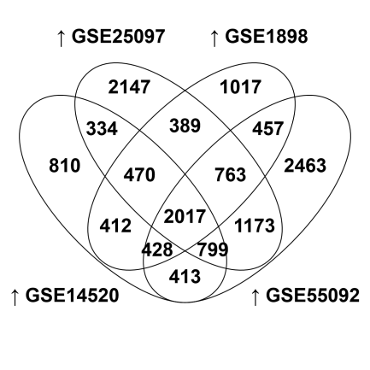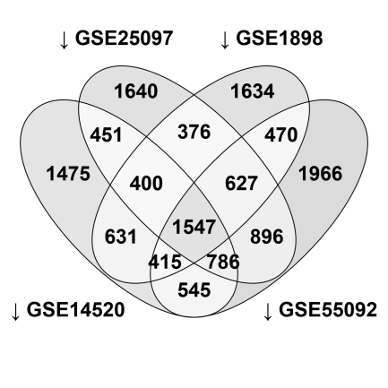

a.

b.



1. Venn diagram result showing the number of upregulated or downregulated genes in all 4 human HCC microarray datasets.
2. Ontology of the upregulated genes in the HCC microarrays compared to the poorly differentiated cell lines profile.

**Figure S3.** Overlap of the gene and protein expression pattern in the cell lines compared with human HCC-tissue derived metabolic genes.

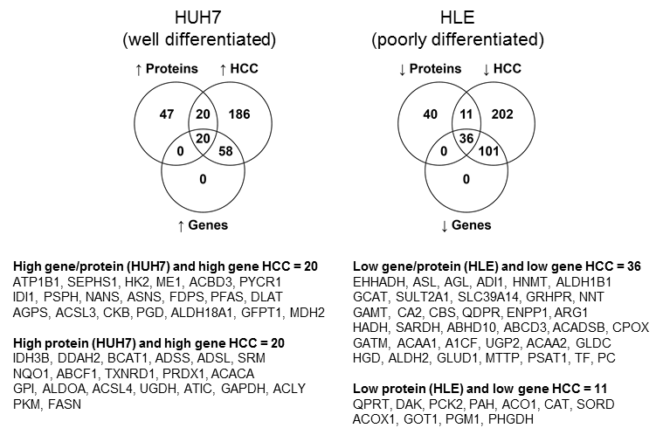

Venn diagram showing the number of differentially expreesed metabolic genes in HLE relative to HUH7 cells (*P*<0.05) that their expression pattern (i.e. up- or down) was confirmed at protein level (proteomics).

**Figure S4.** Metabolic pathways targeted by the drugs used in this study and the effect of glycolysis inhibition or glutamine withdrawal on the proliferation of HCC cell lines.

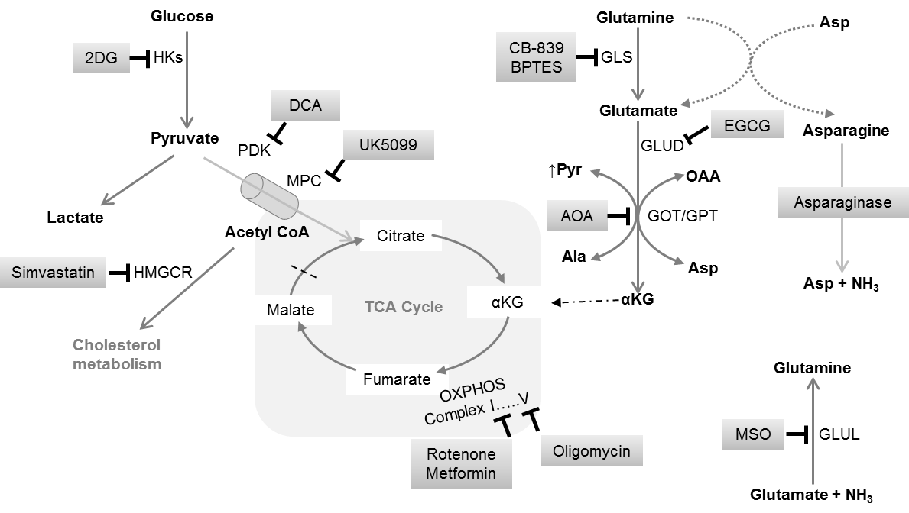

a.

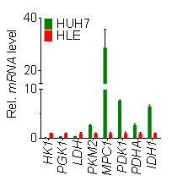



c.

b.

1. Schematic representation of metabolic pathways targeted in the HCC cell lines. Next to it is an additional qPCR data on the distinct expression of known metabolic targets related to glycolysis and the initial phase of TCA cycle.
2. MTT proliferation assay showing the effect of 2-deoxy-glucose (2DG) treatment on the HCC cell lines.
3. MTT proliferation assay showing the effect of extracellular glutamine withdrawal on the HCC cell lines. Bars represent mean ± SD; MTT assays were in quadruplicates, except HUH7 (n=8 per group). CM – complete medium; UT – Untreated.

**References**

1. Battello N, Zimmer AD, Goebel C, Dong X, Behrmann I, Haan C, et al (2016). The role of HIF-1 in oncostatin M-dependent metabolic reprogramming of hepatic cells. Cancer Metab. 4:3. doi: 10.1186/s40170-016-0141-0.
2. Chiu M, Tardito S, Pillozzi S, et al. (2014). Glutamine depletion by crisantaspase hinders the growth of human hepatocellular carcinoma xenografts. Br J Cancer. 111(6):1159-67. doi: 10.1038/bjc.2014.425.
3. Dropmann A, Dediulia T, Breitkopf-Heinlein K, et al. (2016). TGF-β1 and TGF-β2 abundance in liver diseases of mice and men. Oncotarget. 7:15. 19499-518. doi: 10.18632/oncotarget.6967.
4. Foretz M, Hébrard S, Leclerc J, Zarrinpashneh E, Soty M, Mithieux G, Sakamoto K, Andreelli F, Viollet B. Metformin inhibits hepatic gluconeogenesis in mice independently of the LKB1/AMPK pathway via a decrease in hepatic energy state. J Clin Invest.;120(7):2355-69. doi: 10.1172/JCI40671.
5. Li W, Wang J, Chen QD, Qian X, Li Q, Yin Y, Shi ZM, Wang L, Lin J, Liu LZ, Jiang BH (2013). Insulin promotes glucose consumption via regulation of miR-99a/mTOR/PKM2 pathway. PLoS One;8(6):e64924. doi: 10.1371/journal.pone.0064924.
6. Son J, Lyssiotis CA, Ying H, Wang X, Hua S, Ligorio M, Perera RM, Ferrone CR, Mullarky E, Shyh-Chang N, Kang Y, Fleming JB, Bardeesy N, Asara JM, Haigis MC, DePinho RA, Cantley LC, Kimmelman AC (2013). Glutamine supports pancreatic cancer growth through a KRAS-regulated metabolic pathway. Nature. 496(7443):101-5. doi: 10.1038/nature12040.
7. Zieker D, Königsrainer I, Tritschler I, Löffler M, Beckert S, Traub F, Nieselt K, Bühler S, Weller M, Gaedcke J, Taichman RS, Northoff H, Brücher BL, Königsrainer A (2010). Phosphoglycerate kinase 1 a promoting enzyme for peritoneal dissemination in gastric cancer. Int J Cancer.;126(6):1513-20. doi: 10.1002/ijc.24835.