Latent Class Analysis to Define Radiological Subgroups in Pulmonary Nontuberculous Mycobacterial Disease

Steven A. Cowman, Joseph Jacob, Sayed Obaidee, R. Andres Floto, Robert Wilson, Charles S. Haworth and Michael R. Loebinger.

Supplementary Material

Recruitment

Subjects were identified through a search of clinic letters, new referral letters and by notification from the Microbiology department of new mycobacterial smear and culture results during the study period. Exclusion criteria were: age < 18 years, pregnancy, active malignancy, active tuberculosis, cystic fibrosis and immunosuppression other than oral prednisolone.

Subjects were defined as having no underlying pulmonary disease if prior to their diagnosis with NTM-pulmonary disease they had never been diagnosed with a pulmonary disease.

 | Bronchiectasis extent | Bronchiectasis severity | Tree-in-bud opacification | Nodules | Cavitating nodules | Severe cavitation | Consolidation | Aspergilloma
Right upper lobe

Left upper lobe

Right middle lobe

Lingula

Right lower lobe

Left lower lobe

Total

Table S1. CT scoring matrix. The features were scored as follows: Bronchiectasis extent: 0 = none; 1 = 1 bronchopulmonary segment, 2 = >1 bronchopulmonary segments, 3 = >2 bronchopulmonary segments; Bronchiectasis severity: 0 = none, 1 = mild (1-2x diameter of accompanying artery), 2 = severe (>2x diameter of accompanying artery); Tree-in-bud opacification : 0 = none, 1 = mild, 2= moderate, 3 = severe; Nodules: 0 = none, 1 = 1 nodule, 2 = 2-4 nodules, 3 = >4 nodules; Cavitating nodules: 0 = no, 1 = yes; Severe cavitation: 0 = no, 1 = yes; Consolidation: 0 = none, 1 = mild, 2 = moderate, 3 = severe; Aspergilloma: 0 = no, 1 = yes. Nodules were only counted if >5mm diameter, Severe cavitation was defined as the pattern of cavitation classically seen in tuberculosis. Adapted from Zoumot et al. [1]

Female sex | 54 (63.5%)
Age (years) | 65.3 (±10.8)
Smoking history
Never smoker | 41 (48.2%)
Ex-smoker | 36 (42.4%)
Current smoker | 8 (9.4%)
Ethnicity
Asian | 6 (7.1%)
Black | 2 (2.4%)
Chinese | 2 (2.4%)
White | 75 (88.2%)
Diagnosis
Bronchiectasis | 43 (50.6%)
COPD | 30 (35.3%)
Other | 8 (9.4%)
No underlying lung disease | 14 (16.5%)
Systemic corticosteroid use | 16 (18.8%)
Inhaled corticosteroid use | 48 (56.5%)
Oral antibiotic prophylaxis | 22 (25.9%)
Nebulised antibiotic prophylaxis | 7 (8.2%)
FEV1 (% predicted) | 61.7 (±24.3)
FVC (% predicted) | 91.0 (±20.7)
TLCOc (% predicted) | 59.3 (±23.0)
BMI (kg/m²) | 21.8 (±4.1)
SGRQ total score | 45.8 (±24.1)
Chronic Pseudomonas infection | 10 (11.8%)
Mycetoma | 5 (5.9%)
Semi-invasive Aspergillus disease | 3 (3.5%)
Dominant NTM species
M. abscessus | 14 (16.5%)
M. avium complex | 44 (51.8%)
M. kansasii | 9 (10.6%)
M. xenopi | 11 (12.9%)
Other | 7 (8.2%)
Interval since diagnosis (years) | 2.9 (±3.8)
Age at diagnosis (years) | 62.4 (±11.3)
Currently receiving anti-mycobacterial treatment | 18 (21.2%)
Ever received anti-mycobacterial treatment | 37 (43.5%)

Table S2. Clinical characteristics of the Royal Brompton cohort.

CT feature | Score | Brompton  N = 85 | Papworth  N = 62
Bronchiectasis extent | Low | 26 (30.6%) | 17 (27.4%)
 | Medium | 26 (30.6%) | 29 (46.8%)
 | High | 33 (38.8%) | 16 (25.8%)
Bronchiectasis severity | Low | 54 (63.5%) | 24 (38.7%)
 | High | 31 (36.5%) | 38 (61.3%)
Tree-in-bud opacification | Low | 71 (83.5%) | 15 (24.2%)
 | Medium | 12 (14.1%) | 32 (51.6%)
 | High | 2 (2.4%) | 15 (24.2%)
Nodules | Low | 74 (87.1%) | 57 (91.9%)
 | Medium | 11 (12.9%) | 3 (4.8%)
 | High | 0 (0%) | 2 (3.2%)
Cavitating nodules | Absent | 69 (81.2%) | 53 (85.5%)
 | Present | 16 (18.8%) | 9 (14.5%)
Severe cavitation | Absent | 69 (81.2%) | 51 (82.3%)
 | Present | 16 (18.8%) | 11 (17.7%)
Consolidation | Low | 79 (92.9%) | 59 (95.2%)
 | Medium | 6 (7.1%) | 2 (3.2%)
 | High | 0 (0%) | 1 (1.6%)
Aspergilloma | Absent | 77 (90.6%) | 52 (83.9%)
 | Present | 8 (9.4%) | 10 (16.1%)

Table S3. Scores of individual CT features in the Brompton and Papworth cohorts. Figures indicate numbers of subjects.

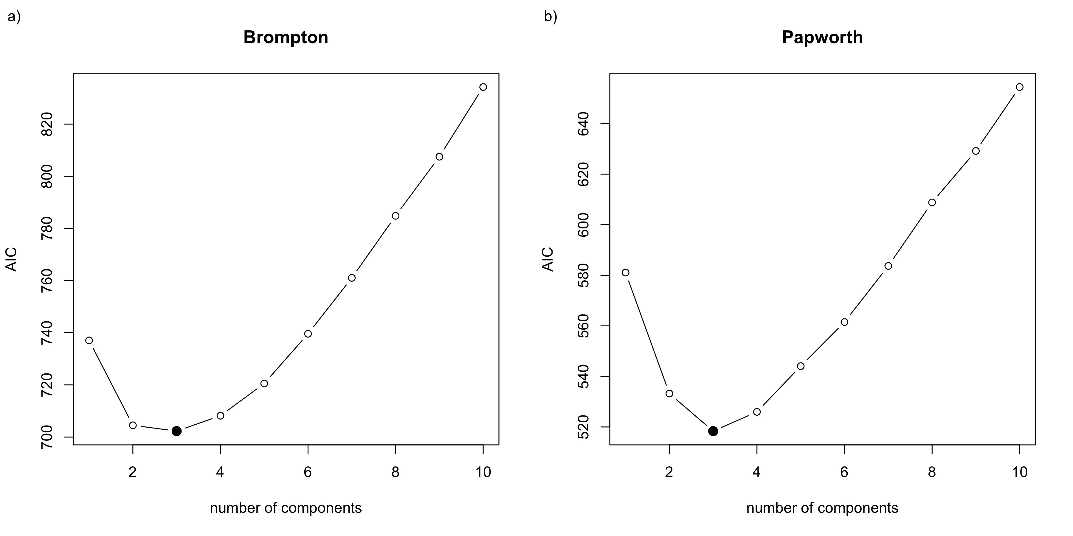
Figure S1. Identification of the optimum number of groups in a) the Royal Brompton cohort and b) the Papworth cohort. AIC = Aikake information criteria.

 | Total | Class |  |  | P value
 |  | 1 | 2 | 3
 | N = 63 | N = 8 | N = 19 | N = 35
Female Sex | 36 (58.1%) | 7 (87.5%) | 8 (42.1%) | 21 (60.0%) | 0.099
Age (years) | 68.3 (±14.8) | 71.8 (±11.3) | 64.7 (±17.8) | 69.4 (±13.8) | 0.432
Diagnosis |  |  |  |  | 0.033
Bronchiectasis | 45 (72.6%) | 5 (62.5%) | 10 (52.6%) | 30 (85.7%)
COPD | 7 (11.3%) | 1 (12.5%) | 4 (21.1%) | 2 (5.7%)
Other | 6 (9.7%) | 0 (0.0%) | 4 (21.1%) | 2 (5.7%)
No underlying lung disease | 4 (6.5%) | 2 (25.0%) | 1 (5.3%) | 1 (2.9%)
NTM species |  |  |  |  | 0.880
M. avium complex | 45 (72.6%) | 7 (87.5%) | 13 (68.4%) | 25 (71.4%)
M. abscessus | 8 (12.9%) | 1 (12.5%) | 2 (10.5%) | 5 (14.3%)
M. kansasii | 1 (1.6%) | 0 (0.0%) | 0 (0.0%) | 1 (2.9%)
M. xenopi | 1 (1.6%) | 0 (0.0%) | 1 (5.3%) | 0 (0.0%)
Other species | 7 (11.3%) | 0 (0.0%) | 3 (15.8%) | 4 (11.4%)

Table S4. Clinical characteristics of the Papworth cohort.

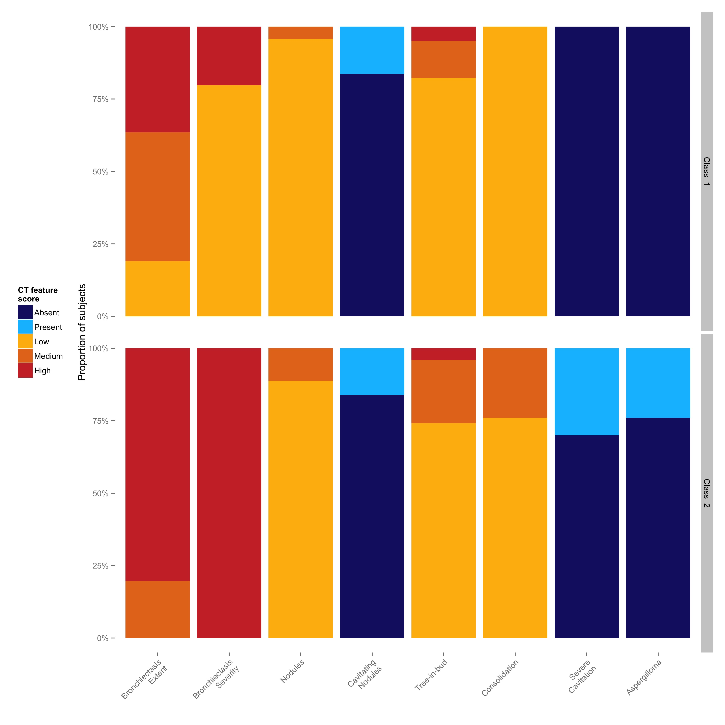
Figure S2. CT features of latent classes identified in subjects with bronchiectasis in the Royal Brompton cohort. The individual CT features used in the NTM scoring system are shown on the x-axes and the proportion of subjects on the y-axes. Colours represent the severity (low, medium or high), or the presence or absence of the CT feature.

a) |  | Original Analysis
 |  | Cavitary | Nodular | Bronchiectatic
Bronchiectasis only analysis | Class 1 | 0 | 13 | 12
 | Class 2 | 5 | 0 | 13
b) |  | Original Analysis
 |  | Cavitary | Nodular | Bronchiectatic
Bronchiectasis only analysis | Class 1 | 0 | 0 | 29
 | Class 2 | 0 | 9 | 0
 | Class 3 | 5 | 1 | 1

Table S5. Comparison of latent class membership in bronchiectasis subgroup analysis versus original analysis of the a) Brompton and b) Papworth cohorts.
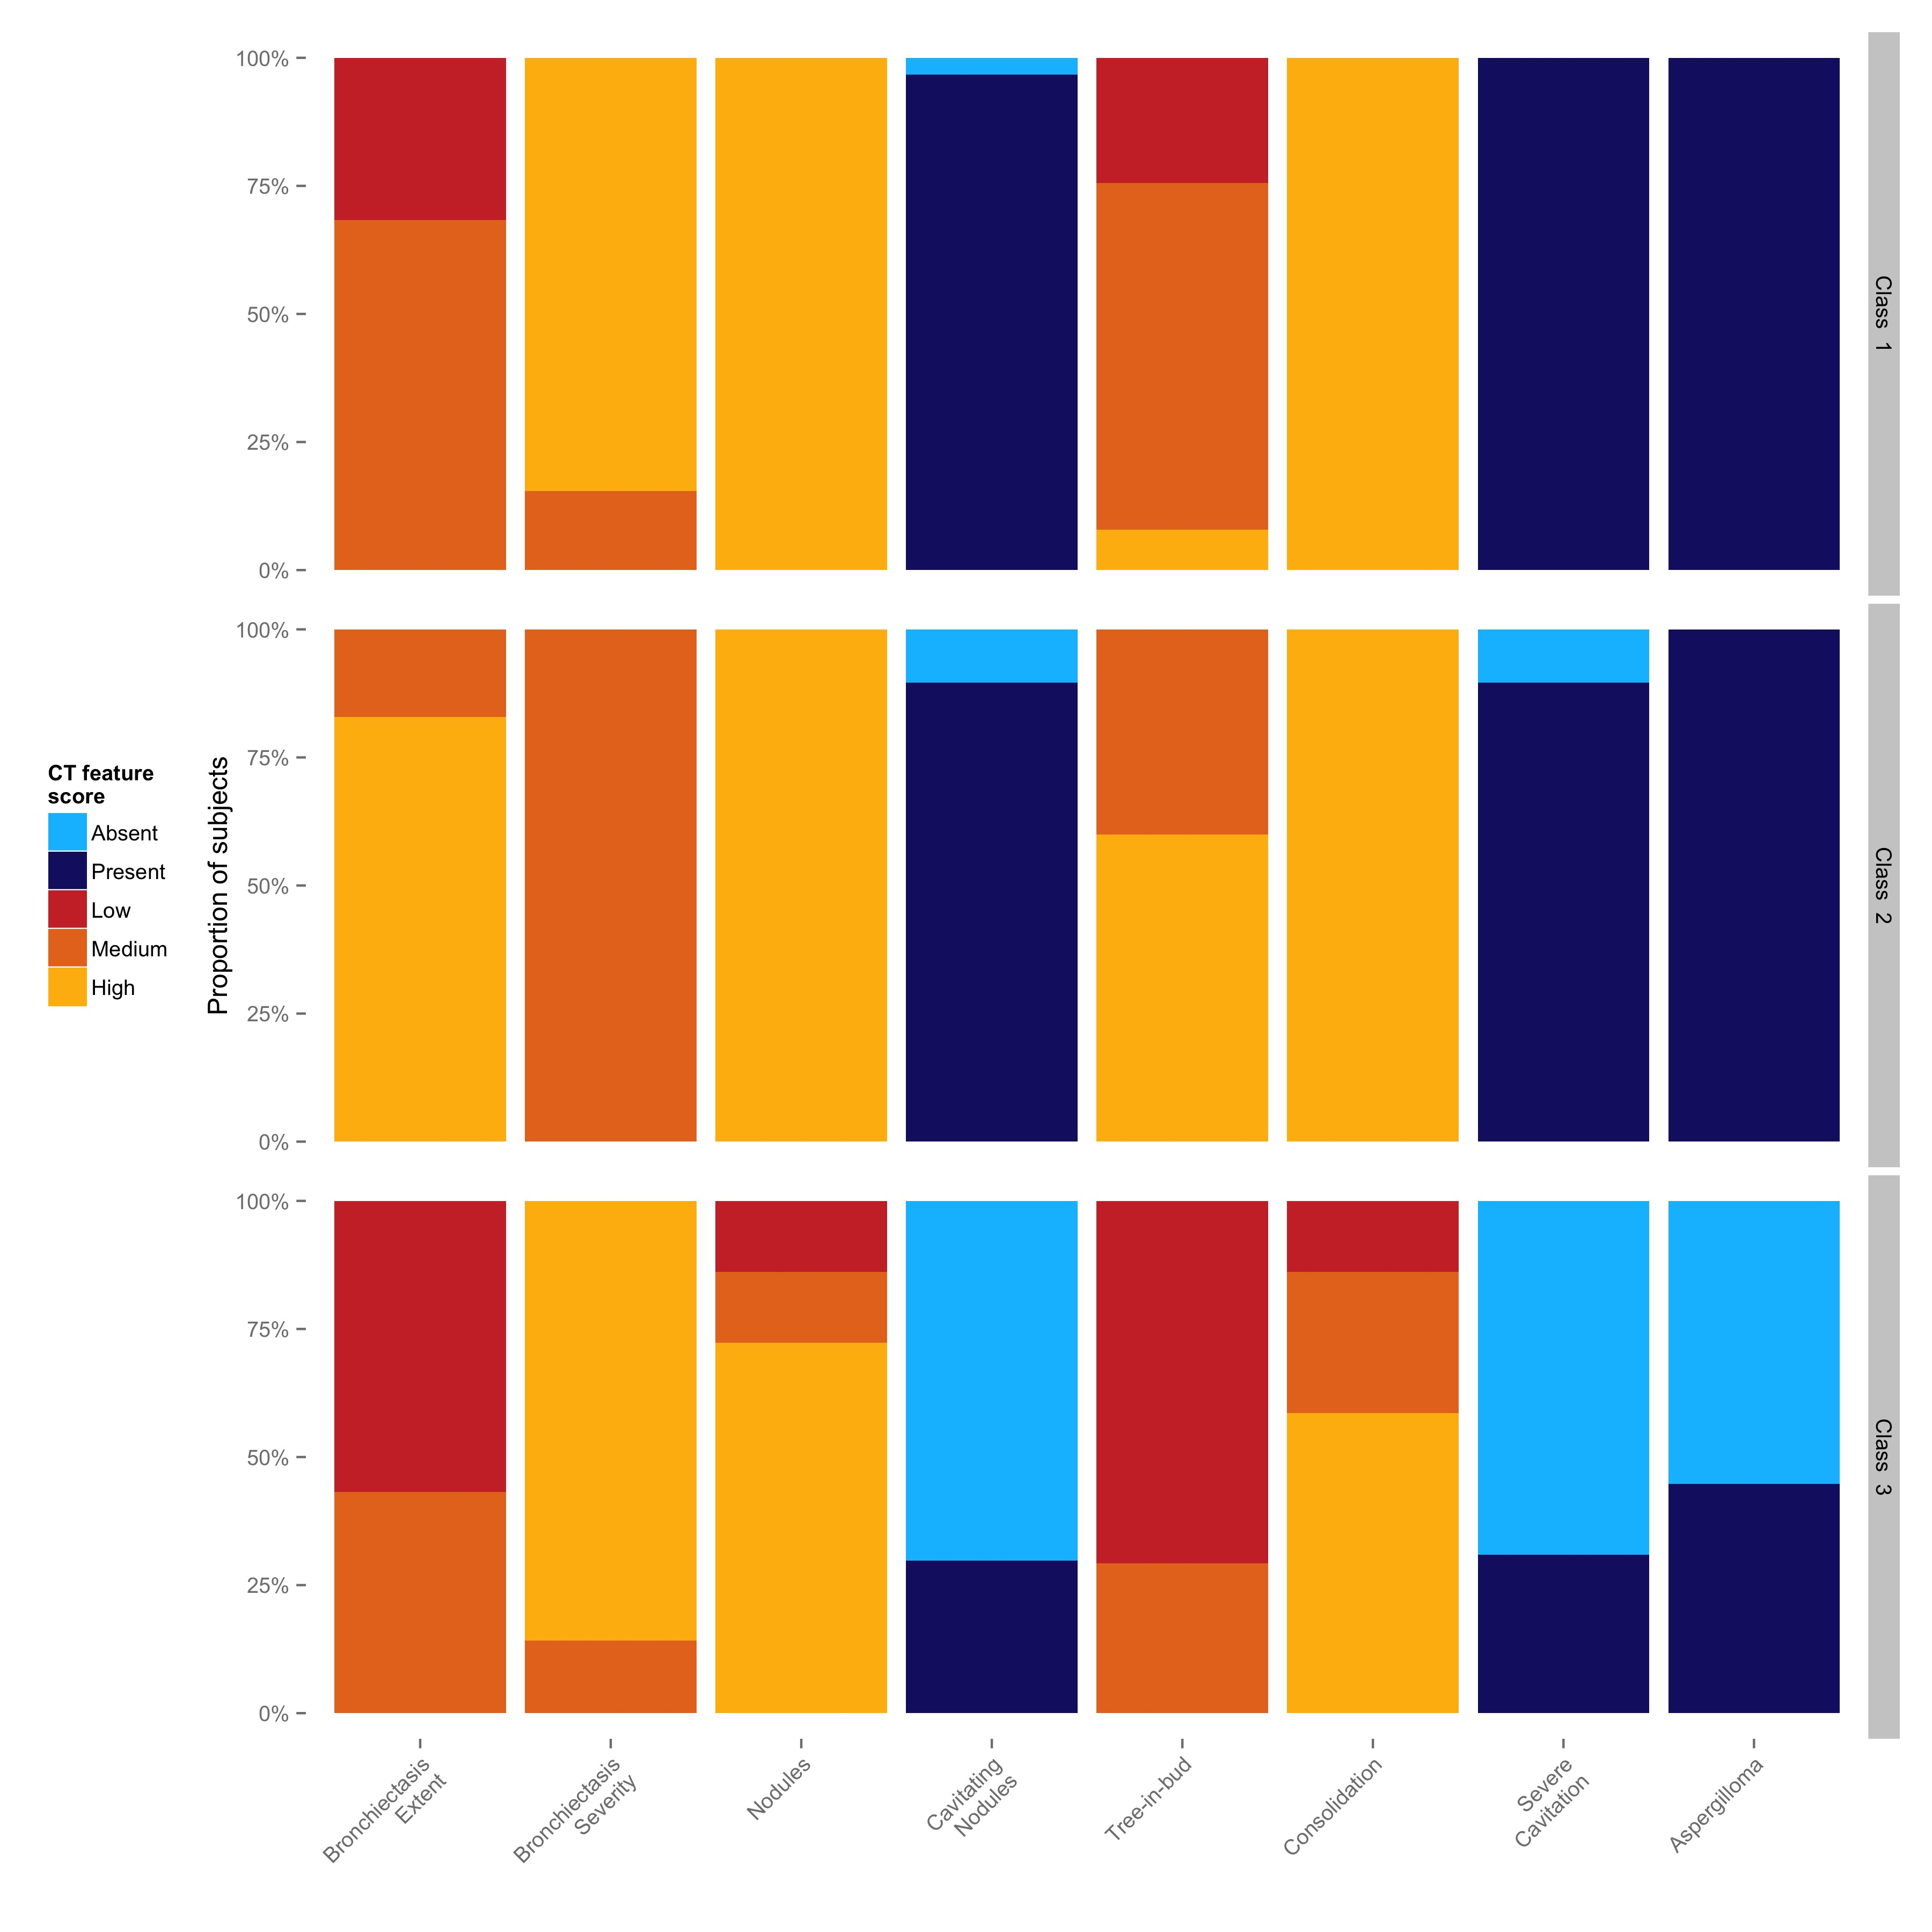
Figure S3. CT features of latent classes identified in subjects with bronchiectasis in the Papworth cohort. The individual CT features used in the NTM scoring system are shown on the x-axes and the proportion of subjects on the y-axes. Colours represent the severity (low, medium or high), or the presence or absence of the CT feature.

Supplementary References

1. Zoumot Z, Boutou AK, Gill SS, van Zeller M, Hansell DM, Wells AU, et al. Mycobacterium avium complex infection in non-cystic fibrosis bronchiectasis. Respirology. 2014;19:714–22.

