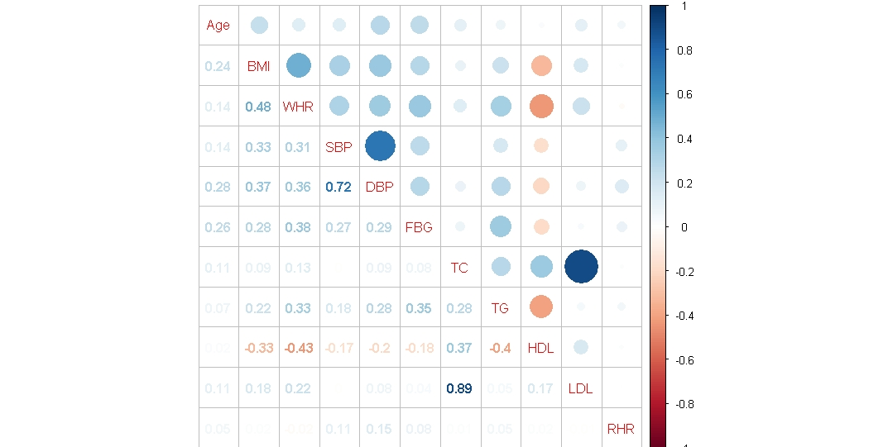
Figure S1 The correlation coefficients in independent variables
Statistically significant associations between two variables are shown, while the insignificant correlation coefficients are blank in the boxes. The positive correlations are represented by blue color, while negative correlations are represented by red color. BMI: body mass index; WHR: waist-hip ratio; FBG: fasting blood triglycerides; SBP: systolic blood pressure; DBP: diastolic blood pressure; TC: total cholesterol; TG: triglyceride; HDL: high-density lipoprotein; LDL: low-density lipoprotein; RHR: resting heart rate.

