Table S1 Quality control metrics of targeted sequencing data

|  |  |  |
| --- | --- | --- |
| DNA-seq statistics | Metastatic tumor sample | Normal Blood sample |
| Total paired reads | 131,511,308 | 23,179,706 |
| Aligned reads | 129,405,376 | 23,020,766 |
| Aligned reads(%) | 98.4% | 99.3% |
| Total bases | 9,966,484,989 | 1,757,394,414 |
| Aligned bases | 9,766,788,744 | 1,750,394,917 |
| Aligned bases(%) | 98.0% | 99.6% |
| Seq coveragea | 4806 | 479 |
| deduped coverage | 1728 | 432 |
| On target(%) | 69.58 | 71.63 |
| On flanking(%) | 17.13 | 17.09 |
| Off target(%) | 13.29 | 11.28 |
| Seq error-rate | 0.0045 | 0.0039 |
| Insert size estimated | 224.49 | 223.87 |

a sequence coverage before de-duplication.

Table S2 Quality control metrics of RNA-seq data

|  |  |
| --- | --- |
| RNA-seq statistics | Metastatic tumor sample |
| Total reads | 52,843,454 |
| Aligned reads | 49,785,763 |
| Aligned reads(%) | 94% |
| Total bases | 7,923,888,724 |
| Aligned bases | 7,375,518,110 |
| Aligned bases(%) | 93% |
| Ribosomal bases | 211,452,983 |
| Ribosomal bases(%) | 3% |
| Coding bases | 1,808,476,976 |
| Coding bases(%) | 25% |
| UTR bases | 1,737,703,765 |
| UTR bases(%) | 24% |
| Intronic bases | 494,191,043 |
| Intronic bases(%) | 7% |
| Intergenic bases | 3,125,511,437 |
| Intergenic bases(%) | 42% |

Figure S1. Average coverage (Log10 transformed) of targeted genes with data deduplication. Coverage of mutant genes were shown in grey bar, error bars indicted standard deviation of sequencing depths for each gene. Coverage of all genes sequenced were shown in red line.

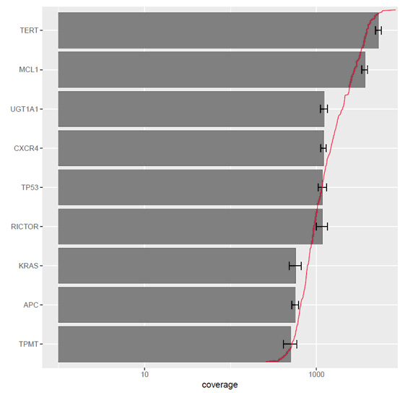

Figure S2. Fraction of reads that mapped to coding, intergenic, ribosomal, intronic, UTR and unmapped reads for metastasis RNA-seq.

