Supporting Information
Facile Synthesis of Two-dimensional Ruddlesden Popper Perovskite Quantum Dots with Fine Tunable Optical Properties
Yi-Hsuan Chang, ^{1#} Jou-Chun Lin,^{1,2#} Yi-Chia Chen,¹ Tsung-Rong Kuo,²* Di-Yan Wang¹*

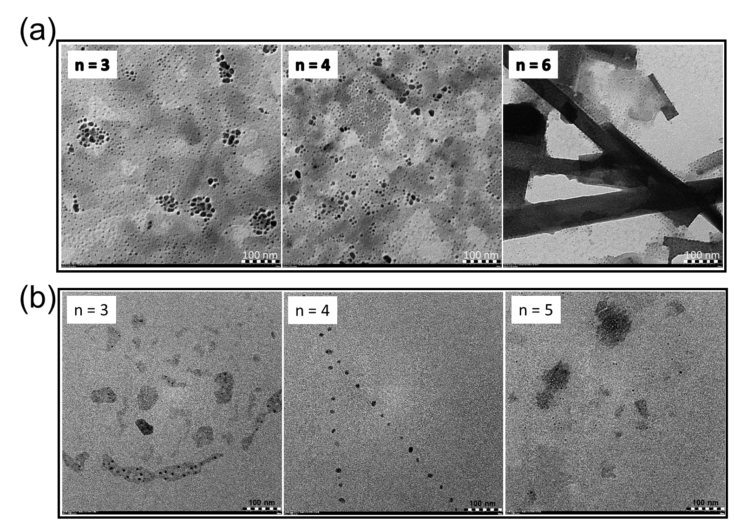
Figure S1. (a) TEM images of 2D Br-series perovskite QDs with n= 3,4 and 6. (b) TEM images of 2D I-series perovskite QDs with n= 3, 4 and 5.

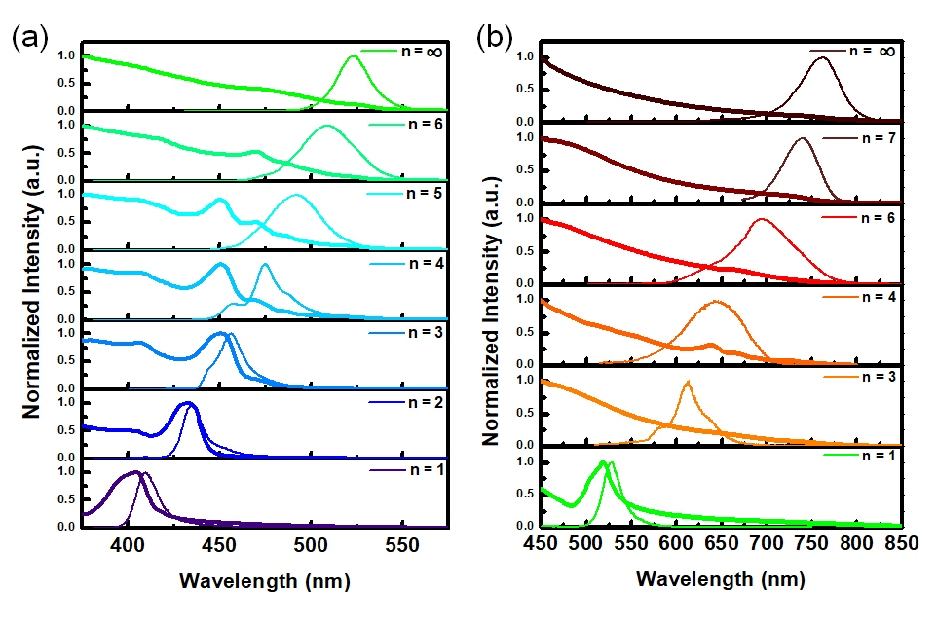
Figure S2. The UV-Vis absorption spectra and related PL spectra of 2D RP perovskite QDs with (a) Br-series and (b) I-series with varied n values.

