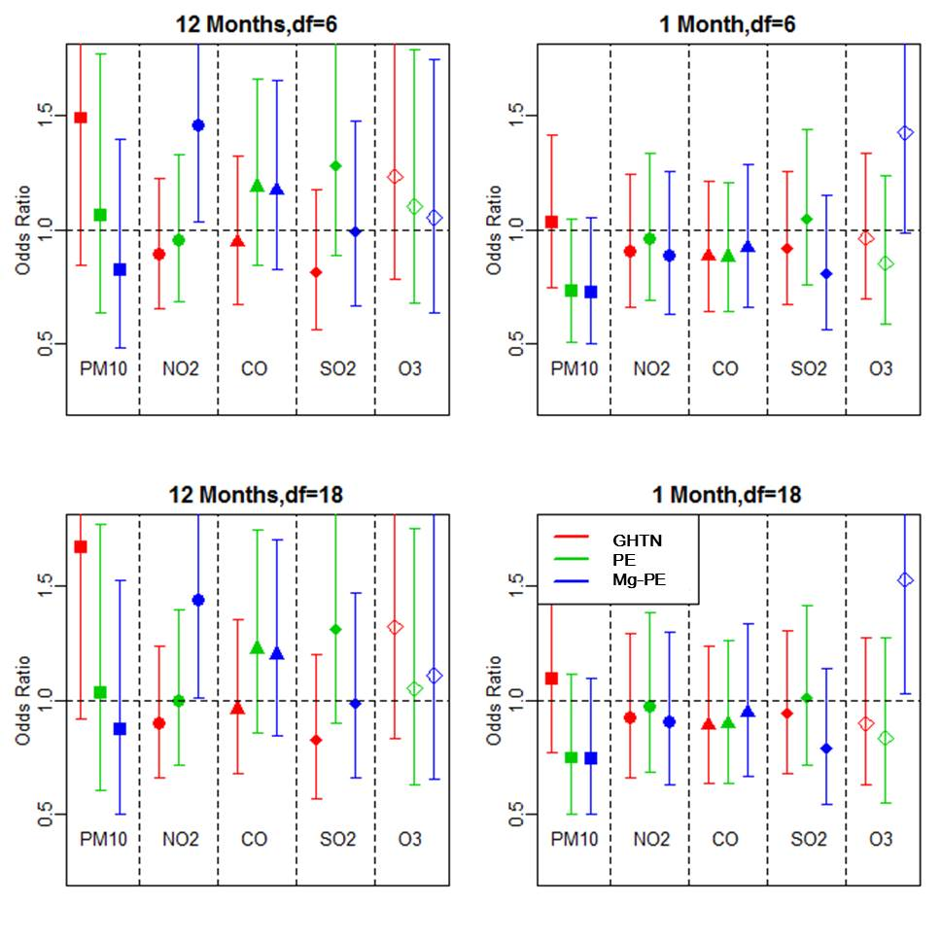
Supplemental figure 2. Additional sensitivity analysis with different degrees of freedom for risk of each hypertensive disorder of pregnancy.
PM_{10,} particulate matter; NO_{2,} nitrogen dioxide; CO, carbon monoxide, SO_{2,} sulfur dioxide; O_{3,} ozone; GHTN, Gestational hypertension; PE, preeclampsia; Mg-PE, preeclampsia requiring magnesium sulfate.

