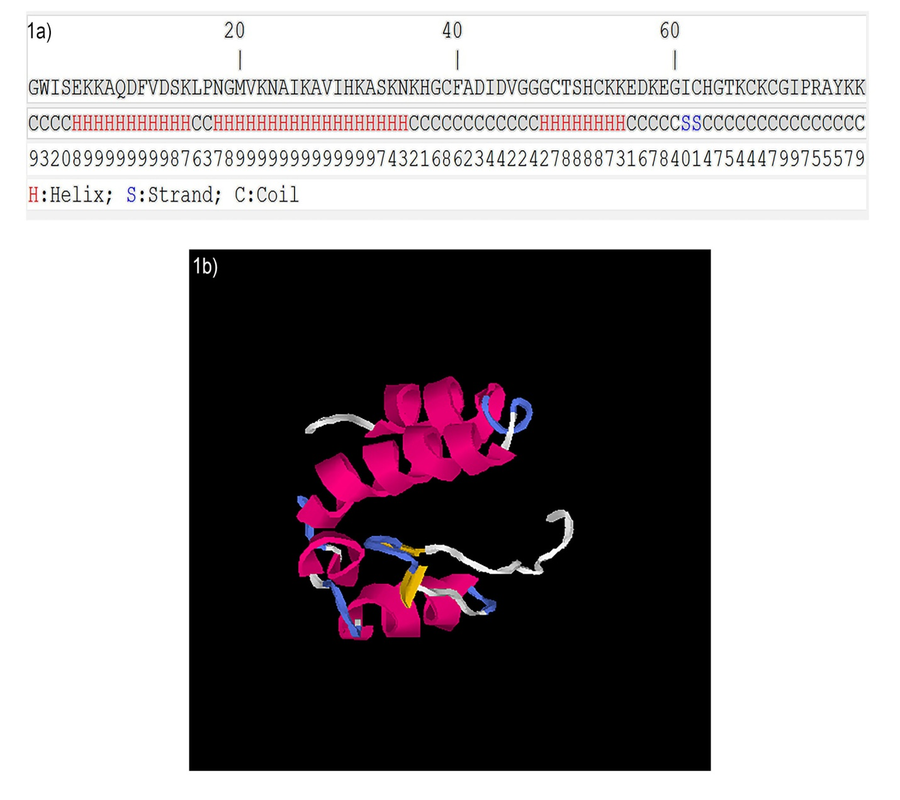

Additional file 1: Figure S1. The amino acid sequence and depiction of the three-dimensional structure of scorpine like molecule (SLM). (a) SLM sequence showing predicted domains with helix-coil structure. (b) 3-D structure of SLM as depicted by I-TASSER.

