AMB Express

ADDITIONAL FILE

Metabolomics analysis of Pseudomonas chlororaphis JK12 Algicidal Activity Under Aerobic and Micro-aerobic Culture Condition

Jaejung Kim¹, Xiaomei Lyu¹, Jaslyn Jie Lin Lee¹, Guili Zhao¹, Chin Seow Fong², Liang Yang²*, Wei Ning Chen¹*

* Corresponding authors:
Wei Ning Chen
Email: WNChen@ntu.edu.sg
Tel: (+65) 6316 2870

Liang Yang
Email: Yangliang@ntu.edu.sg
Tel: (+65) 65923085

¹Address: School of Chemical and Biomedical Engineering, College of Engineering, Nanyang Technological University, 62 Nanyang Drive, Singapore 637459, Singapore
Tel: (+65)6316 2870

²Address: Singapore Centre for Environmental Life Sciences Engineering, Nanyang Technological University, 60 Nanyang Drive, Singapore 637551, Singapore

List of Figures
Fig. S1 ESI mass spectrum recorded by LC-MS analysis in positive ion mode for JK12 metabolites from a. aerobic culture and b. micro-aerobic culture
Fig. S2 ESI mass spectrum recorded by LC-MS analysis in negative ion mode for JK12 metabolites from a. aerobic culture and b. micro-aerobic culture
Fig. S3 PCA plot based on LC-MS analysis in positive ion mode for JK12 metabolites from aerobic and micro-aerobic culture
Fig. S4 PCA plot based on LC-MS analysis in negative ion mode for JK12 metabolites from aerobic and micro-aerobic culture
Fig. S5 Heatmap correlation based on LC-MS analysis in positive ion mode for JK12 metabolites from aerobic and micro-aerobic culture
Fig. S6 Heatmap correlation based on LC-MS analysis in negative ion mode for JK12 metabolites from aerobic and micro-aerobic culture

List of Tables
Table S1 List of identified metabolites extracted from JK12 media based on LC-MS analysis in positive ion mode
Table S2 List of identified metabolites extracted from JK12 media based on LC-MS analysis in negative ion mode
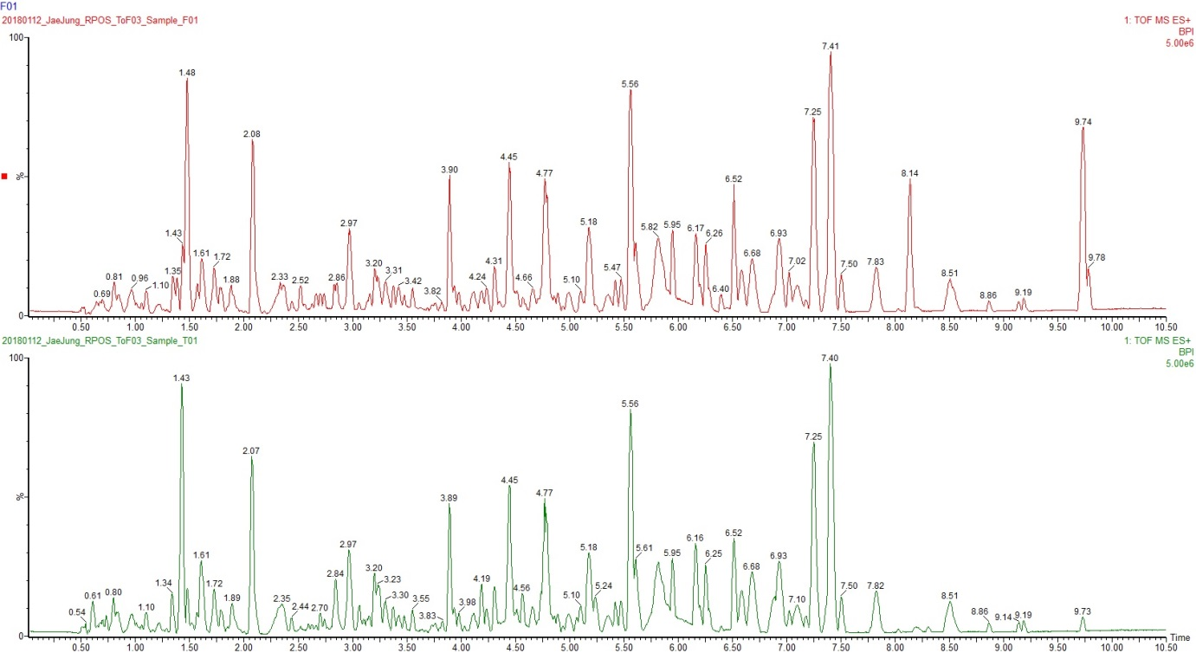
b
a
a
Fig. S1 ESI mass spectrum recorded by LC-MS analysis in positive ion mode for JK12 metabolites from a. aerobic culture and b. micro-aerobic culture
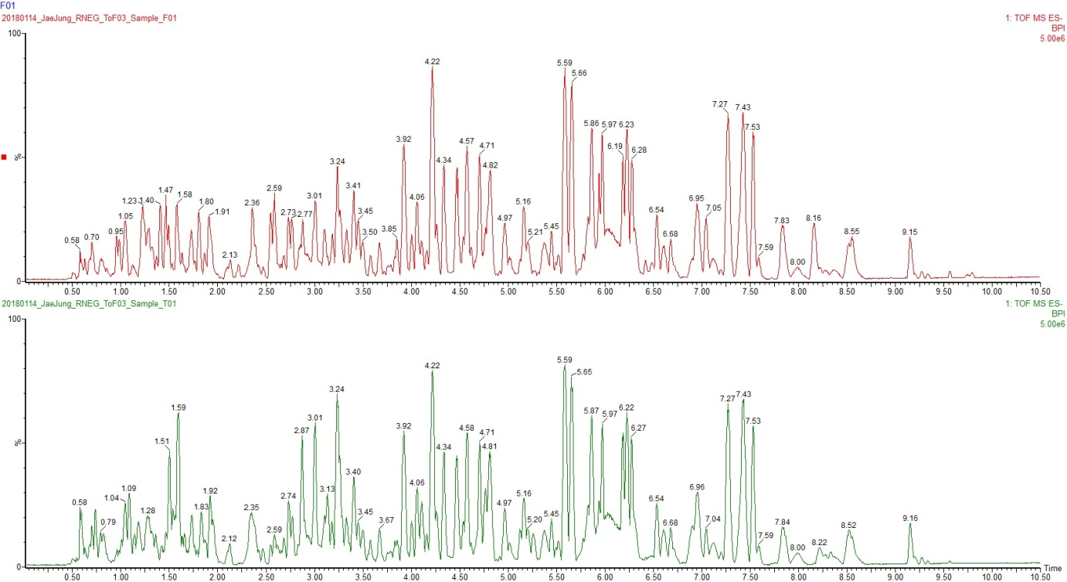
b

Fig. S2 ESI mass spectrum recorded by LC-MS analysis in negative ion mode for JK12 metabolites from a. aerobic culture and b. micro-aerobic culture

Fig. S3 PCA plot based on LC-MS analysis in positive ion mode for JK12 metabolites from aerobic and micro-aerobic culture

Fig. S4 PCA plot based on LC-MS analysis in negative ion mode for JK12 metabolites from aerobic and micro-aerobic culture

Fig. S5 Heatmap correlation based on LC-MS analysis in positive ion mode for JK12 metabolites from aerobic and micro-aerobic culture

Fig. S6 Heatmap correlation based on LC-MS analysis in negative ion mode for JK12 metabolites from aerobic and micro-aerobic culture

Table S1 List of identified metabolites extracted from JK12 media based on LC-MS analysis in positive ion mode
Feature | ANOVA  p-value | Putative Identification |  | Aerobic JK12 |  | Micro-aerobic JK12
 |  | Name | ID | Intensity | %CV | Intensity | %CV
0.50_177.0616m/z | 8.22E-06 | Allantoic acid | HMDB01209 | 8,189.28 | 22.28 | 480,626.07 | 2.74
0.50_427.1525m/z | 2.05E-05 | Chitobiose | HMDB03556 | 365.74 | 62.13 | 967,011.34 | 0.50
0.57_147.1136m/z | 2.41E-05 | L-Lysine | HMDB00182 | 895.23 | 21.57 | 14,163.45 | 5.98
0.57_156.0773m/z | 1.10E-05 | L-Histidine | HMDB00177 | 5,340.43 | 19.12 | 142,197.82 | 5.77
0.57_175.1197m/z | 8.78E-06 | L-Arginine | HMDB00517 | 57,378.03 | 6.87 | 425,968.41 | 10.13
0.61_166.0540m/z | 2.05E-06 | Methionine sulfoxide | HMDB02005 | 276,086.31 | 0.13 | 148,856.34 | 2.58
0.64_248.1147m/z | 4.25E-05 | Malonylcarnitine | HMDB02095 | 429,449.56 | 1.95 | 338,679.61 | 0.86
0.66_144.0661m/z | 2.13E-06 | Vinylacetylglycine | HMDB00894 | 192,334.26 | 3.61 | 46,360.58 | 4.75
0.69_397.2562m/z | 3.82E-08 | PGF2alpha-11-acetate | 4266024 | 120,842.37 | 0.27 | 402,920.36 | 1.85
0.70_259.0935m/z | 4.07E-07 | Ribothymidine | HMDB00884 | 1,753,932.59 | 0.22 | 719,848.19 | 2.50
0.73_306.0498m/z | 1.17E-07 | Cyclic CMP | HMDB11691 | 146,359.71 | 5.02 | 2,127,122.98 | 2.04
0.92_130.0869m/z | 1.25E-07 | Pipecolic acid | HMDB00070 | 28,422.98 | 4.76 | 303,779.29 | 1.06
0.93_146.0930m/z | 6.16E-07 | 4-Guanidinobutanoic acid | HMDB03464 | 67,716.15 | 3.90 | 406,394.97 | 3.91
0.93_181.0705m/z | 3.95E-07 | D-Glucose | HMDB00122 | 179,131.77 | 1.24 | 47,316.69 | 3.46
0.95_324.0603m/z | 0.0005 | Cytidine monophosphate | HMDB00095 | 68,603.98 | 5.25 | 29,040.80 | 13.72
0.96_517.3349m/z | 1.64E-06 | IC202C | LMFA08020184 | 209,593.13 | 6.90 | 1,190,155.30 | 0.42
1.00_139.0508m/z | 1.54E-06 | Urocanic acid | HMDB00301 | 10,782.63 | 5.17 | 245,489.47 | 10.92
1.02_262.1297m/z | 4.04E-06 | Methylmalonylcarnitine | HMDB13133 | 1,132,116.04 | 0.80 | 1,338,901.07 | 0.23
1.07_307.0335m/z | 1.76E-06 | Cyclic UMP | HMDB11640 | 177,486.20 | 4.59 | 2,104,311.87 | 9.00
1.11_169.0363m/z | 2.46E-06 | Uric acid | HMDB00289 | 113,752.47 | 6.96 | 966,230.18 | 6.16
1.38_227.1036m/z | 2.41E-06 | Porphobilinogen | HMDB00245 | 653,301.46 | 0.73 | 535,010.77 | 0.48
1.38_348.0713m/z | 1.40E-06 | Adenosine monophosphate | HMDB00045 | 4,118,450.12 | 5.08 | 1,054,283.62 | 0.58
1.44_152.0571m/z | 1.81E-06 | Guanine | HMDB00132 | 1,396,388.43 | 3.47 | 438,235.52 | 3.12
1.47_330.0607m/z | 7.06E-05 | Cyclic AMP | HMDB11616 | 3,001,312.45 | 5.39 | 5,246,635.98 | 1.96
1.56_346.0557m/z | 1.23E-05 | Cyclic GMP | HMDB11629 | 2,064,230.53 | 2.17 | 3,004,501.02 | 1.20
1.71_268.1052m/z | 5.66E-05 | Adenosine | HMDB00050 | 185,245.43 | 4.98 | 89,295.52 | 4.96
1.78_308.0985m/z | 0.0001 | (S)-Succinyldihydrolipoamide | HMDB01177 | 370,875.25 | 1.04 | 451,249.95 | 1.94
2.41_237.0876m/z | 7.05E-07 | N'-Formylkynurenine | HMDB01200 | 23,645.69 | 6.57 | 261,104.54 | 3.85
2.65_209.0927m/z | 0.0135 | L-Kynurenine | HMDB00684 | 1,026,764.27 | 1.30 | 1,106,129.27 | 2.78
2.66_181.0975m/z | 0.1025 | Tyrosinamide | HMDB13319 | 111,885.05 | 1.86 | 117,809.50 | 3.81
2.73_220.1189m/z | 1.56E-05 | Pantothenic acid | HMDB00210 | 124,604.41 | 1.11 | 259,480.54 | 5.05
3.25_188.0713m/z | 1.67E-05 | L-Tryptophan, fragment | HMDB00929 | 181,073.22 | 25.44 | 11,002,632.68 | 9.14
3.69_190.0505m/z | 1.07E-06 | Kynurenic acid | HMDB00715 | 1,118,687.15 | 3.89 | 255,731.32 | 3.59
4.87_377.1462m/z | 0.0002 | Riboflavin | HMDB00244 | 277,841.86 | 4.18 | 411,445.79 | 3.11
5.07_239.0589m/z | 0.0003 | L-4-Chlorotryptophan | HMDB30400 | 2,990.77 | 54.16 | 344,169.70 | 5.35
5.51_484.3100m/z | 2.10E-05 | Taurolithocholic acid | 24702367 | 88,395.18 | 1.19 | 231,747.95 | 6.98
7.03_1008.5723m/z | 7.32E-05 | CDP-DG(18:0/18:1) | HMDB06979 | 10,479,453.09 | 4.64 | 6,565,398.58 | 1.05

Table S2 List of identified metabolites extracted from JK12 media based on LC-MS analysis in negative ion mode
Feature | ANOVA  p-value | Putative Identification |  | Aerobic JK12 |  | Micro-aerobic JK12
 |  | Name | ID | Intensity | %CV | Intensity | %CV
0.55_145.0972m/z | 1.17E-09 | L-Lysine | HMDB00182 | 49,340.81 | 1.95 | 1,576,807.50 | 1.11
0.56_154.0611m/z | 5.24E-08 | L-Histidine | HMDB00177 | 17,457.06 | 4.85 | 848,780.75 | 4.32
0.57_173.1031m/z | 0.0001 | L-Arginine | HMDB00517 | 20,093.98 | 2.84 | 104,820.86 | 20.31
0.58_195.0501m/z | 1.21E-05 | Galactonic acid | HMDB00565 | 3,749,047.50 | 3.60 | 8,184,125.26 | 3.62
0.73_304.0331m/z | 4.80E-08 | Cyclic CMP | HMDB11691 | 487,053.05 | 0.80 | 6,946,763.27 | 4.32
0.76_132.0291m/z | 0.0292 | L-Aspartic acid | HMDB00191 | 30,113.32 | 6.18 | 25,722.73 | 5.36
0.86_116.0707m/z | 5.07E-07 | L-Valine | HMDB00883 | 10,877.08 | 12.81 | 833,783.90 | 0.77
0.88_307.0324m/z | 6.35E-07 | dUMP | HMDB01409 | 108,581.66 | 1.39 | 643,409.43 | 5.43
0.96_322.0436m/z | 1.05E-05 | Cytidine monophosphate | HMDB00095 | 6,256,084.84 | 2.26 | 2,759,785.52 | 4.65
0.97_515.3190m/z | 7.50E-07 | IC202C | LMFA08020184 | 92,998.79 | 4.69 | 1,024,342.75 | 6.26
1.09_305.0173m/z | 3.88E-08 | Cyclic UMP | HMDB11640 | 1,361,722.54 | 4.28 | 21,996,453.92 | 0.70
1.14_167.0201m/z | 4.58E-08 | Uric acid | HMDB00289 | 555,388.74 | 2.75 | 4,769,739.14 | 2.13
1.23_323.0278m/z | 6.19E-09 | Uridine monophosphate | HMDB00288 | 17,784,490.73 | 1.90 | 1,220,087.08 | 1.80
1.42_346.0551m/z | 2.72E-06 | Adenosine monophosphate | HMDB00045 | 10,706,538.80 | 5.08 | 3,199,751.00 | 1.85
1.47_180.0656m/z | 7.65E-08 | L-Tyrosine | HMDB00158 | 129,909.35 | 6.68 | 4,815,417.91 | 0.97
1.47_362.0500m/z | 5.76E-06 | Guanosine monophosphate | HMDB01397 | 10,105,873.15 | 4.76 | 4,020,543.96 | 1.62
1.49_286.1036m/z | 3.34E-05 | N-Ribosylhistidine | HMDB02089 | 1,349,471.44 | 0.44 | 1,568,558.27 | 1.19
1.50_328.0445m/z | 2.82E-05 | Cyclic AMP | HMDB11616 | 7,942,235.28 | 5.62 | 15,798,332.06 | 0.64
1.54_130.0864m/z | 8.79E-07 | L-Isoleucine | HMDB00172 | 19,776.44 | 14.64 | 1,683,753.17 | 5.23
1.59_133.0145m/z | 6.74E-06 | L-Malic acid | HMDB00156 | 120,363.18 | 3.58 | 225,641.20 | 0.20
1.59_344.0393m/z | 1.98E-06 | Cyclic GMP | HMDB11629 | 12,419,480.55 | 2.96 | 25,478,751.25 | 0.31
1.63_257.0771m/z | 6.38E-07 | 3-Methyluridine | HMDB04813 | 712,610.27 | 4.93 | 4,001,638.23 | 2.27
1.67_205.0344m/z | 2.84E-06 | 2-Methylcitric acid | HMDB00379 | 1,275,365.68 | 2.36 | 543,108.79 | 3.04
1.81_673.0924m/z | 3.45E-05 | cyclic GMP-AMP | HMDB60465 | 281,187.55 | 6.26 | 39,663.80 | 15.87
1.87_296.0983m/z | 3.66E-05 | 1-Methylguanosine | HMDB01563 | 277,803.99 | 0.23 | 176,730.60 | 3.94
2.23_497.1007m/z | 2.65E-06 | N,N'-Bis(gamma-glutamyl)cystine | HMDB38458 | 77,626.58 | 1.66 | 190,687.01 | 3.64
2.25_351.0480m/z | 0.0002 | Arbutin 6-phosphate | nnF5b@911lWF@lo | 212,968.72 | 1.16 | 249,252.88 | 1.80
2.35_164.0708m/z | 4.20E-08 | L-Phenylalanine | HMDB00159 | 390,532.37 | 3.46 | 6,912,646.72 | 2.98
2.36_249.1343m/z | 1.70E-06 | Isopentyl beta-D-glucoside | HMDB34750 | 155,728.03 | 1.52 | 229,156.72 | 0.28
2.76_218.1025m/z | 6.57E-07 | Pantothenic acid | HMDB00210 | 576,611.61 | 1.53 | 1,383,866.78 | 2.31
3.14_232.1180m/z | 2.59E-05 | Hydroxypropionylcarnitine | HMDB13125 | 440,723.98 | 1.13 | 128,211.32 | 9.99
3.27_203.0816m/z | 1.70E-06 | L-Tryptophan | HMDB00929 | 103,586.63 | 10.28 | 3,511,704.05 | 9.70
3.36_543.2717m/z | 4.11E-07 | 2-deoxy-20-hydroxyecdysone 22-phosphate | 85300615 | 1,867,155.79 | 1.75 | 4,835,710.88 | 2.02
3.48_644.3222m/z | 0.0002 | S-(9-hydroxy-PGA1)-glutathione | HMDB13059 | 424,803.89 | 1.40 | 479,696.64 | 0.84
3.59_222.0760m/z | 6.34E-05 | N-Acetyl-L-tyrosine | HMDB00866 | 145,592.94 | 1.66 | 112,903.44 | 1.90
3.72_188.0343m/z | 7.49E-07 | Kynurenic acid | HMDB00715 | 987,696.02 | 4.35 | 227,853.77 | 2.05
3.83_784.1497m/z | 6.60E-07 | FAD | HMDB01248 | 395,917.13 | 3.47 | 86,163.92 | 3.34
3.87_175.0600m/z | 9.94E-09 | 2-Isopropylmalic acid | HMDB00402 | 233,437.11 | 1.82 | 1,970.73 | 4.97
5.09_237.0427m/z | 0.0001 | L-4-Chlorotryptophan | HMDB30400 | 3,199.78 | 68.30 | 1,297,294.64 | 4.49
7.04_1006.5592m/z | 3.47E-05 | CDP-DG(18:0/18:1) | HMDB06979 | 18,597,878.19 | 0.74 | 11,589,660.00 | 4.01
7.04_1028.5408m/z | 0.0004 | CDP-DG(18:0/20:4) | HMDB06982 | 2,489,119.42 | 2.89 | 1,977,840.67 | 2.09
7.12_625.3352m/z | 0.0005 | PI(20:1/0:0) | 123066181 | 12,164,418.64 | 0.49 | 12,687,373.83 | 0.53
7.75_655.3813m/z | 0.0001 | PI(22:0/0:0) | 123066186 | 2,413,614.37 | 3.77 | 3,367,639.49 | 0.48

