Supplementary material 1. Schematic representation of the study design.
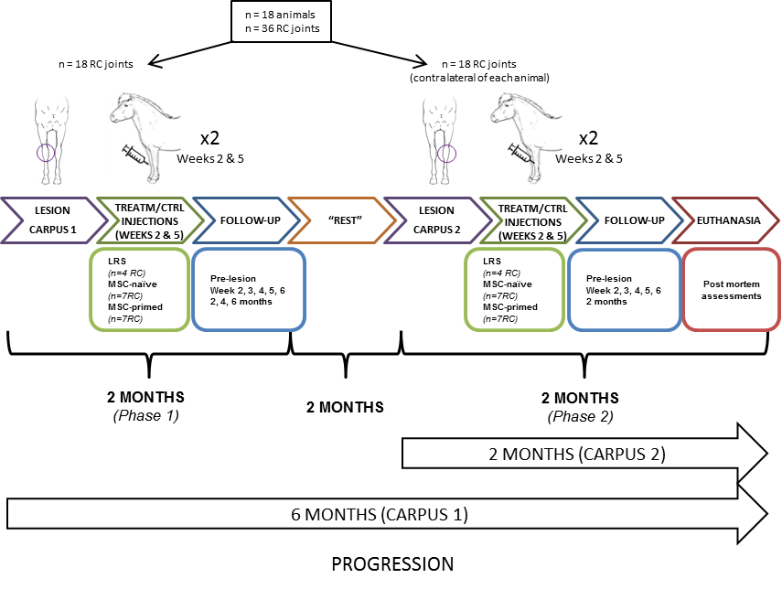
In phase 1, lesion was created in one random radio-carpal (RC)-joint of each animal. On weeks 2 and 5 after inducing the arthritis, repeat injections of corresponding substance (TREATM = treatment: 10·10⁶ unstimulated mesenchymal stem cells [MSC-naïve] or 10·10⁶ of TNFα + IFNγ-stimulated cells [MSC-primed]; or CTRL = control: Lactate’s Ringer Solution [LRS]) were administered to corresponding RC-joints from animals in the MSC-naïve, MSC-primed and control groups; respectively. Serial follow-up (clinical, synovial and imaging assessments) was carried out up to two months and animals “rested” for additional two months. Thus, four months after inducing the first lesion, phase 2 was carried out in which the contralateral RC-joint of each animal was subjected to the same corresponding procedure: second lesion was induced, identical injections administered –depending on the group- and follow-up performed during two months. At this point (six months since the first lesion induction for phase 1, two months since the second one for phase 2), animals were euthanized to conduct post-mortem assessments including magnetic resonance imaging (MRI), gross anatomy, histopathology and gene expression analysis. Therefore, first lesion induced in phase 1 had progressed along six months (long-term) while second lesion created in phase 2 had progressed for only two months (short-term), providing two different end-points for post-mortem assessments without duplicating the number of animals involved.

