Expression of a hyperthermophilic endoglucanase in hybrid poplar modifies the plant cell wall and enhances digestibility

Yao Xiao; Xuejun He; Yemaiza Ojeda-Lassalle; Charleson Poovaiah¹; Heather D. Coleman*
Biology Department, Syracuse University, Syracuse, NY, USA 13244
¹Current affiliation: Scion, Te Papa Tipu Innovation Park, 49 Sala Street, Rotorua 3010, New Zealand
*Corresponding author: Heather D. Coleman (hcoleman@syr.edu)
ADDITIONAL FILE 1
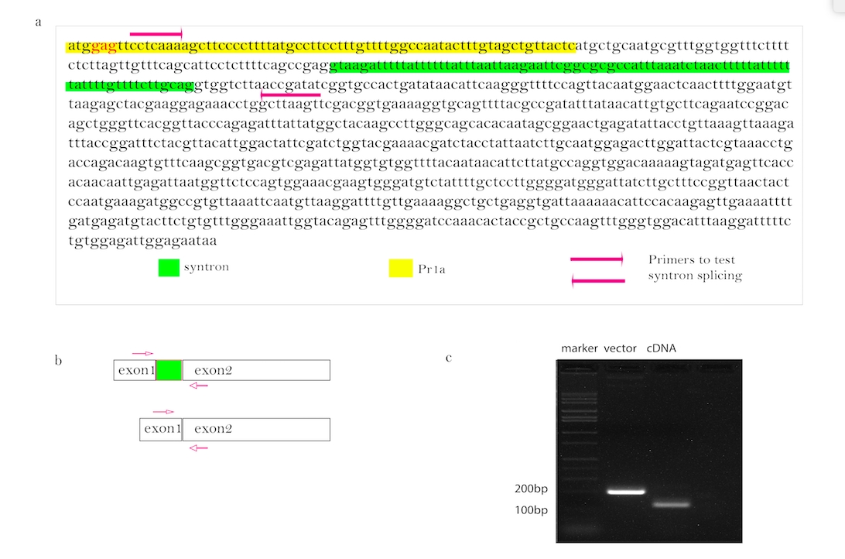

Fig S1. Fig S1. Synthesized TnCelB gene sequence and splicing confirmation. (a) Codon optimized sequence of TnCelB (b) Primer location to detect splicing of intron (c) PCR results detecting correct intron splicing

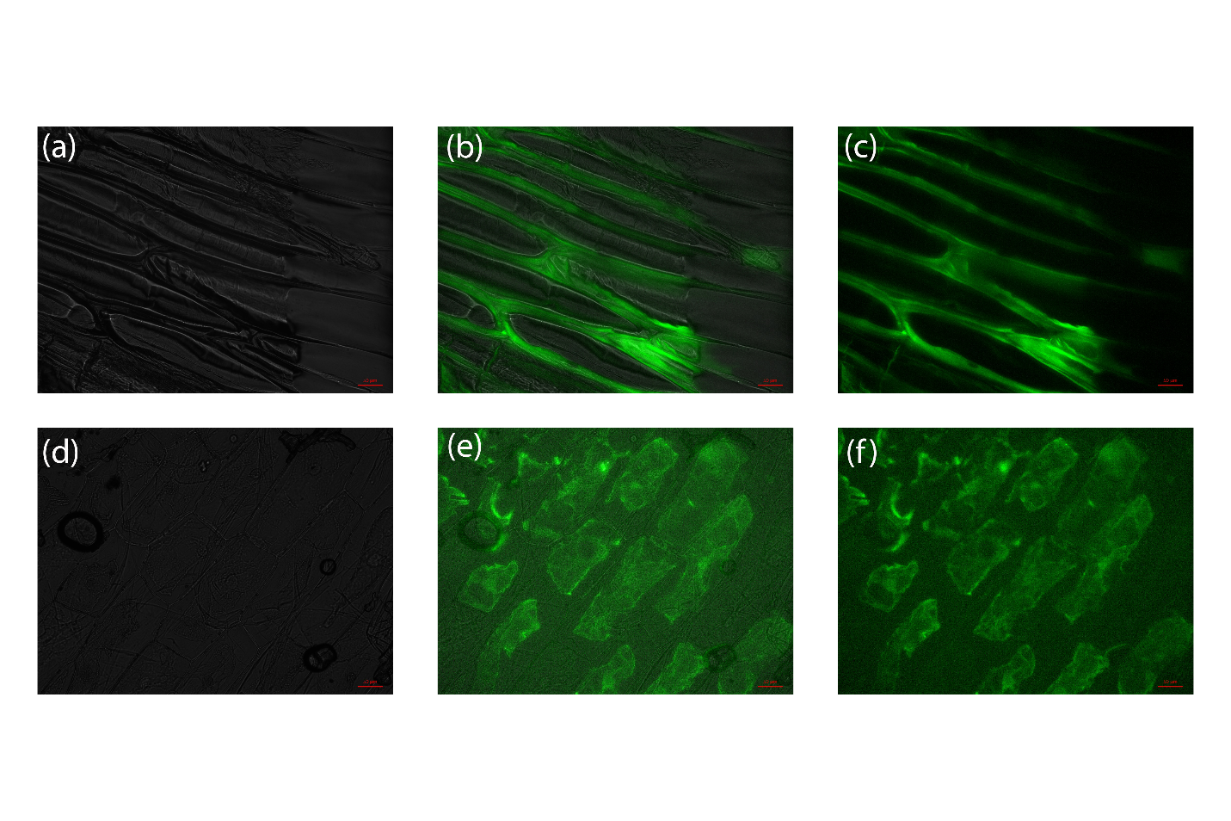
Fig S2. Mutated PR1a targeted GFP to the apoplast. Onion epidermal cells infiltrated with GFP fused with the mutated PR1a sequence (a,b,c) or with GFP without the targeting sequence (d,e,f); pictures were taken under white field (a,d); fluorescent light (e,f); merged (b,e)

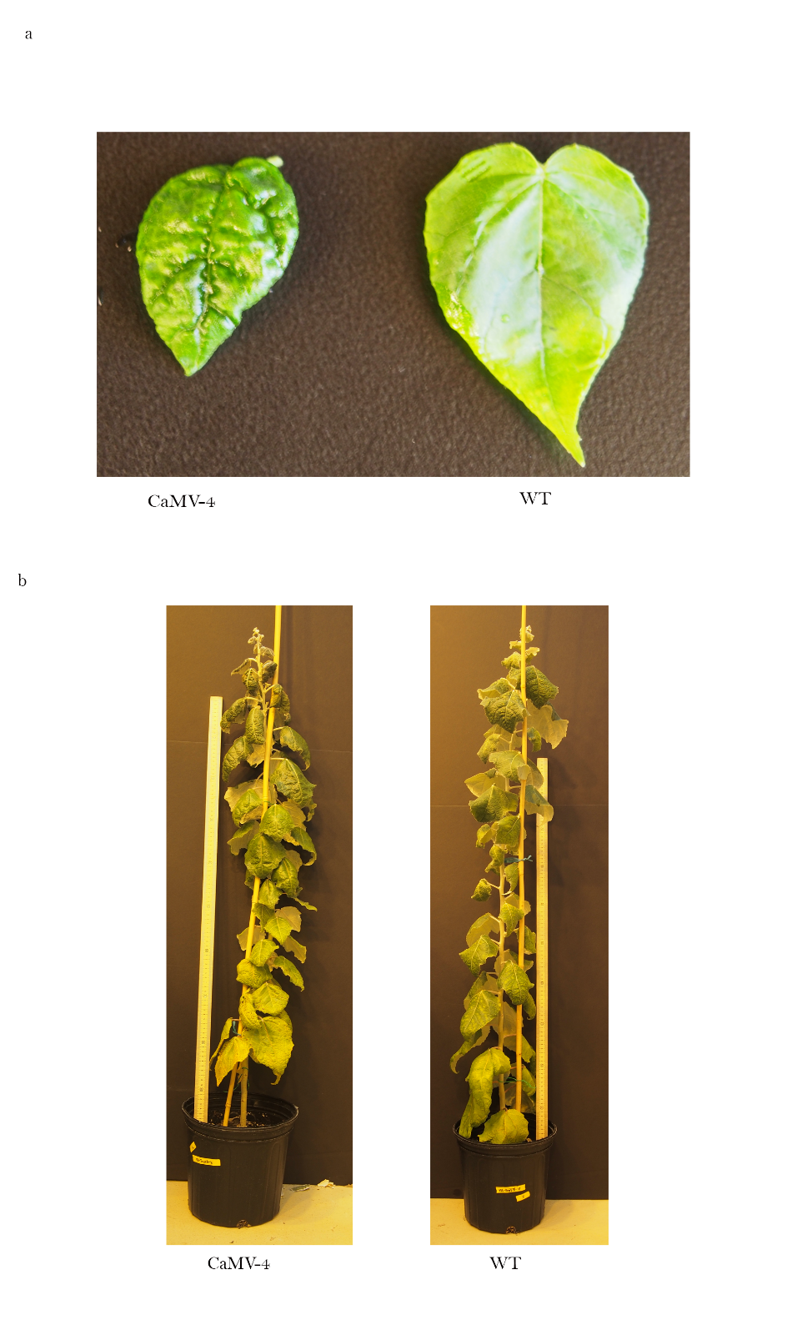
Fig S3. Abnormal phenotypes of CaMV-4. (a) Wrinkled leaf surface of CaMV-4 line expressing TnCelB compared with WT; (b) Dehydrated apical region of CaMV-4 line expressing TnCelB compared to WT

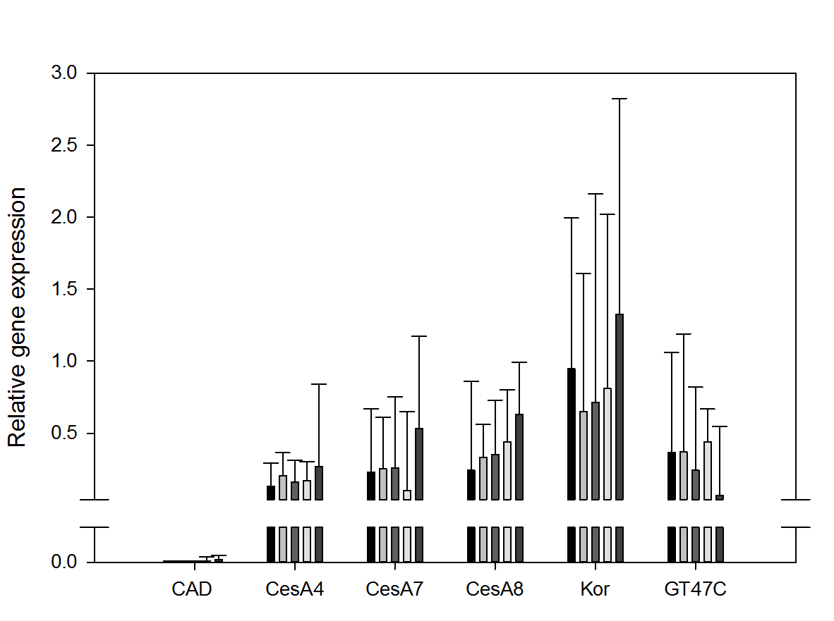
Fig S4. Expression level of genes involved in synthesis of monolignol (CAD), cellulose (CesA4, CesA7, CesA8, Kor), and hemicellulose (GT47C). Three individual plants per event were analyzed. Error bars are standard error.

Table S1. Primers used in the study
Primer name | Sequence | Note | Tm(°C)
PRSE-Fwd | GCGGCCGCCATGGAGTTCCTCAAAAGCTTCC | Forward primer to amplify Pr1a sequence with Asn mutated to Glu, NotI site added | 65
TnCelB-Rvs-Not1 | GCGGCCGCTTATTCTCCAATCTCCACAGAA | Reverse primer for cloning TnCelB, NotI site added
UBC11-Fwd | GTTGATTTTTGCTGGGAAGC | Homologous locus in Arabidopsis: NM_001125464 | 60
UBC11-Rvs | GATCTTGGCCTTCACGTTGT
EF1β-Fwd | GGCATTAAGTTTTGTCGGTCTG | elongation factor 1-beta 2 (LOC7489318) | 60
EF1β-Rvs | GCGGTTCATCATTTCATCTGG
TnCelB-Fwd | ATGCGTTTGGTGGTTTCTTTTC | Forward primer for qPCR | 60
TnCelB-Rvs | AAAGTTGAGTTCCATTGTAACT | Reverse primer for qPCR
CesA4-Fwd | CACAGGTTATCCCACTTTTGCT | JCI accession number: eugene3.00002636 | 60
CesA4-Rvs | CATACGCTTGCTTGCTAACAGA
CesA7-Fwd | CAAGCAATGTGGACTCAACTGTTA | JCI accession number: gw1.XVIII.3152.1 | 60
CesA7-Rvs | AAGCAGGATGCACATGTATCTTCT
CesA8-Fwd | AAGCACATATCGCTGTCAGTATTTA | JCI accession number: eugene3.00040363 | 60
CesA8-Rvs | TTCAACACAATCAAAACCTGTATTT
Kor-Fwd | GCAGCAAAATCATCTTACCAA | GenBank: AY535003.1 | 60
Kor-Rvs | GGATTGACAAGAACACCATAT
CAD1-Fwd | GCAAGCTTATTCACTGAACAACAAT | JCI accession number: estExt_Genewise1_v1.C_LG_IX2359 | 60
CAD1-Rvs | AAAGCAAAGACACACTGTCACATTT
GT47C-Fwd | TCCTCCAACTCCACTTTCATTC | Accession numbers: PoGT47C (DQ899955) | 60
GT47C-Rvs | AGCCAGTCCGTGTTGTATTT
CaMV-Fwd | CTGCAGGGCTAGAGCAGCTTGCCAAC | Primer to check presence of expression cassette | 55
TnCelB-Rvs-Not1 | GCGGCCGCTTATTCTCCAATCTCCACAGAA | Reverse primer for checking presence of expression cassette

