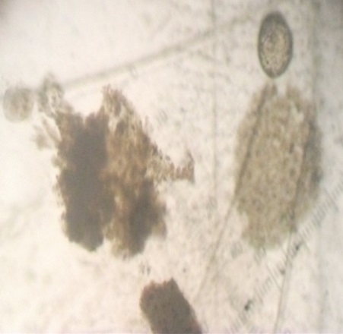
a b c
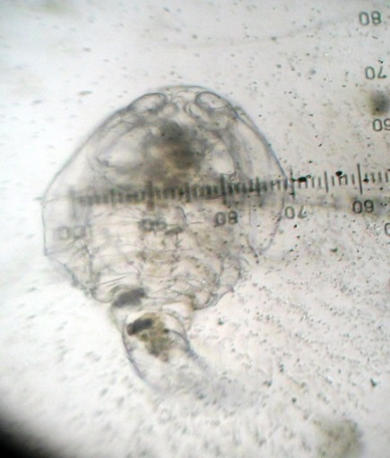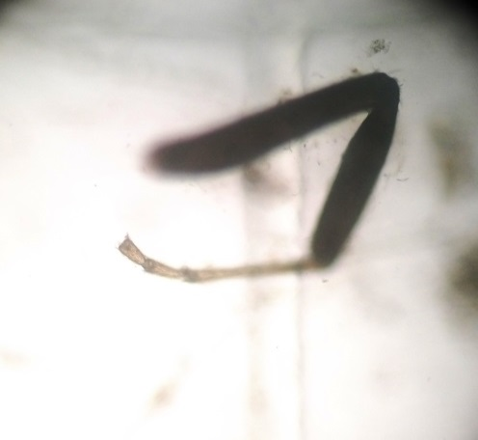
d e

Plate S1. Food items detected in the sampled clay quarry pit and reservoir a: Filamentous algae (x10); b: Detritus (x4); c: Plant part (x4); d: Copepod (x4); e: Insect leg (x4)
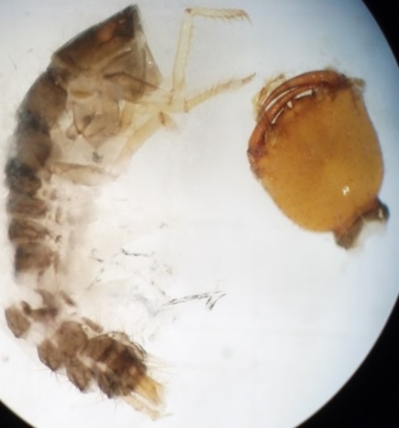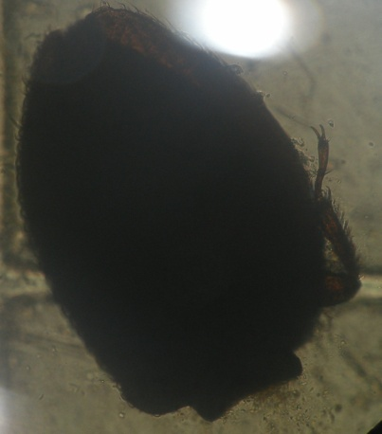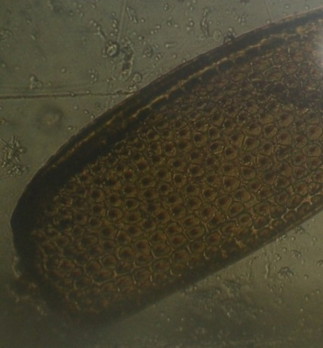
a b c
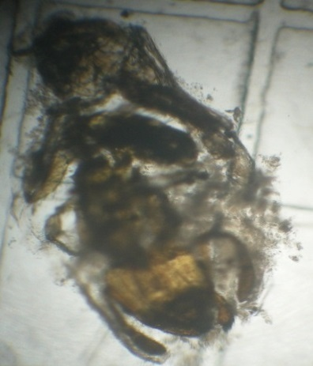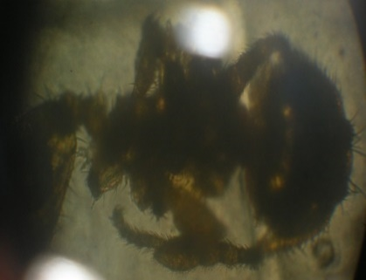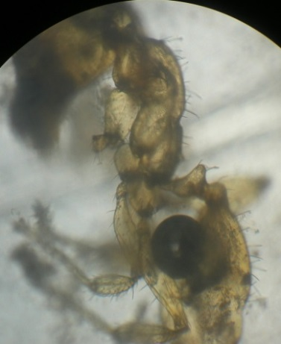
d e f

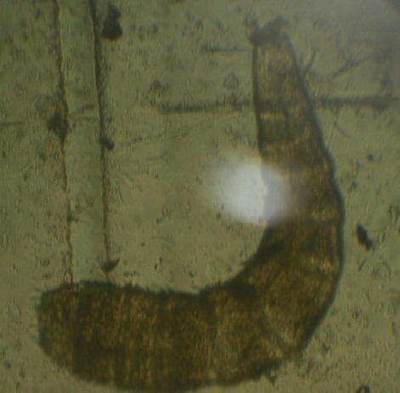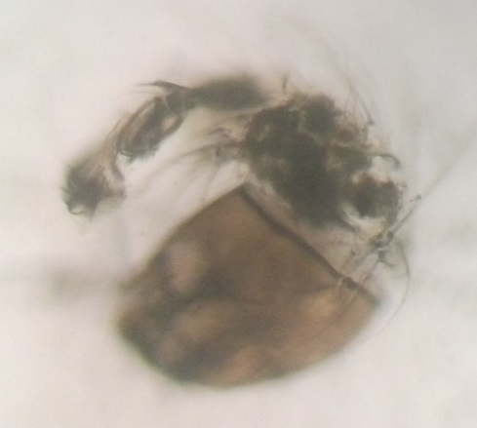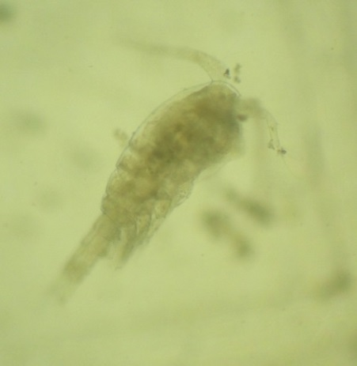
g h i

Plate S2. Food items identified in the gut of A. parvus inhabiting the sampled clay quarry pit and reservoir – a: Coleopteran larvae (x4); b: Adult Coleopteran (x4); c: Part of a Coleopteran (x4); d:e:f: Hymenopterans (x4); g:h:Insect larval stages(x); i:Copepod
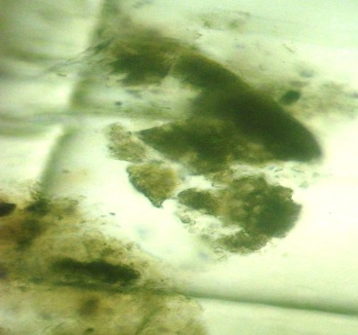
a b c

Plate S3. Food items detected in the sampled natural stream and man-made canal - a: Filamentous algae (x10); b: Detritus (x4); c: Eggs (x10)
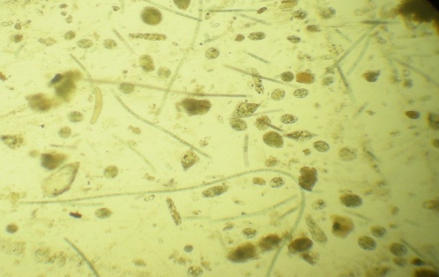

Plate S4. Food items identified in the gut of P. reticulata inhabiting the sampled man- made canal - Microscopic field consisted of filamentous algae and diatoms(x4)

