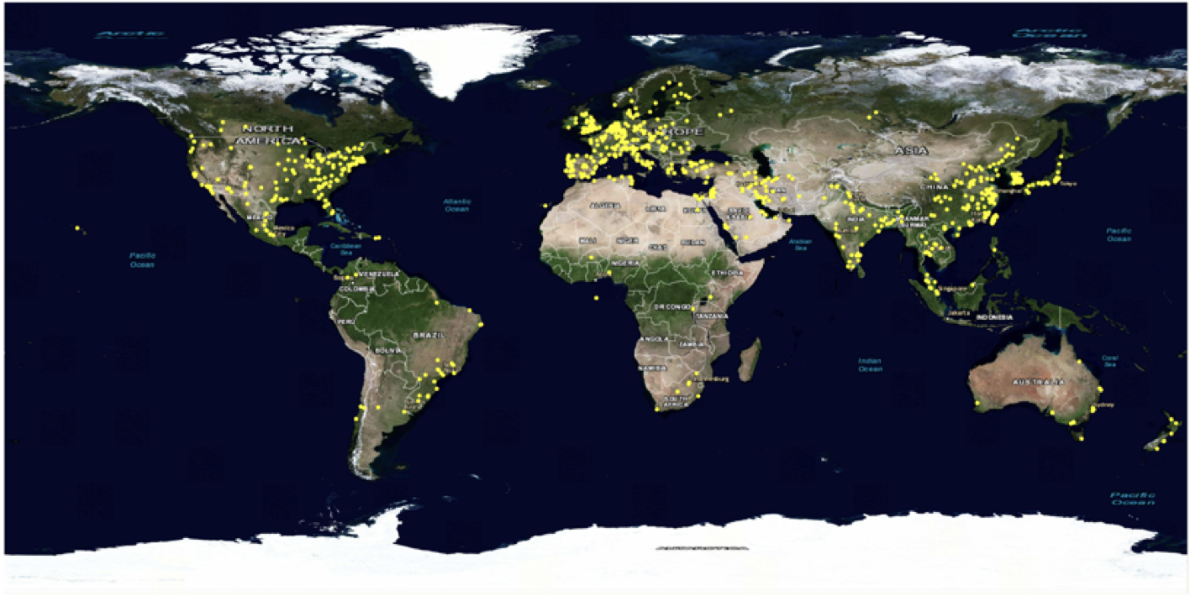
Figure S1 The geographical distribution of institutions.

Figure S2 The number of publications of the top 5 productive institutions during 1997–2016. TP: the total number of publications.

Figure S3 The number of articles of the top 6 productive subject categories.

Figure S4 The number of articles of the top 5 productive journals during 1998–2013.

