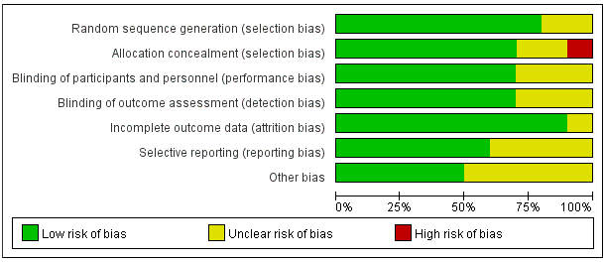
Additional file 2 Risk of Bias Graph

