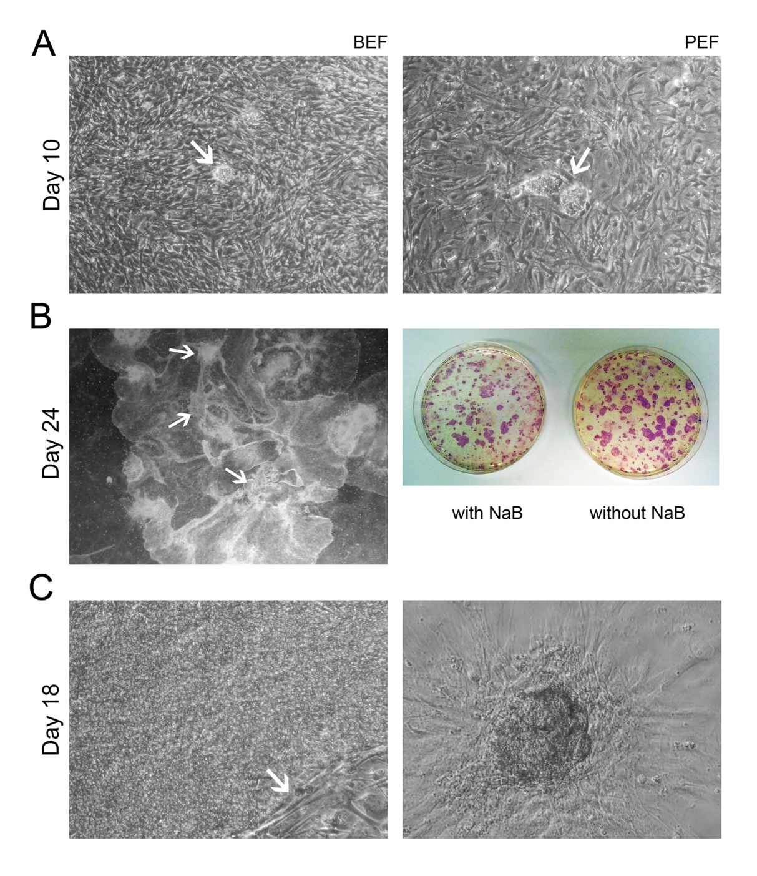
Supplementary Figure 2: iPS-like cells from BEF and PEF transduced with STEMCCA vector cultured in DMEM/F12 with KSR and FGF. (A) Emerging colonies (arrows) at day 10 post- transduction from BEF (left) and PEF (right). (B) p-iPS like cells at day 24 post-transduction. Arrows indicate globular structures similar to extraembryonic lineage tissue (left) and AP activity with or without 0.1 mM sodium butyrate, NaB (right). (C) p-iPS like cells’ colony before (left) and after (right) expansion at day 18. Arrow indicates the edge between the selected colony and the MEF feeder layer.

