Additional Information for Publication
Tolerance and Metabolic Response of Pseudomonas taiwanensis VLB120 towards Biomass Hydrolysate Derived Inhibitors
Gossa G. Wordofa† and Mette Kristensen†*
† Novo Nordisk Foundation Center for Biosustainability, Technical University of Denmark, DK-2800 Lyngby, Denmark

Corresponding Author
*Phone: +45 24649328 Email: metk@biosustain.dtu.dk

- Evaluation of different carbon sources for growth by P. taiwanensis VLB120

Additional file 1: Figure S1. Growth profile of P. taiwanensis VLB120 in different carbon source (A) and mixed carbon sources (B). Growth rate (C) was calculated from growth curves. Aerobic cultivations were carried out in 24-well clear bottom microplate (EnzyScreen, Heemstede, The Netherlands) working volume 750 µL at 30 °C, 225 rpm. Error bars are the standard deviation of three biological replicate cultures. Abbreviations: glucose (glc), sodium benzoate (SB), sodium acetate (SA), galactose (gal), glycerol (gly) and xylose (xyl).

- Effect of biomass hydrolysate derived inhibitors on P. taiwanensis VLB120

Additional file 1: Figure S2. Growth curve of P. taiwanensis VLB120 in the presence of furfural, 5-HMF, levulinic acid, formic acid, acetic acid and vanillin. Aerobic cultivations were carried out in 24-well clear bottom microplate (EnzyScreen, Heemstede, The Netherlands) working volume 750 µL at 30 °C, 225 rpm. Concentration: [g L⁻¹]. Error bars are the standard deviation of three biological replicate cultures.

- Impact of inhibitory compounds on specific glucose uptake rate
I II

Additional file 1: Figure S3. Growth of P. taiwanensis VLB120 in minimal media supplemented with 4 g L⁻¹ of glucose in the presence of 2 g L⁻¹ acetic acid (A), levulinic acid (B), furfural (C), or vanillin (D) and in the absence of inhibitory compound (E). The experiments were performed in 1.3-L bioreactors (SARTORIOUS ®) with 0.5 L working volume. The temperature, stirrer speed and pH were set at 30 °C, 800 rpm and 7.0, respectively. Cultures were supplied with air at a flow rate of 1 slpm, and minimum dissolved oxygen saturation level was 40%. Error bars indicate standard deviations of three independent cultures. CDW, cell dry weight. (I) glucose phase, (II) gluconate phase.

- Venn diagram

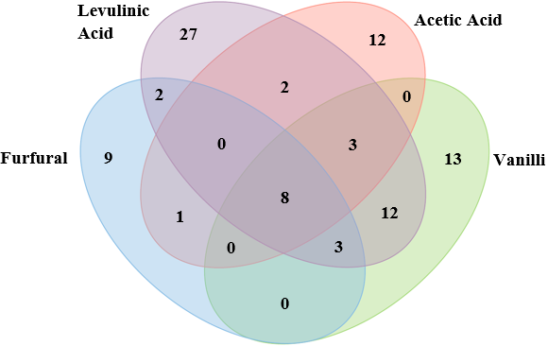
Additional file 1: Figure S4. Venn diagram illustrating number of significantly (>20%) increased metabolites that overlap between different conditions.

- PCA loading plot
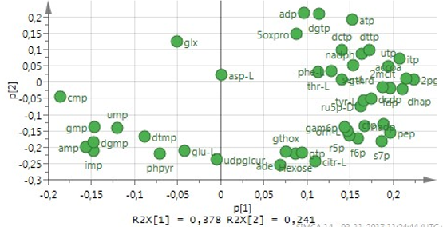
Additional file 1: Figure S5. Score plots of principal component analysis (PCA) of P. taiwanensis VLB120 metabolites under various inhibitory test.

- Heat map based on LC-MS data

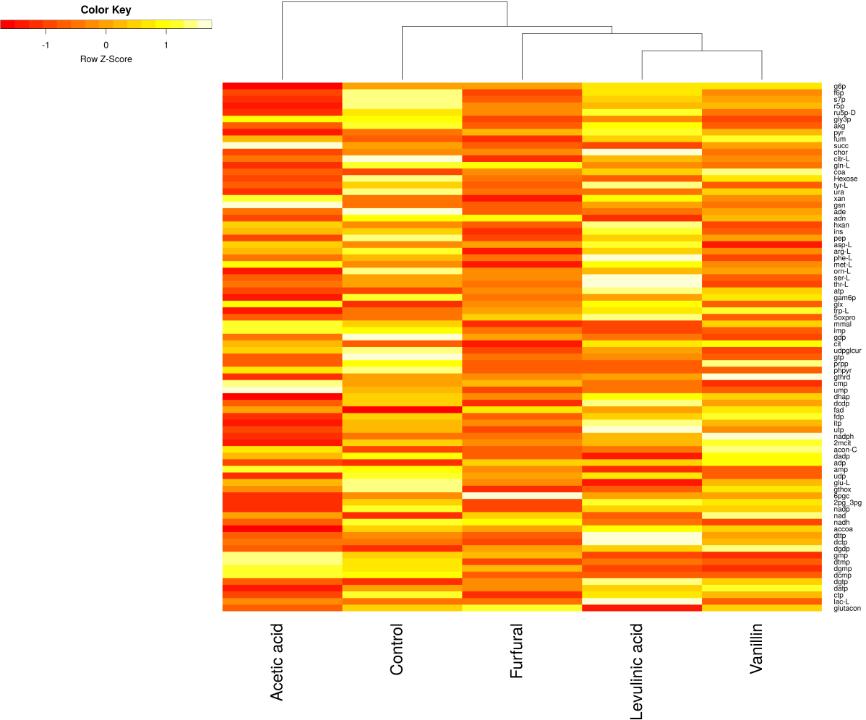
Additional file 1: Figure S6. Heatmap of metabolites extracted from P. taiwanensis VLB120 under different stress conditions. Metabolites abundance differences were clustered according to trends measured across all biological replicates (n = 3).

