**Additional information**

**Gene mining-based identification of aldo-keto reductases for highly stereoselective reduction of bulky ketones**

Chen Liang1, Yao Nie1,*, Xiaoqing Mu1, Yan Xu1,2

1School of Biotechnology and Key laboratory of Industrial Biotechnology of Ministry of Education, Jiangnan University, 1800 Lihu Road, Wuxi 214122, China

2State Key Laboratory of Food Science and Technology, Jiangnan University, 1800 Lihu Road, Wuxi 214122, China

E-mail addresses for all authors: autumnsummer@yeah.net (C. Liang); ynie@jiangnan.edu.cn (Y. Nie); xqmuf@163.com (X. Mu); yxu@jiangnan.edu.cn (Y. Xu).

* Corresponding author

Address: School of Biotechnology and Key laboratory of Industrial Biotechnology, Ministry of Education, Jiangnan University, 1800 Lihu Road, Wuxi 214122, China

E-mail address: ynie@jiangnan.edu.cn (Y. Nie);

Tel.: +86-510-85197760; Fax: +86-510-85918201.

Table S1 Oligonucleotide primers for amplification of the genes encoding AKRs involving restriction sites underlined.

|  |  |
| --- | --- |
| Gene | Primer sequence |
| CaCR | F:5'-GCGCTCATATGATGACTTCACATACCCATCCTG-3' |
| R:5'-GGGGCTCGAGCTATAAATCTTTAAATGCTTCATGG-3' |
| ScCR | F:5'-GCCCCCCATATGATGTCATTTCACCAACAGTTC-3' |
| R:5'-AATTATGCGGCCGCTTATACTTTTTGAGCAGCGTAGTTG-3' |
| KmCR | F:5'-CCGCGGGCATATGATGACAAACCAAAAGTTCTTTAC-3' |
| R:5'-CCACCCTCGAGTCATTTTTGGGCTTCGGAGTTGTAC-3' |
| CPR-C1 | F:5'-AAGGAGATATACATATGTCACTTGCTGGAAAAGAATTT-3' |
| R:5'-GGTGGTGGTGCTCGAGATCATACTTGGAATACTCTTTCG-3' |
| CPR-C2 | F:5'-AAGGAGATATACATATGACTCAAAGTAACTTACTACC-3' |
| R:5'-GGTGGTGGTGCTCGAGCAAATCTTTAAATTGCTCATGGAAG-3' |

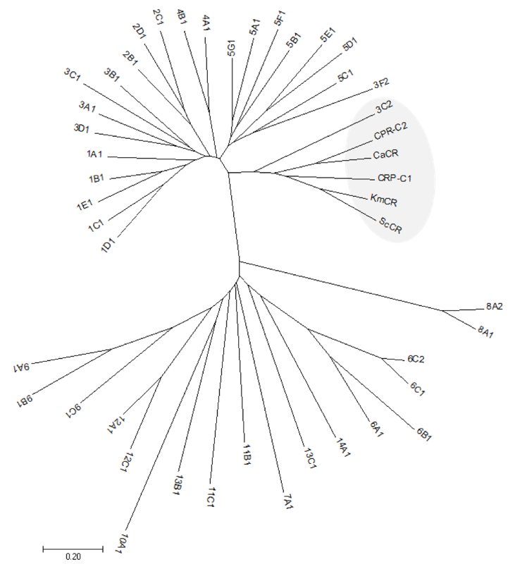

**Fig. S1** Phylogenetic tree of the enzymes and other AKRs generated from the web of http://www.med.upenn.edu/akr/.

paper1---/NADH%20酶活.pdf

**Fig. S2** Substrate specificities of the enzymes with NADH towards the tested carbonyl substrates, including (1a) methyl benzoylformate, (2a) ethyl benzoylformate, (3a) ethyl 2-oxo-4-phenylbutyrate, (4a) ethyl benzoylacetate, and (5a) 1-benzyl-3-pyrrolidinone. The reaction mixture consisted of 0.1 M sodium phosphate buffer (pH6.5), 0.5 mM NADH, 5 mM substrate, and the appropriate enzyme in a total volume of 100 µL. The experiments were carried out in triplicate, and the error bars represent the standard error of the mean.

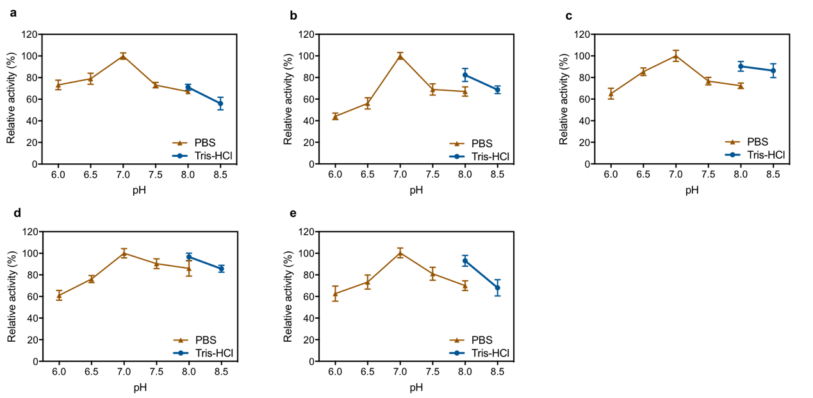

**Fig. S3** The effect of pH on the enzyme activity of (a) CaCR, (b) ScCR, (c) KmCR, (d) CPR-C1, and (e) CPR-C2 in reduction of 2a. The reaction mixture consisted of 0.1 M sodium phosphate buffer (pH 6.5 to 8.0) or 0.1 M Tris-HCl buffer (pH 8.0 to 8.5), 0.5 mM NADPH, 5 mM substrate, and the appropriate enzyme in a total volume of 100 µL. Maximal enzyme activity observed was set as 100% relative activity for each enzyme.