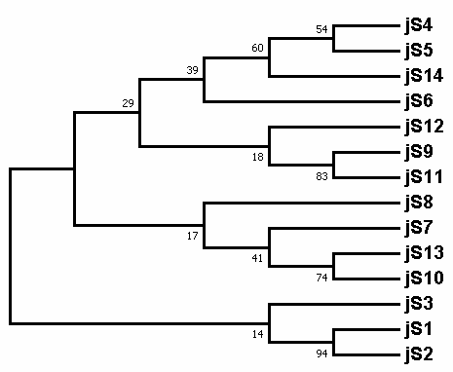
Figure S5. Phylogenetic tree of the 14 jasmintide precursors. The precursors were aligned using Clustal Omega and the tree was constructed with 1000 bootstraps using neighbor-joining algorithm.

