Hybrid phenolic-inducible promoters towards construction of self-inducible systems for microbial lignin valorization

Table S1: Oligonucleotides used in this study
Primer name | Sequence (5’→ 3’)
Pr_f10a | gcgcggatccgaatcatttttctaaaacaatacatttactttatttgtcactgtcgttactatatcggctgaaattaatgaggtcatacccaaataaggaggatattatggtttccaagggcgaggag
Pr_f11a | gcgcggatccgaatcatttttctaaaacaatacatttgacaattaatcatcggctcgtataatgatcggctgaaattaatgaggtcatacccaaataaggaggggaattcatggtttccaagggcgaggag
Pr_f12a | gcgcggatccgaatcatttttctaaaacaatacatttgacaattaatcatccggctcgtataatgatcggctgaaattaatgaggtcatacccaaataaggaggggaattcatggtttccaagggcgaggag
Pr_f13a | gcgcggatccgaatcatttttctaaaacaatacatttgacaattaatcatcgcggctcgtataatgatcggctgaaattaatgaggtcatacccaaataaggaggggaattcatggtttccaagggcgaggag
Pr_f10b | cggctgaaattaatgaggtcatacccaa
Pr_r1c | gcgcaagcttgcggccgcagagtttgtagaaacgcaaaaaggcc
Pr_r1d | aagcttgcggccgcagagttt
Pr_f9 | gtcgatcggttcatcattcaccaaa
Pr_r2 | tgtgagttagctcactcattaggca

Table S2: Nucleotide sequence of promoters used in this study
Promoter name | Sequence (5’→ 3’)
P_{emrR} | gaatcatttttctaaaacaatacatttactttatttgtcactgtcgttactatatcggctgaaattaatgaggtcatacccaaat
P_{vtac} | gaatcatttttctaaaacaatacatttgacaattaatcatcggctcgtataatgatcggctgaaattaatgaggtcatacccaaat
P_{vtrc} | gaatcatttttctaaaacaatacatttgacaattaatcatccggctcgtataatgatcggctgaaattaatgaggtcatacccaaat
P_{vtic} | gaatcatttttctaaaacaatacatttgacaattaatcatcgcggctcgtataatgatcggctgaaattaatgaggtcatacccaaat

Table S3: Vanillin induced sub-population of cells with high fluorescence and forward scattering.
Strain | Concentration, mM | Cell population %  (FL3-A >10³) | Cell population %  (FSC-A >10⁴)
RIF01 | 0 | 2.91 ± 0.51 | 54.38 ± 4.47
 | 0.1 | 2.87 ± 0.44 | 54.46 ± 1.65
 | 1.0 | 2.09 ± 0.28 | 40.10 ± 2.17
 | 3.0 | 2.22 ± 0.22 | 28.57 ± 0.48
 | 5.0 | 5.18 ± 0.73 | 24.26 ± 2.98
RIF02 | 0 | 8.62 ± 0.05 | 59.51 ± 1.67
 | 0.1 | 6.37 ± 0.31 | 54.19 ± 2.99
 | 1.0 | 7.08 ± 0.28 | 44.72 ± 1.97
 | 3.0 | 8.68 ± 0.67 | 30.35 ± 0.56
 | 5.0 | 13.52 ± 1.02 | 26.17 ± 2.44
RIF03 | 0 | 7.81 ± 0.46 | 61.97 ± 0.41
 | 0.1 | 6.21 ± 0.93 | 55.98 ± 1.29
 | 1.0 | 6.48 ± 0.74 | 39.91 ± 1.73
 | 3.0 | 8.58 ± 0.77 | 27.39 ± 0.47
 | 5.0 | 16.89 ± 0.60 | 21.34 ± 0.50
RIF04 | 0 | 7.61 ± 0.48 | 69.11 ± 0.39
 | 0.1 | 7.21 ± 0.52 | 66.87 ± 0.72
 | 1.0 | 7.48 ± 0.59 | 57.25 ± 2.04
 | 3.0 | 15.67 ± 1.06 | 39.13 ± 2.03
 | 5.0 | 18.22 ± 1.11 | 25.24 ± 1.21

Table S4: Coumaric acid induced sub-population of cells with high fluorescence and forward scattering.
Strain | Concentration, mM | Cell population %  (FL3-A >10³) | Cell population %  (FSC-A >10⁴)
RIF01 | 0 | 3.34 ± 0.15 | 53.49 ± 0.87
 | 0.1 | 3.07 ± 0.01 | 44.25 ± 0.71
 | 1.0 | 3.87 ± 0.26 | 36.46 ± 0.51
 | 5.0 | 4.01 ± 0.44 | 35.23 ± 3.34
RIF02 | 0 | 20.88 ± 1.12 | 55.27 ± 1.47
 | 0.1 | 24.90 ± 0.58 | 46.40 ± 1.81
 | 1.0 | 24.37 ± 0.99 | 37.67 ± 0.55
 | 5.0 | 21.43 ± 1.05 | 34.60 ± 1.45
RIF03 | 0 | 16.67 ± 1.88 | 57.80 ± 2.17
 | 0.1 | 20.49 ± 0.2 | 48.20 ± 1.31
 | 1.0 | 22.95 ± 0.71 | 39.70 ± 0.89
 | 5.0 | 21.62 ± 1.28 | 37.90 ± 1.40
RIF04 | 0 | 12.93 ± 0.92 | 65.47 ± 0.38
 | 0.1 | 12.58 ± 0.86 | 61.27 ± 0.15
 | 1.0 | 14.45 ± 0.97 | 55.90 ± 0.87
 | 5.0 | 15.85 ± 2.35 | 47.37 ± 2.99

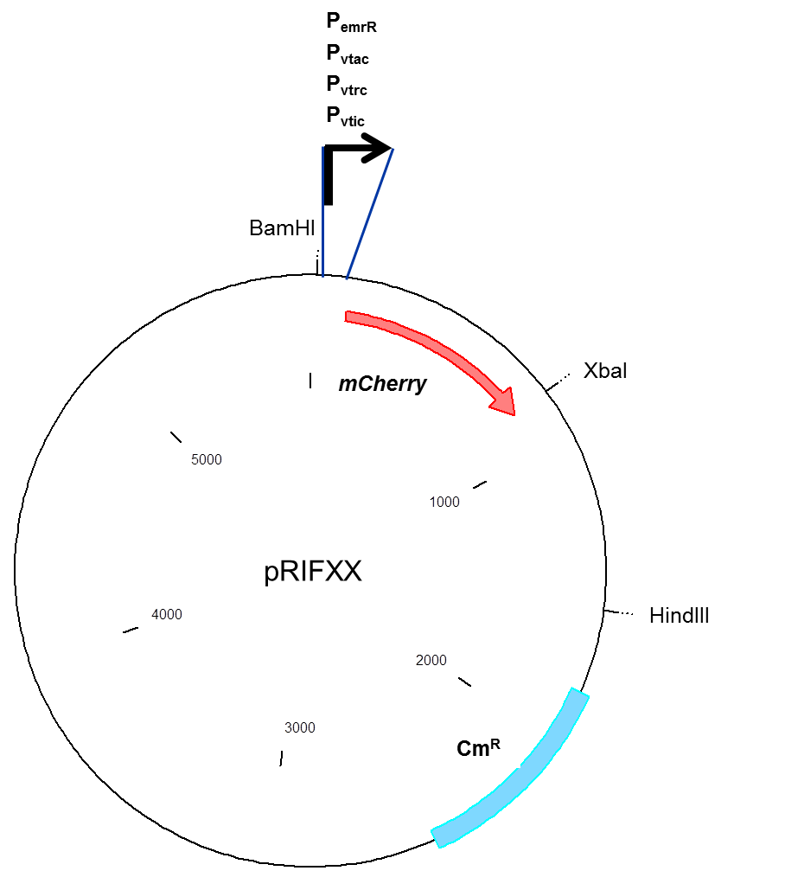
Figure S1: Vector map of the construct utilized to interrogate the strength of the promoters in this study. Based upon the promoter present in the construct, pRIFXX can be pRIF01, pRIF02, pRIF03, or pRIF04.

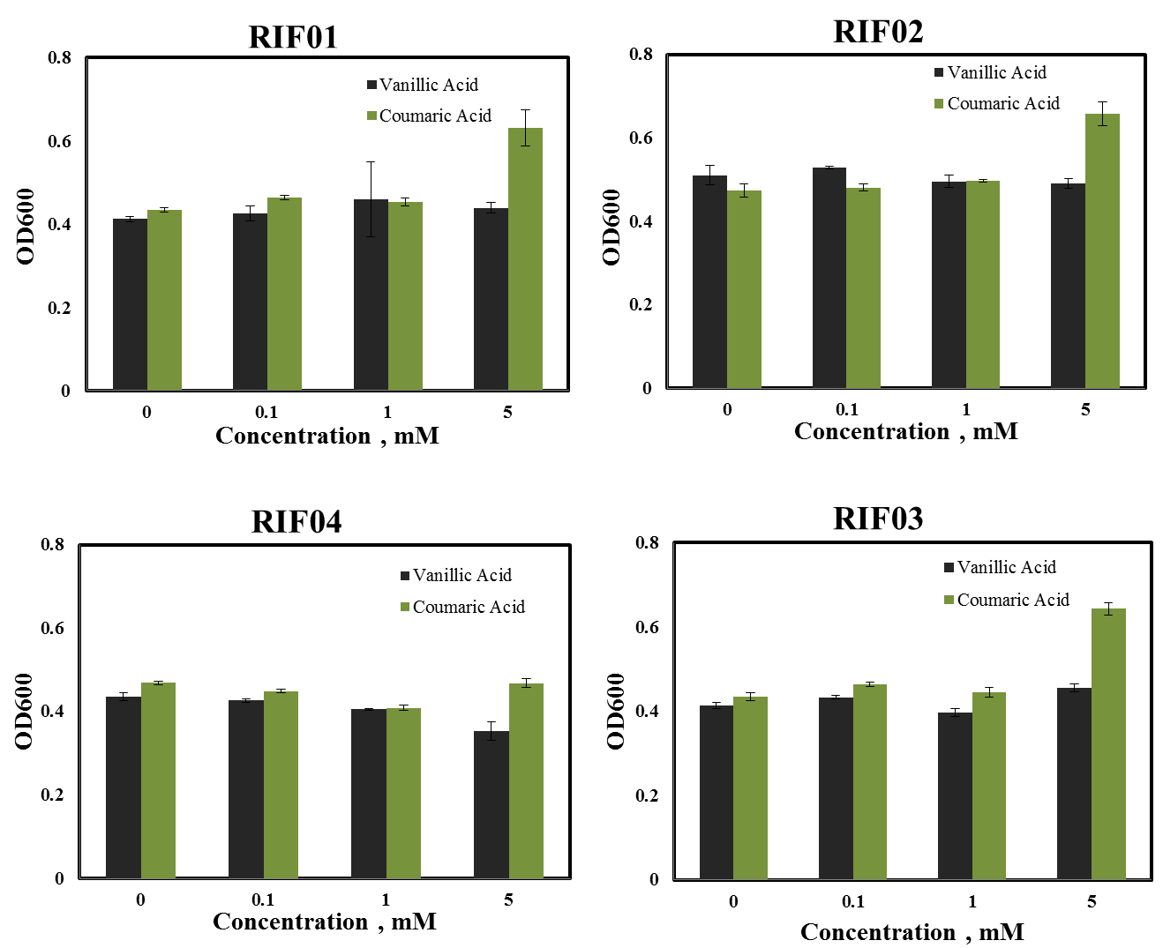
Figure S2: Optical density of the E. coli strains under varying concentrations of vanillic acid and coumaric acid.

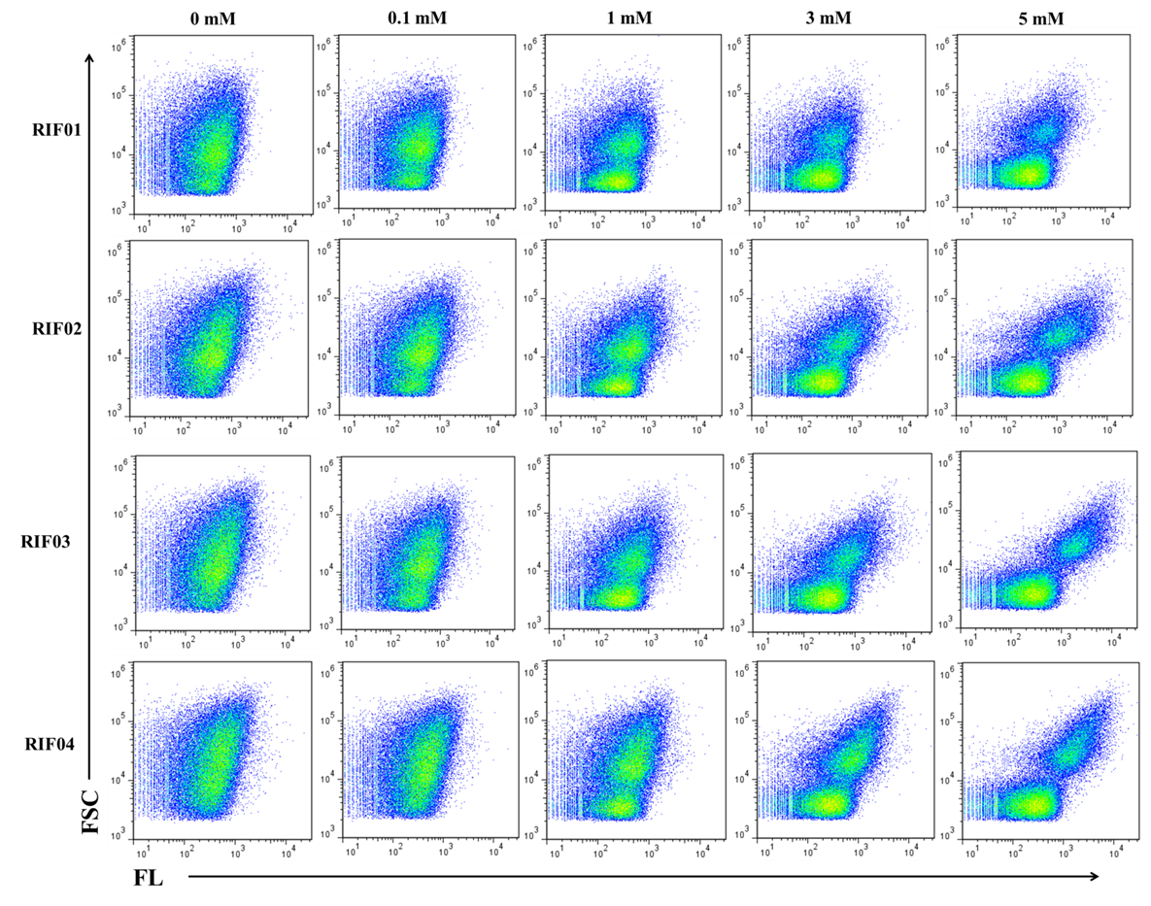
Figure S3: Flow cytometric analysis of vanillin induced cultures.
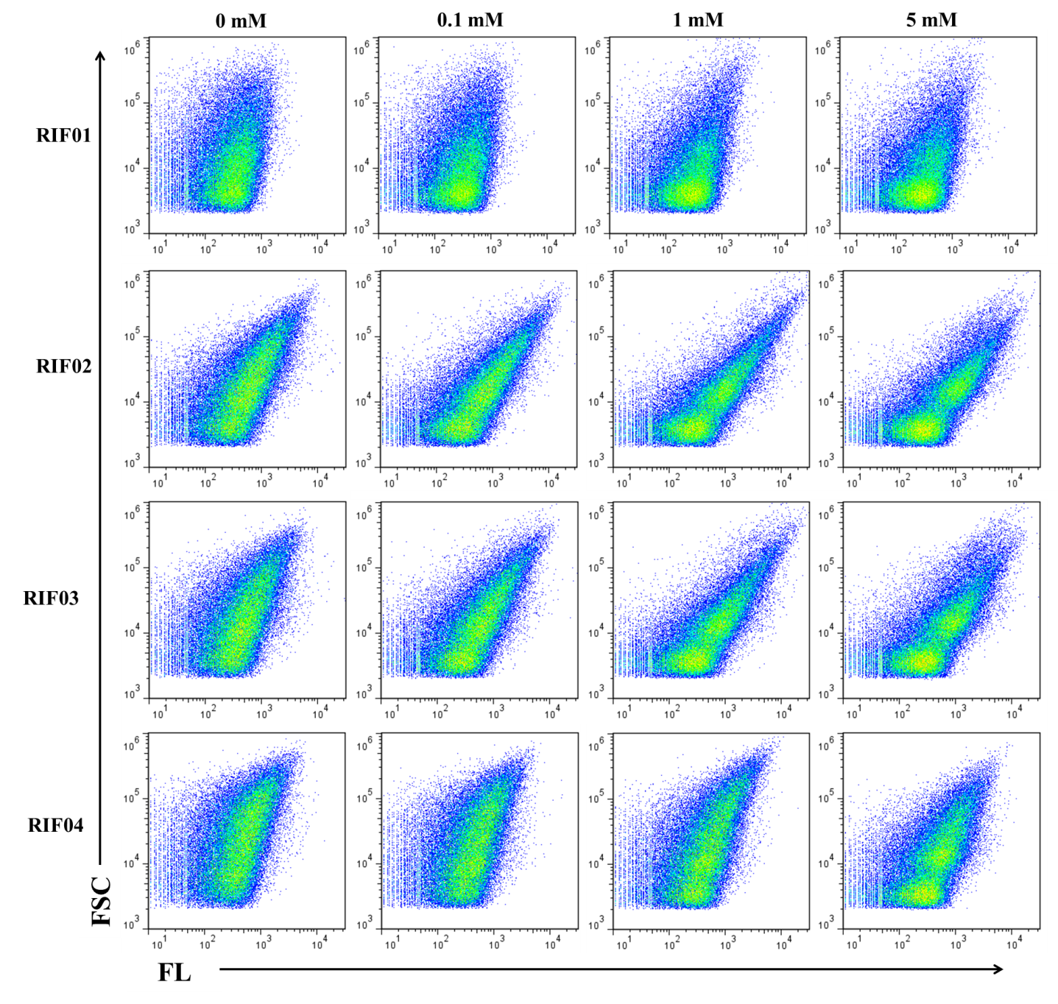
Figure S4: Flow cytometric analysis of coumaric acid induced cultures.

