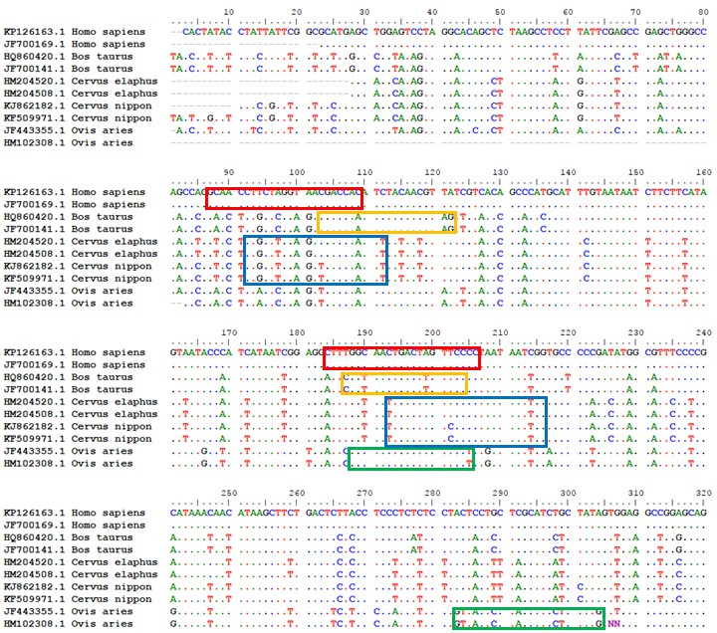
Additional file 2 – Sequences alignment and species-specific diagnostic primer design.
DNA sequence of COI gene from human (Homo sapiens), cow (Bos taurus), deer (Cervus elaphus and Cervus nippon) and sheep (Ovis aries) species were obtained from NCBI GenBank and compared with sequence alignment. Primers used in this studied were highlight in red, yellow, blue, and green boxes, respectively. Dots indicate the nucleotides identical to the top sequence (i.e. KP126163.1 Homo sapiens).

