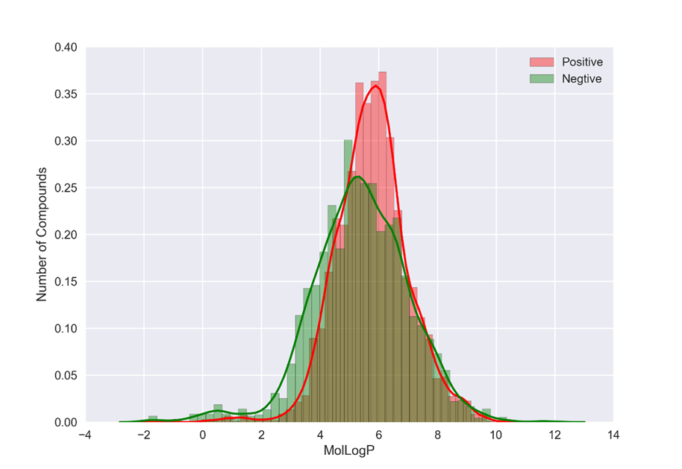
Additional file 2: Fig. S1. Distributions of MolLogP in both active compound and inactive compound

