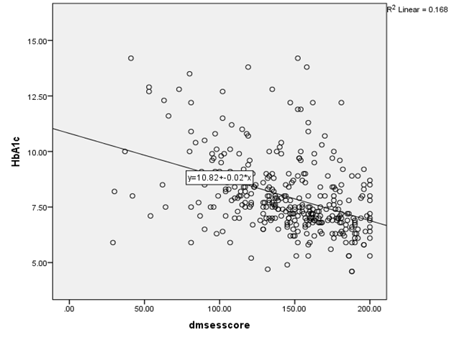

***r* -0.41, *P*<0.001**